**Module 7 Activity 2: Project Implementation for Book Exchange**

Saurabh Kale

IFT 458/554: Middleware Programming & Database Security

Dinesh Sthapit

November 19th, 2023

**Step 1: Prepare your project source code-**

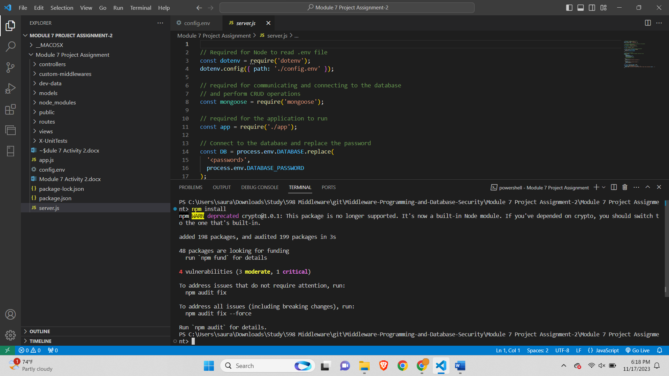

**Step 2: Review the Book Model-**

Mongoose is imported



This block of code defines a Mongoose schema named bookExchangeSchema. It includes fields like title, author, description, exchangeType, owner, and status. Additionally, the timestamps option is set to true, which means Mongoose will automatically add createdAt and updatedAt fields to the documents.

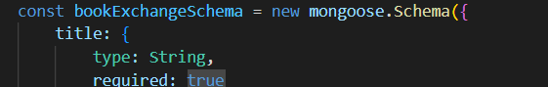

The block of bookExchangeSchema closes with timestamps: true which means Mongoose will add two properties of type Date to your schema createdAt and updatedAt.

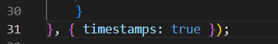

This snippet shows the definition of the title field, specifying that it must be of type String and is required.

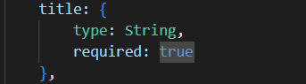

The exchangeType field is of type String and is restricted to the values 'borrow' or 'trade' due to the enum constraint.

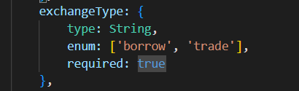

The owner field is an ObjectId that refers to another document in the 'User' collection. This establishes a relationship between the 'BookExchange' and 'User' models.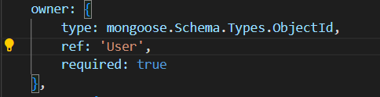

The status field is of type String and is limited to the values 'available' or 'unavailable'. It has a default value of 'available' if not specified.

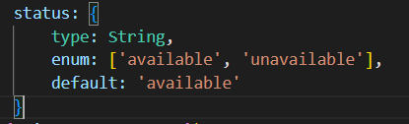

This creates a Mongoose model named **BookExchange** using the defined schema and that model is exported using module.exports to use in other files.

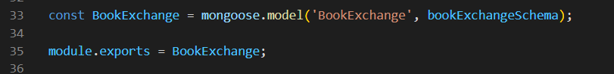

**Step 3: Review the Book Controller-**

The following code imports book model from bookModel file



Created e exported a function addBook to render a view and send as response. The response is in try block and if any error occurs then catch block will be run with the response as 400 and appError view will be loaded with error message.

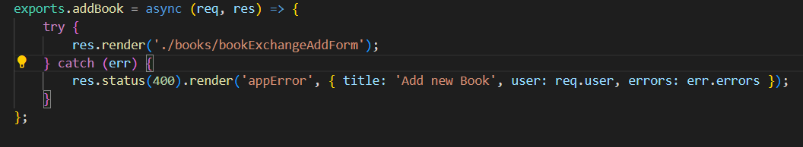

Created and exported a function createBook which will create a new Book model object by taking all the values from request and save the object then redirect to /books page. If any of the operation fails it will run catch block where appError view will be loaded with states 400

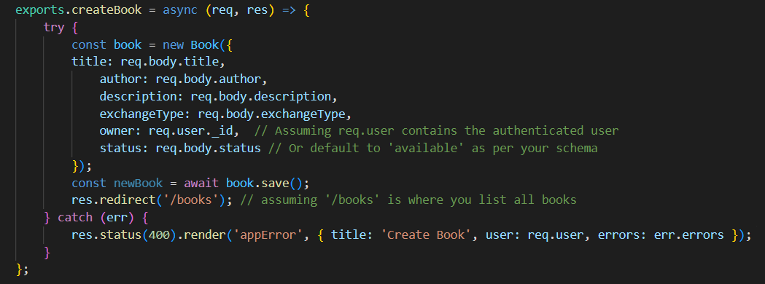

Created and exported a function getBooks which will find all books saved and store in books variable. Then render the bookListForm view by sending the books variable, user and title to the view. If any error occurs in try block then catch block will run with status 500 and error message

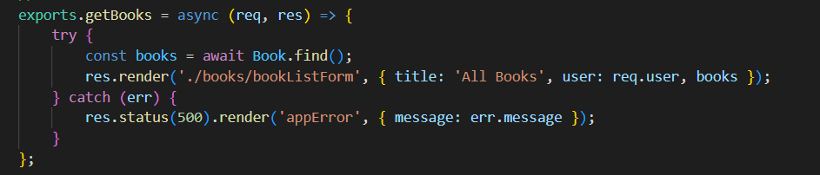

This function will get books by Id hence named getBooksById where the logic is written in try block. It will search Book by id which is sent by user and fetched from req.params.id. If book is not found the response is sent with status 404 and error page with be rendered with message Book not found. If book found then bookExchangeDetails page is rendered and book which is stored will be sent. If there is error in try block then catch block runs with response status 500 and renders error view with error message.

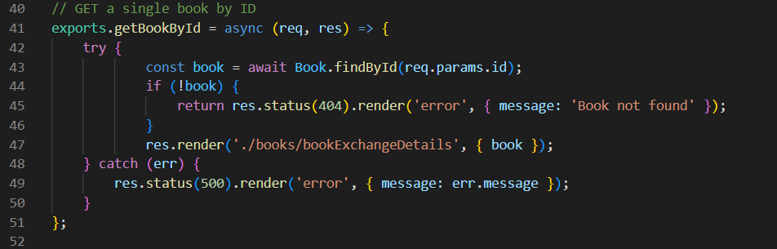

This is updateBookForm function which is exported. In this function the book is searched first using findById if the book is not found the response is sent with status 404 that book is not found. If book found then bookExchangeDetails view is called with book. If the try block faces any error then catch block runs where response is sent 400 and appError page is rendered.

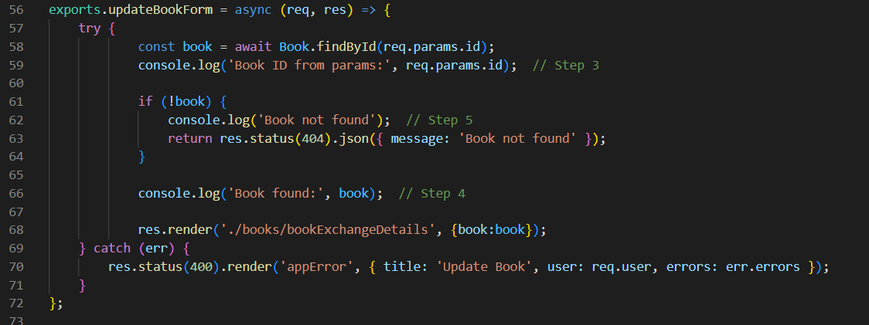

The code exports an asynchronous function **updateBookById** that attempts to update a book in the database using the **Book.findByIdAndUpdate** method, ensuring the updated document is returned. It checks if the book exists, rendering a 404 error page if not. Subsequently, it fetches the updated list of books, renders a view for displaying them, and optionally redirects to the book detail page (commented out). In case of any errors, it renders an error page with a 500 status and includes the error message from the catch block.

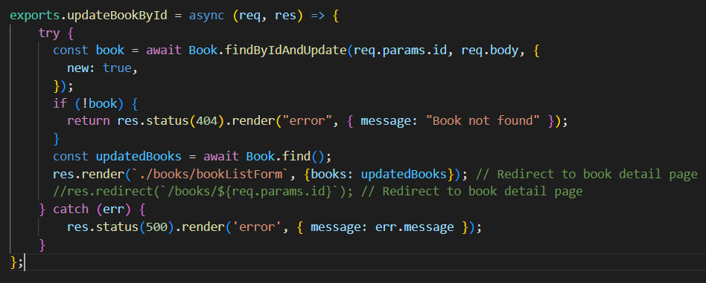

The code exports an asynchronous function named **deleteBook** responsible for deleting a book from the database based on the book's ID obtained from the request parameters. It utilizes Mongoose's **findByIdAndRemove** method to find and remove the book. If the book is not found, it renders an error page with a 404 status and the message 'Book not found.' Upon successful deletion, it redirects the user to the '/books' route, assuming this is where the list of all books is displayed. Any potential errors during the process trigger a catch block, rendering an error page with a 500 status and including the error message.

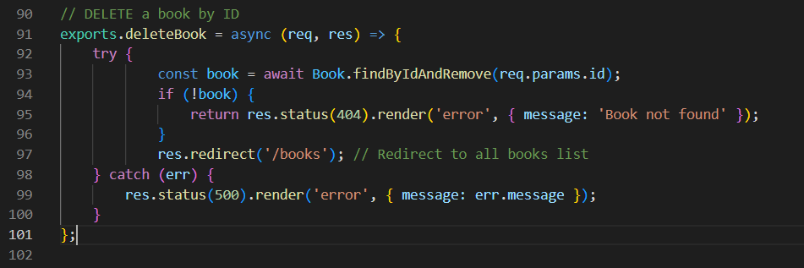

**Step 4: Review Book RoutesCreate a new file for book routes called bookRoutes.js.routes/bookRoutes.js**

The code uses a router to organize these routes and connects them to corresponding functions in the **booksController**. The middleware functions **authenticate** and **authorize** are applied to secure these routes, ensuring that only authenticated and authorized users can perform certain actions.

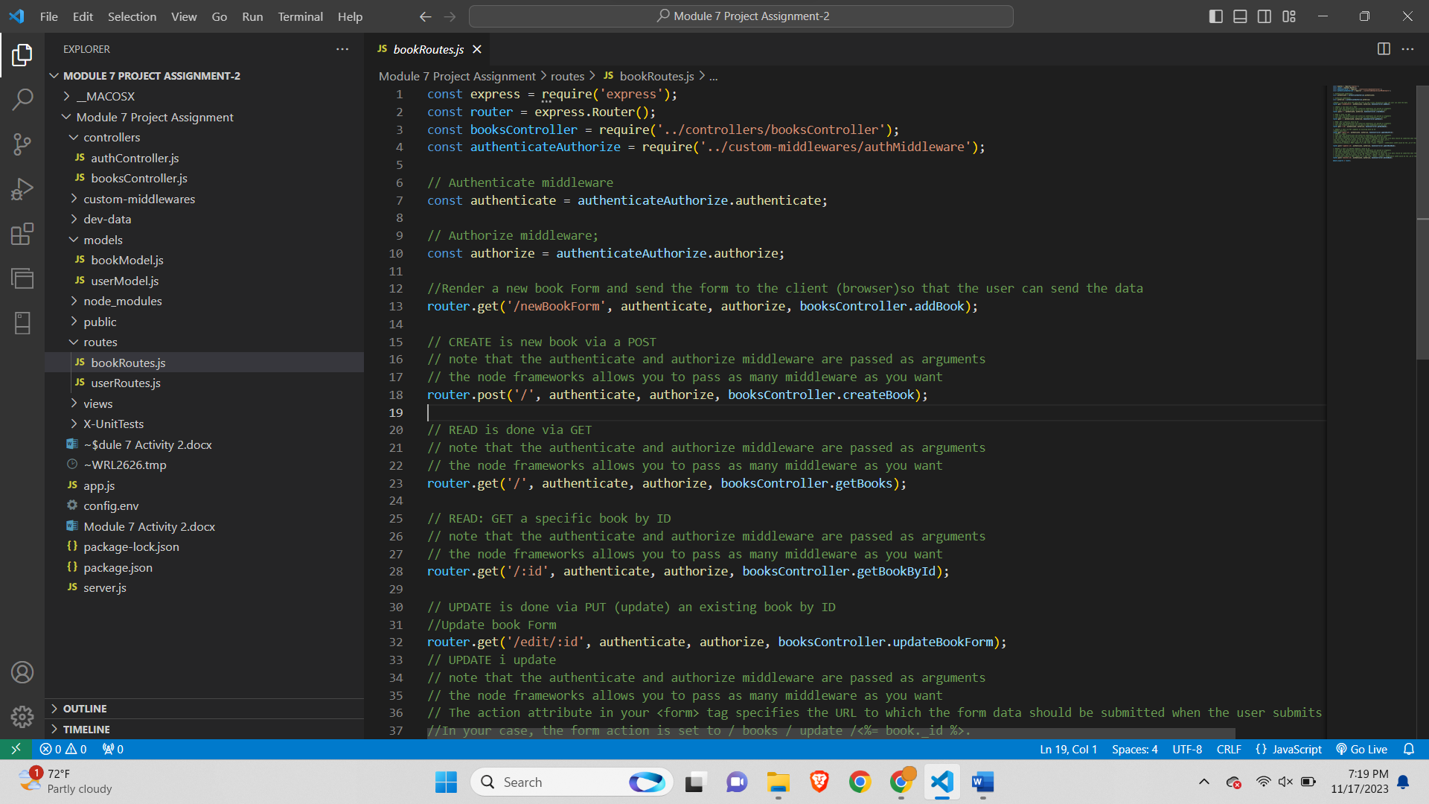

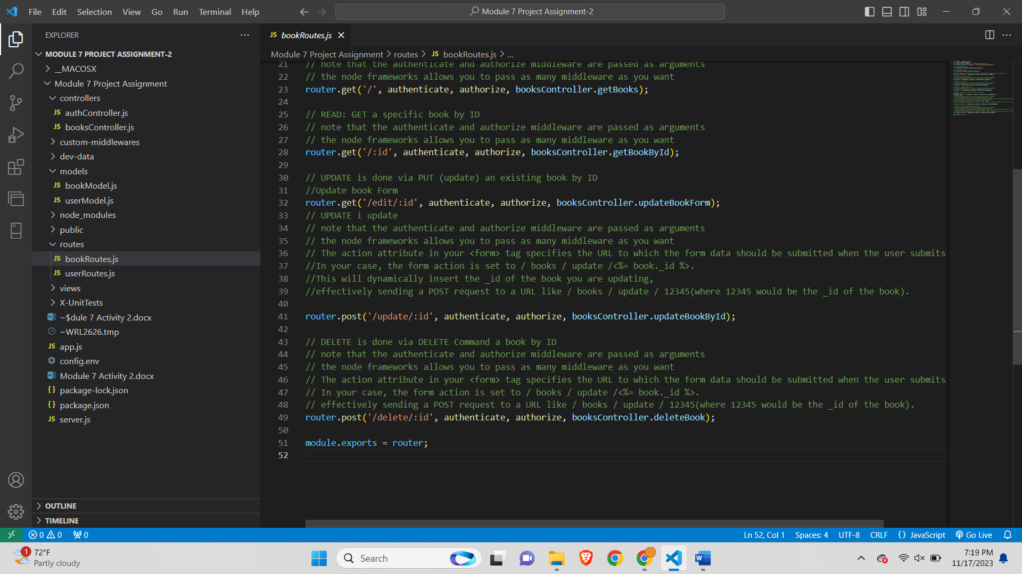

The first route, accessible via a GET request to '/newBookForm', renders a new book form, limiting access to authenticated and authorized users. The second route, handling POST requests to '/', manages the creation of a new book through the **createBook** function in **booksController**, requiring authentication and authorization. The third route, triggered by a GET request to '/', retrieves all books using the **getBooks** function in **booksController**, with authentication and authorization enforced. The fourth route, responding to a GET request to '/:id', retrieves a specific book by its ID using the **getBookById** function in **booksController**, with authentication and authorization required.

Continuing, the fifth route, accessible via a GET request to '/edit/:id', renders an update book form for a specific book identified by its ID, utilizing the **updateBookForm** function in **booksController**. Authentication and authorization are prerequisites for accessing this route. The sixth route, handling POST requests to '/update/:id', oversees the updating of an existing book using the **updateBookById** function in **booksController**, with authentication and authorization enforced. Lastly, the seventh route, triggered by POST requests to '/delete/:id', manages the deletion of a book by its ID using the **deleteBook** function in **booksController**, requiring authentication and authorization.

The route structure adheres to RESTful conventions, assigning specific HTTP methods (GET, POST) to corresponding actions (READ, CREATE, UPDATE, DELETE). Middleware functions **authenticate** and **authorize** bolster security by ensuring that users are authenticated and authorized before performing specific book-related operations. The modular organization of routes enhances code maintainability and readability in this Express.js application.

**Step 5: Review All the Files in the View Folders:**

**bookExchangeForm.ejs-**

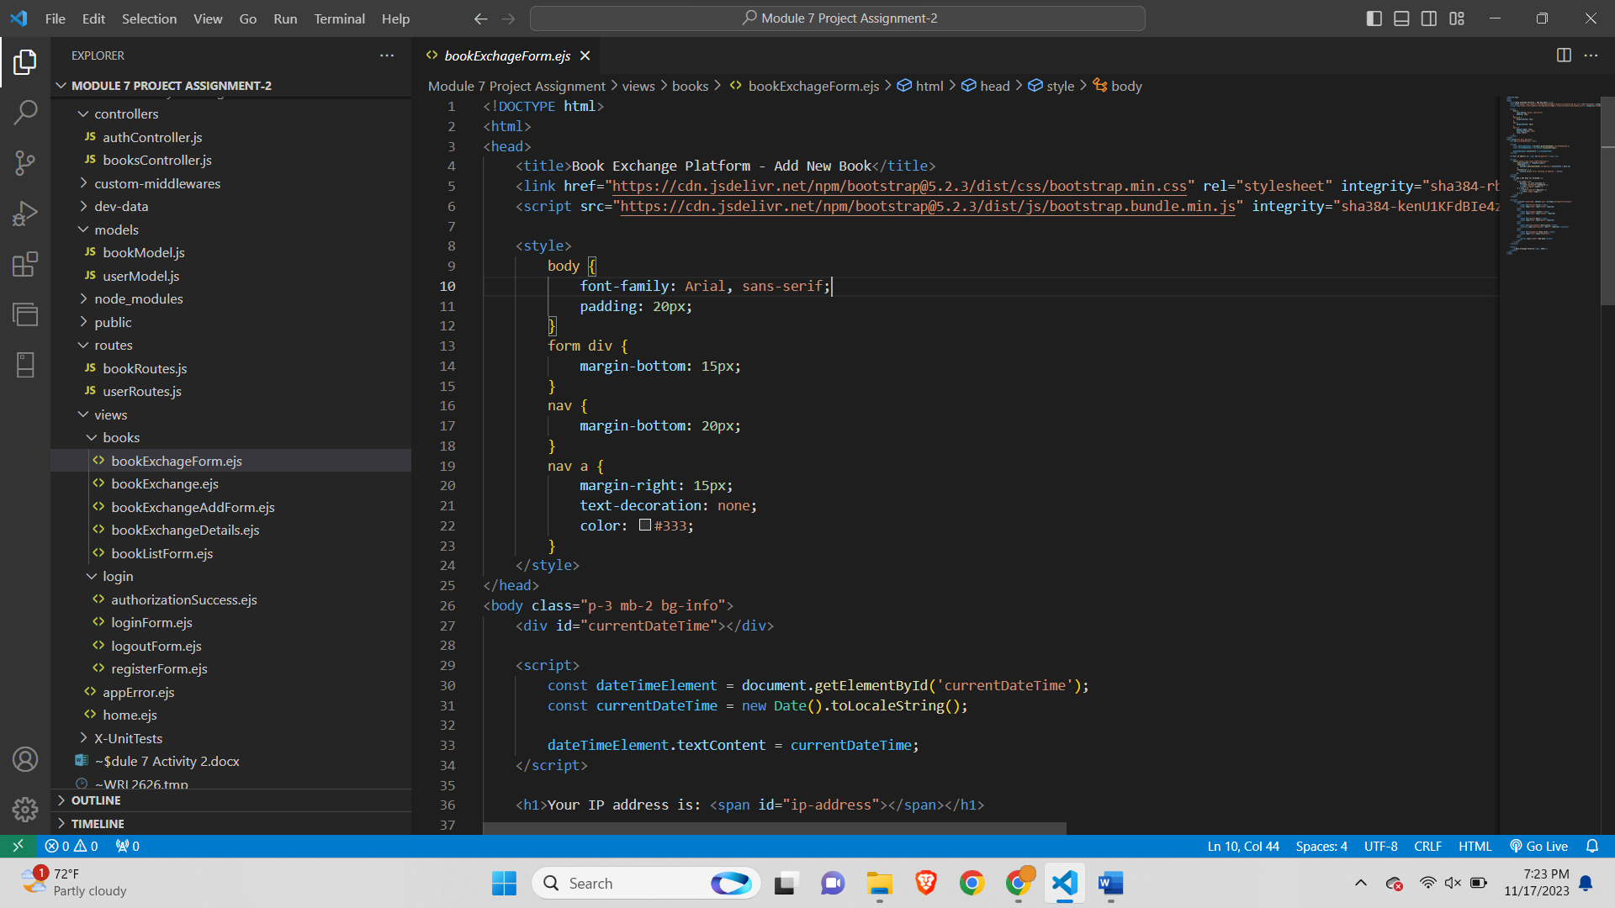

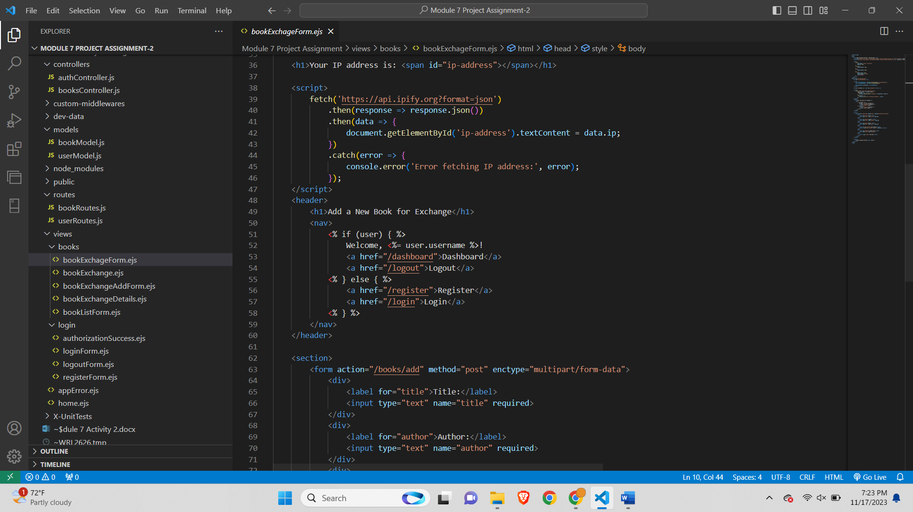

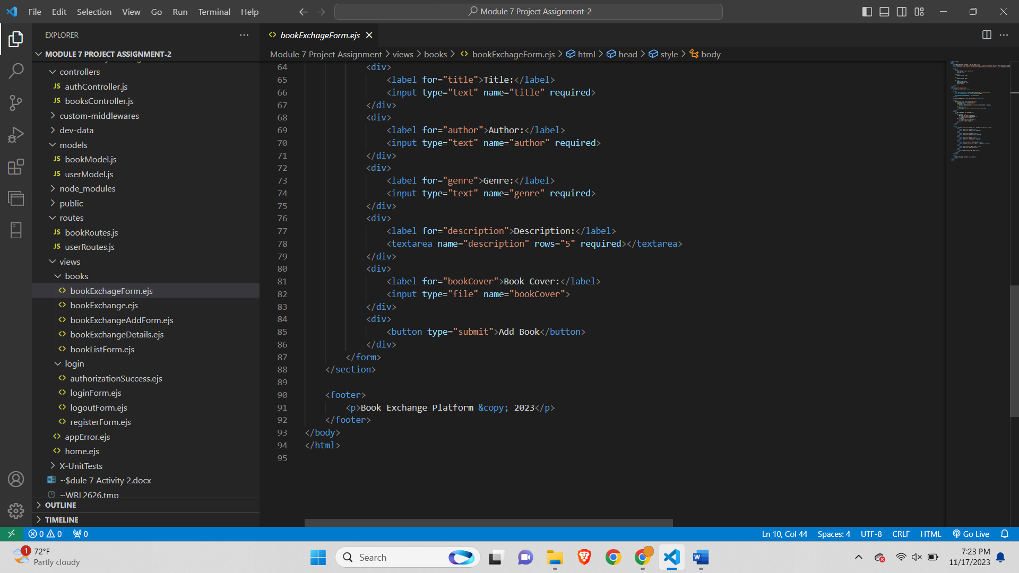

It incorporates Bootstrap for styling and responsiveness. The page begins with the inclusion of Bootstrap's CSS and JavaScript libraries. Inside the **<body>** tag, there's a script to display the current date and time dynamically. Additionally, it fetches the user's IP address using the 'ipify' API and displays it on the page. The header section contains a greeting to the logged-in user, providing links to the dashboard and logout if the user is authenticated. If not, it presents links for registration and login. The main section includes a form for adding a new book, capturing information such as title, author, genre, description, and an optional book cover image. The form submits data to the "/books/add" route using the POST method. Finally, there's a footer displaying the copyright year for the Book Exchange Platform. Overall, the page is designed for user interaction, inputting book details, and features dynamic elements like date, time, and IP address retrieval.

**bookExchange.ejs-**

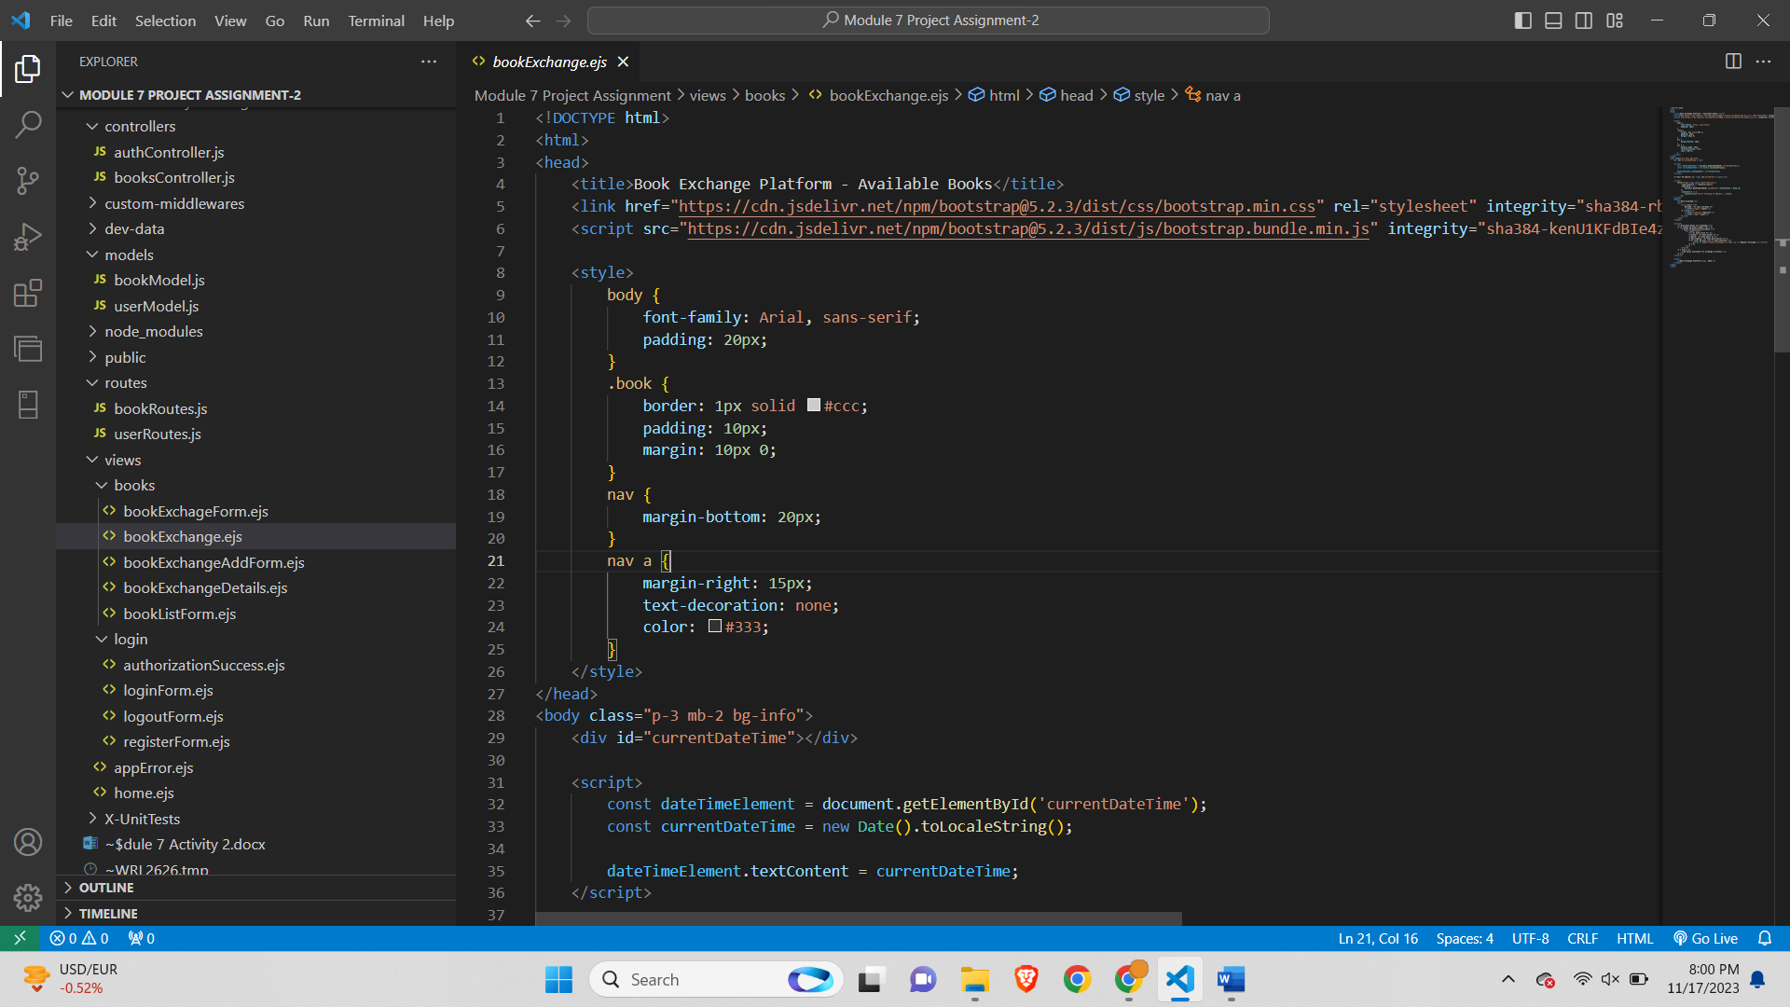

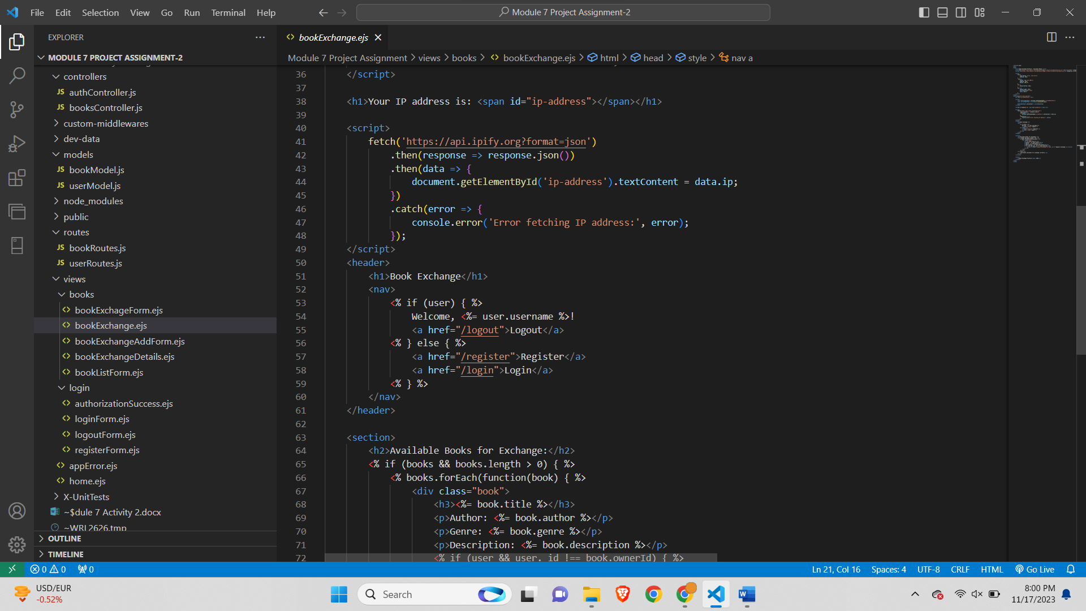

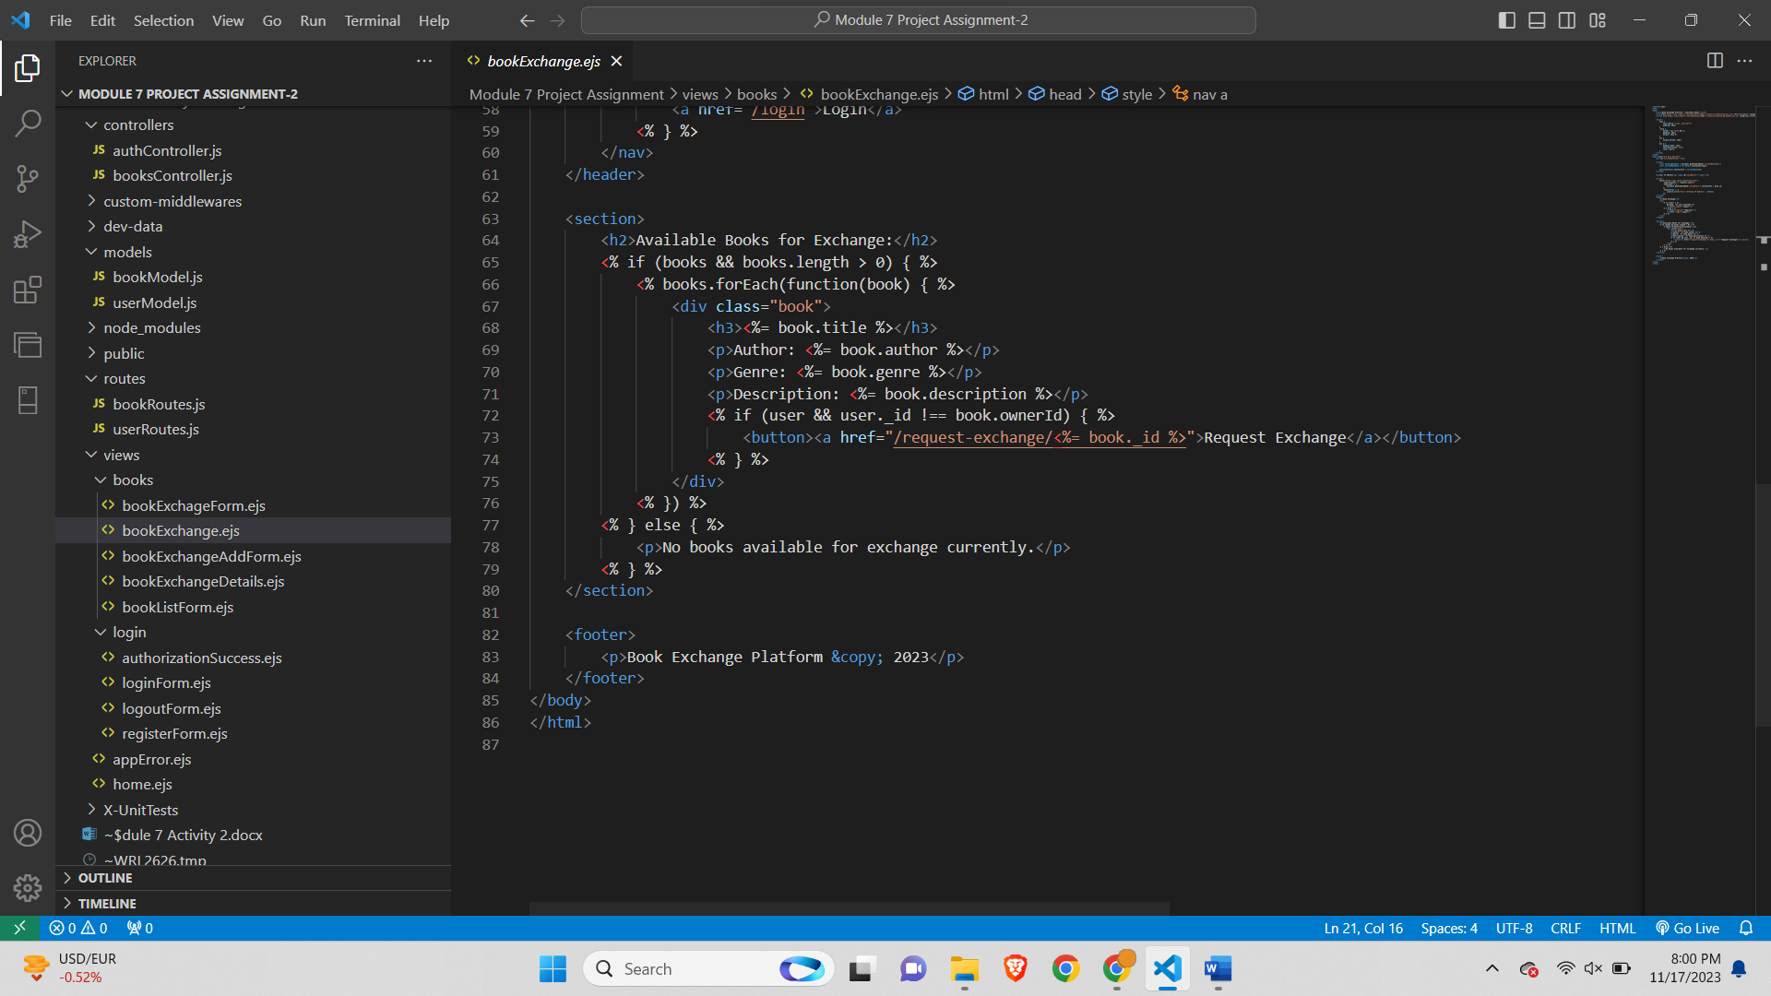

The HTML code provided represents a web page for displaying available books on a Book Exchange Platform. It includes Bootstrap for styling and responsiveness. The page begins with the inclusion of Bootstrap's CSS and JavaScript libraries. Inside the **<body>** tag, there's a script to display the current date and time dynamically, and another script fetches and displays the user's IP address using the 'ipify' API. The header section includes a greeting to the logged-in user, displaying their username and providing a logout link if authenticated. If not, it presents links for registration and login. The main section features a heading indicating "Available Books for Exchange," followed by a loop that iterates through an array of books. For each book, it creates a container with details such as title, author, genre, and description. If the user is authenticated and not the owner of the book, a "Request Exchange" button is displayed, linking to the "/request-exchange/<%= book._id %>" route. If no books are available, a message stating so is presented. The footer includes the copyright year for the Book Exchange Platform. Overall, the page is designed to dynamically showcase available books, allowing users to request exchanges for books owned by others.

Top of Form

**bookExchangeAddForm.ejs-**

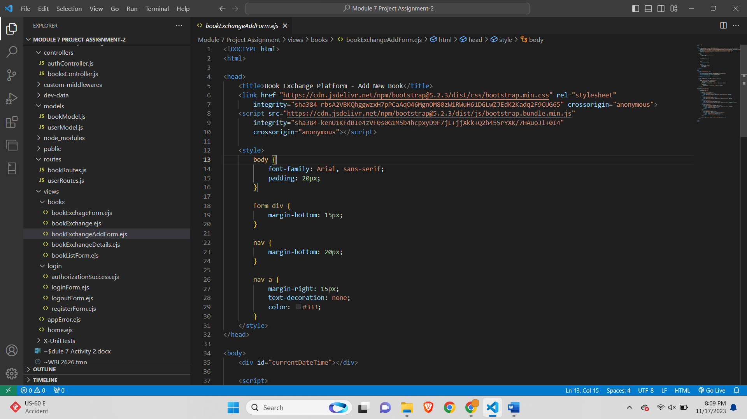

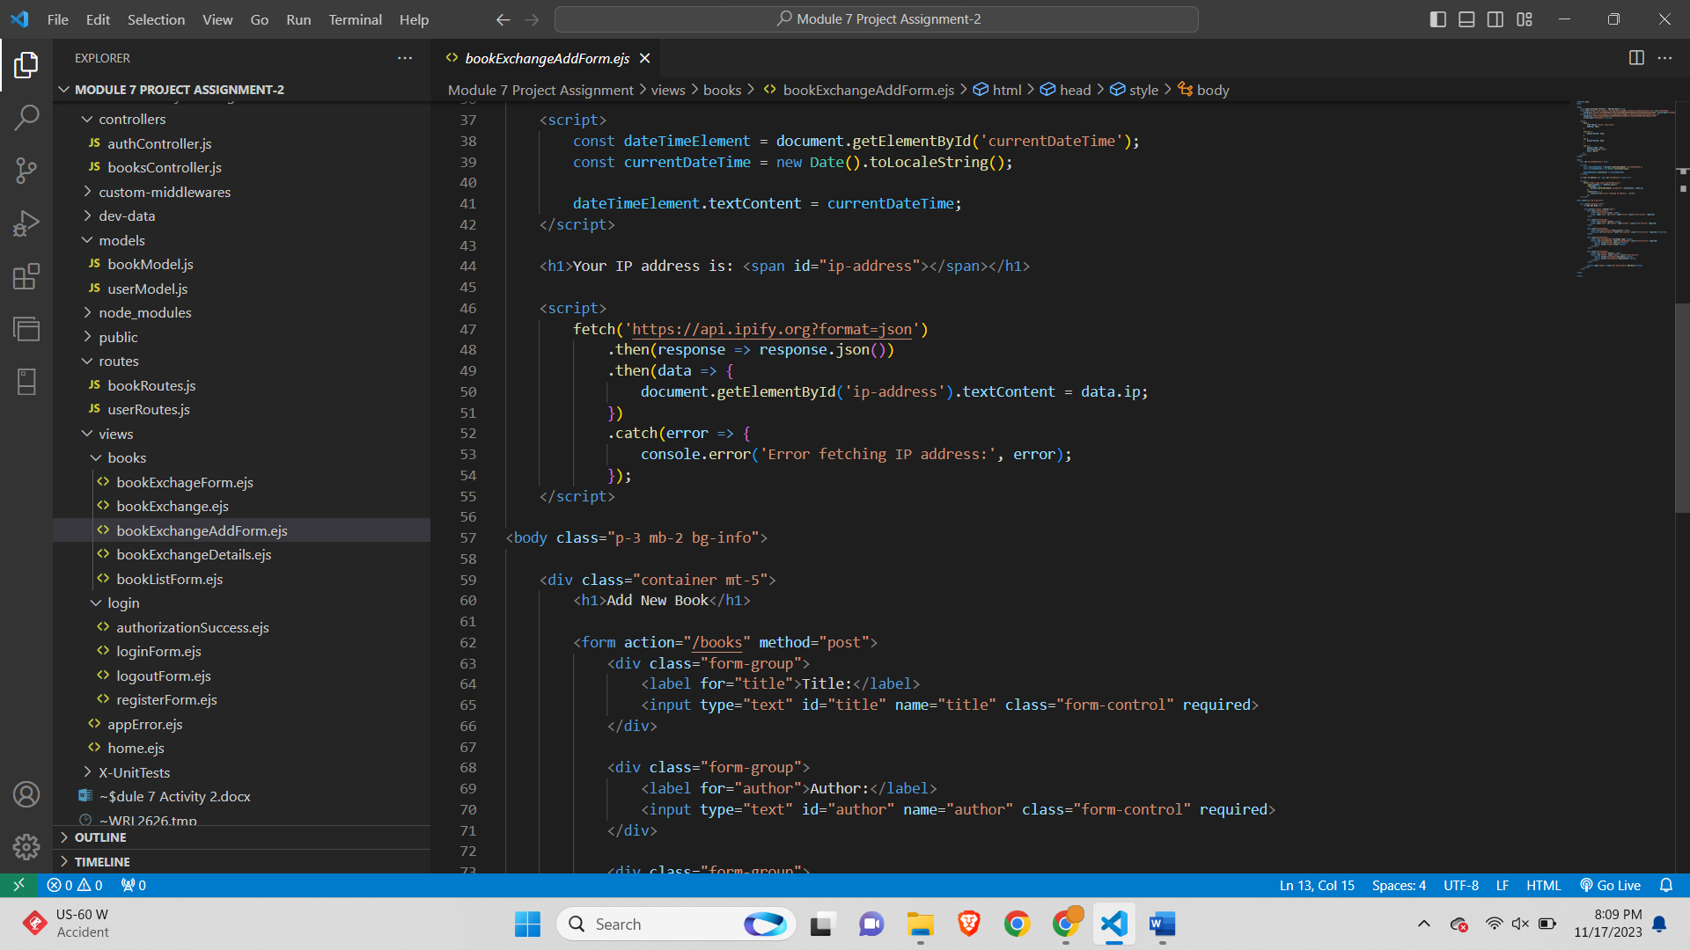

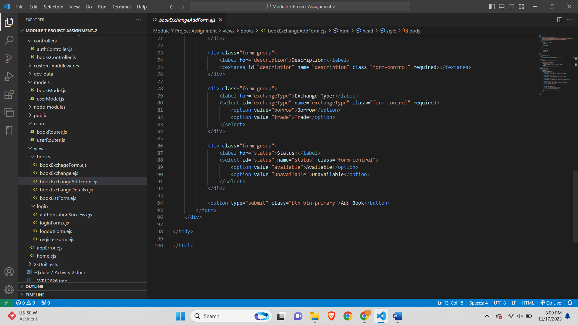

The HTML code provided creates a web page for adding a new book to a Book Exchange Platform. The page utilizes Bootstrap for styling and includes a script to dynamically display the current date and time. Another script fetches and displays the user's IP address using the 'ipify' API. The main content of the page is contained within a **<div>** with a class of "container" for proper formatting. It presents a form with fields for entering the book's title, author, description, exchange type (borrow or trade), and status (available or unavailable). The form is styled using Bootstrap's form components for a clean and responsive design. Upon submission, the form sends a POST request to the "/books" route. The page provides a visually appealing and user-friendly interface for users to input information about a book they wish to add to the Book Exchange Platform.

**bookExchangeDetails.ejs-**

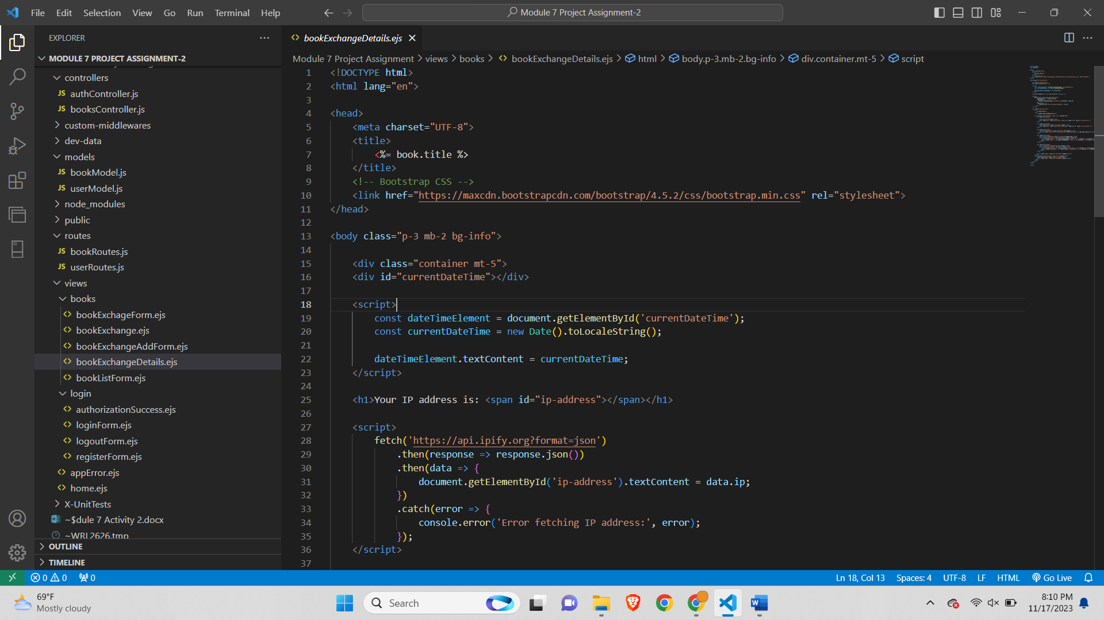

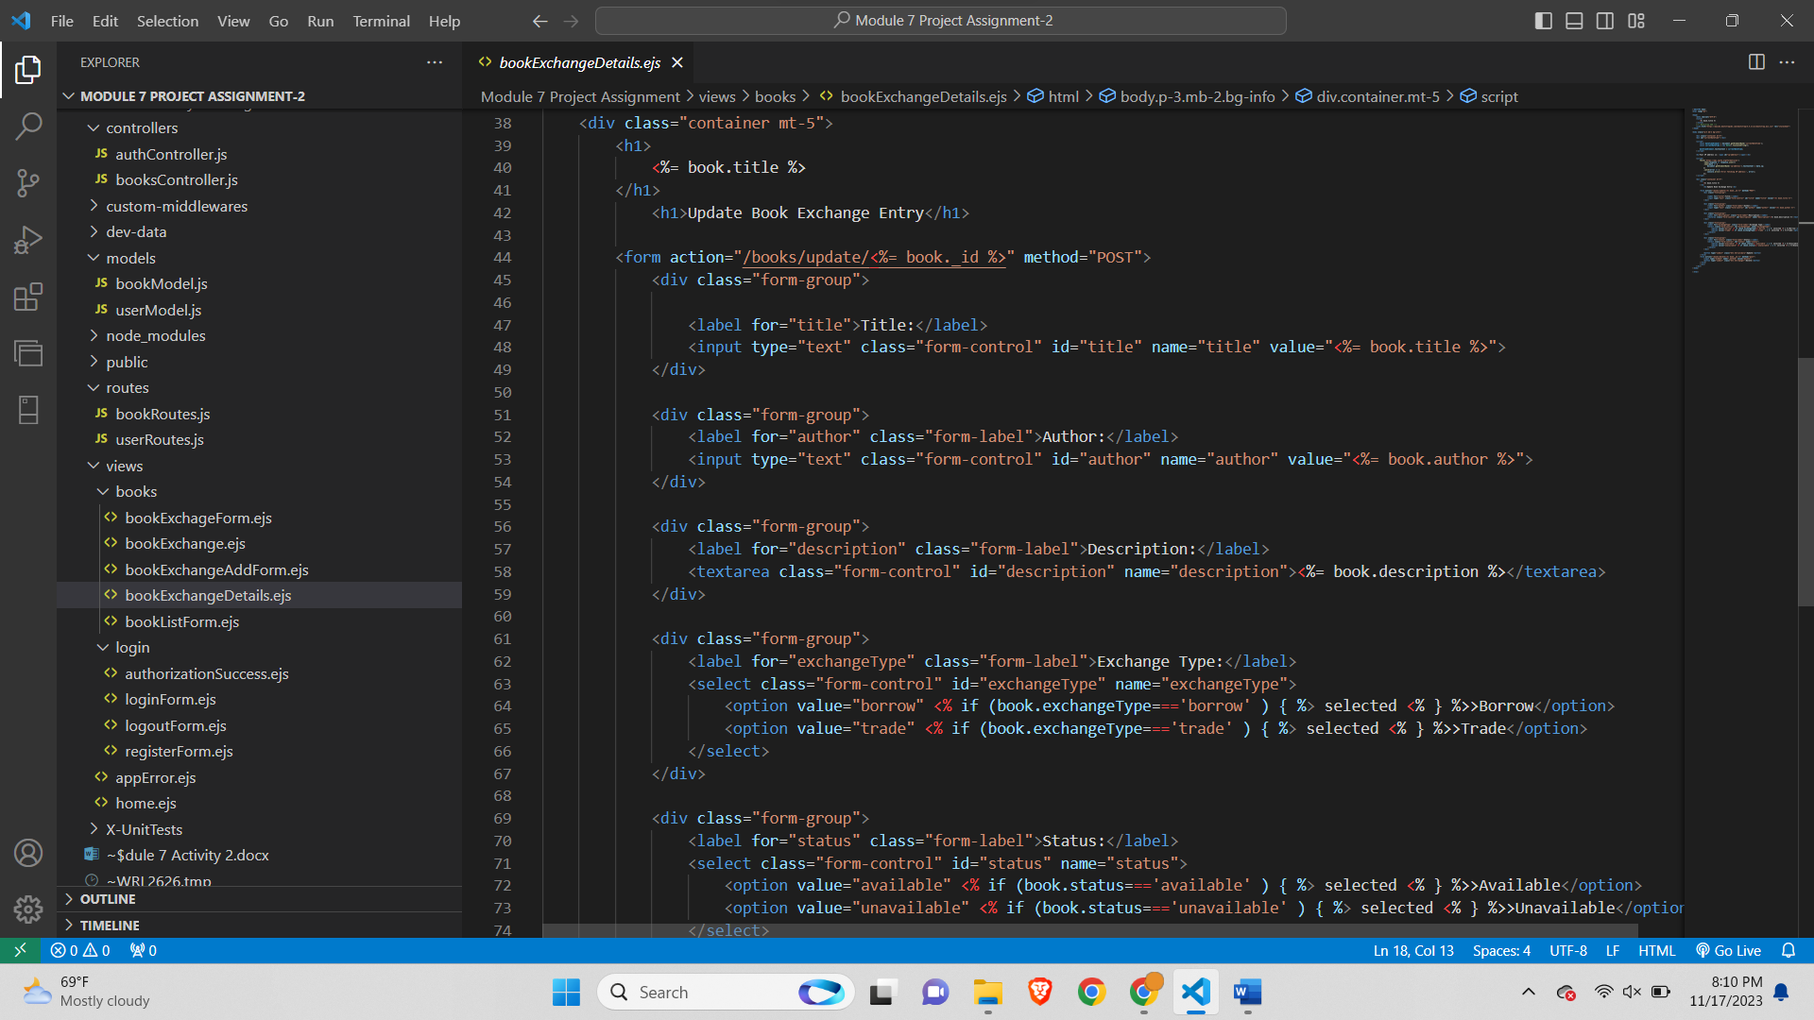

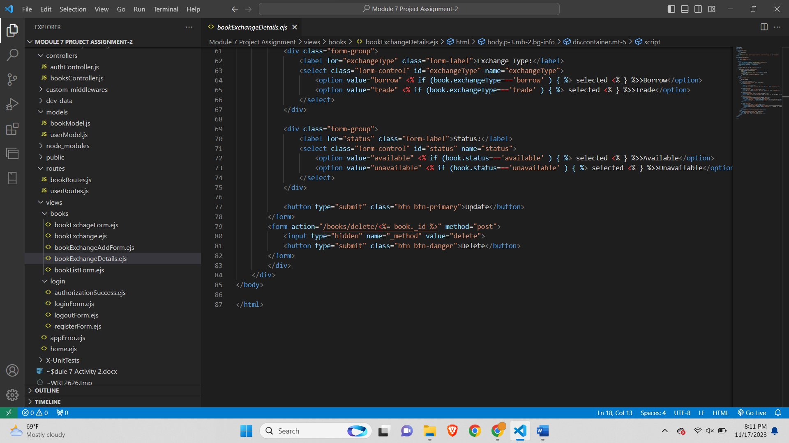

The HTML code constitutes a web page designed for updating and deleting a book entry on a Book Exchange Platform. The page incorporates Bootstrap for styling and includes scripts to dynamically display the current date and time as well as fetch and display the user's IP address using the 'ipify' API. The main content of the page is contained within a Bootstrap-styled container. It features a form with input fields for the book's title, author, description, exchange type (borrow or trade), and status (available or unavailable). The form is pre-populated with the existing details of the book, allowing users to modify them. The update form sends a POST request to the "/books/update/<%= book._id %>" route, while the delete form sends a POST request to the "/books/delete/<%= book._id %>" route with an additional hidden field indicating the HTTP method override for DELETE. The page provides a user-friendly interface for editing and removing book entries from the Book Exchange Platform, enhancing the platform's interactivity and user experience.

**bookListForm.ejs-**

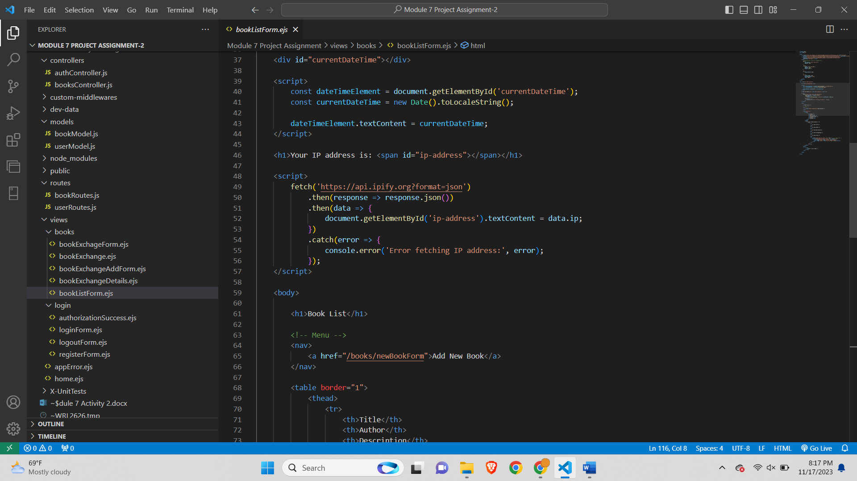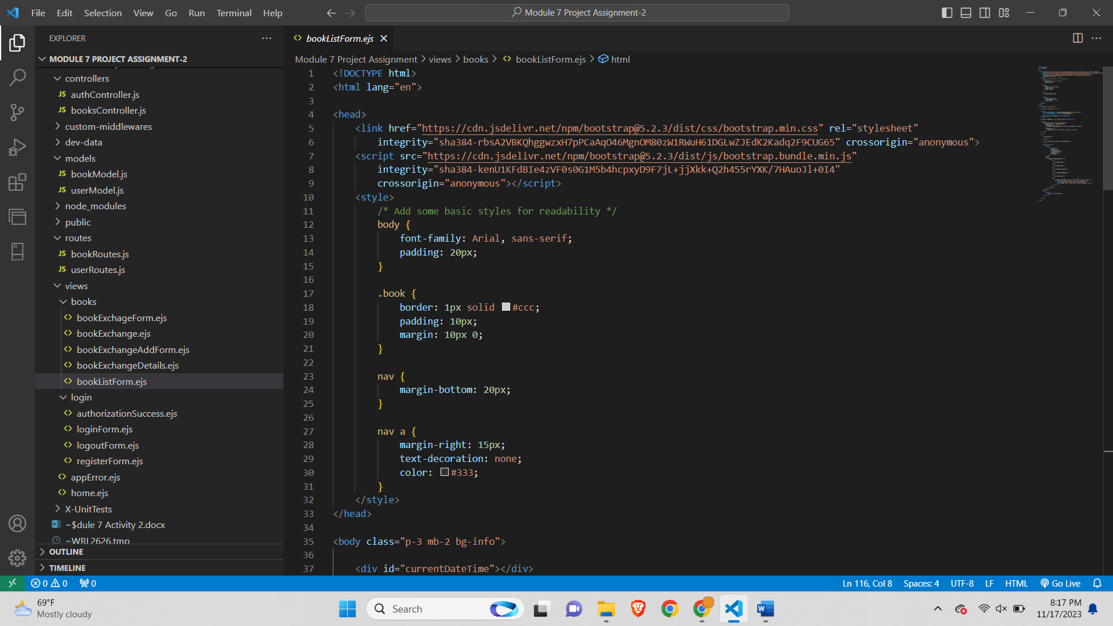

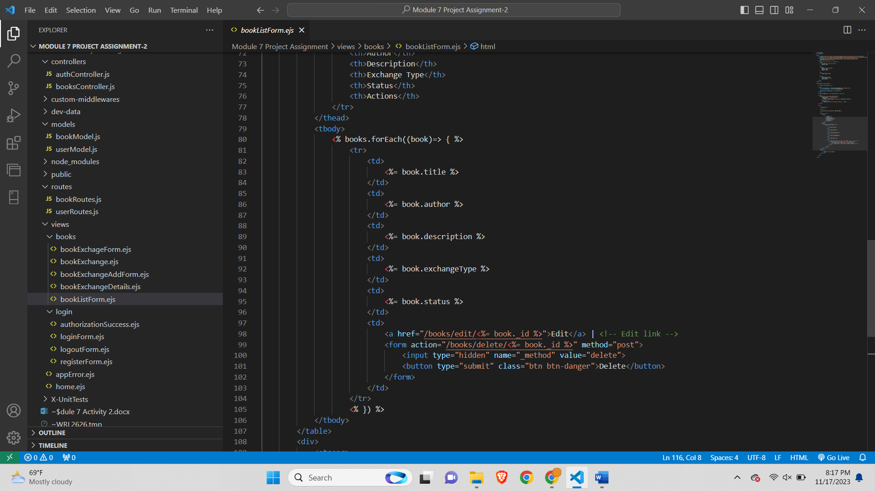

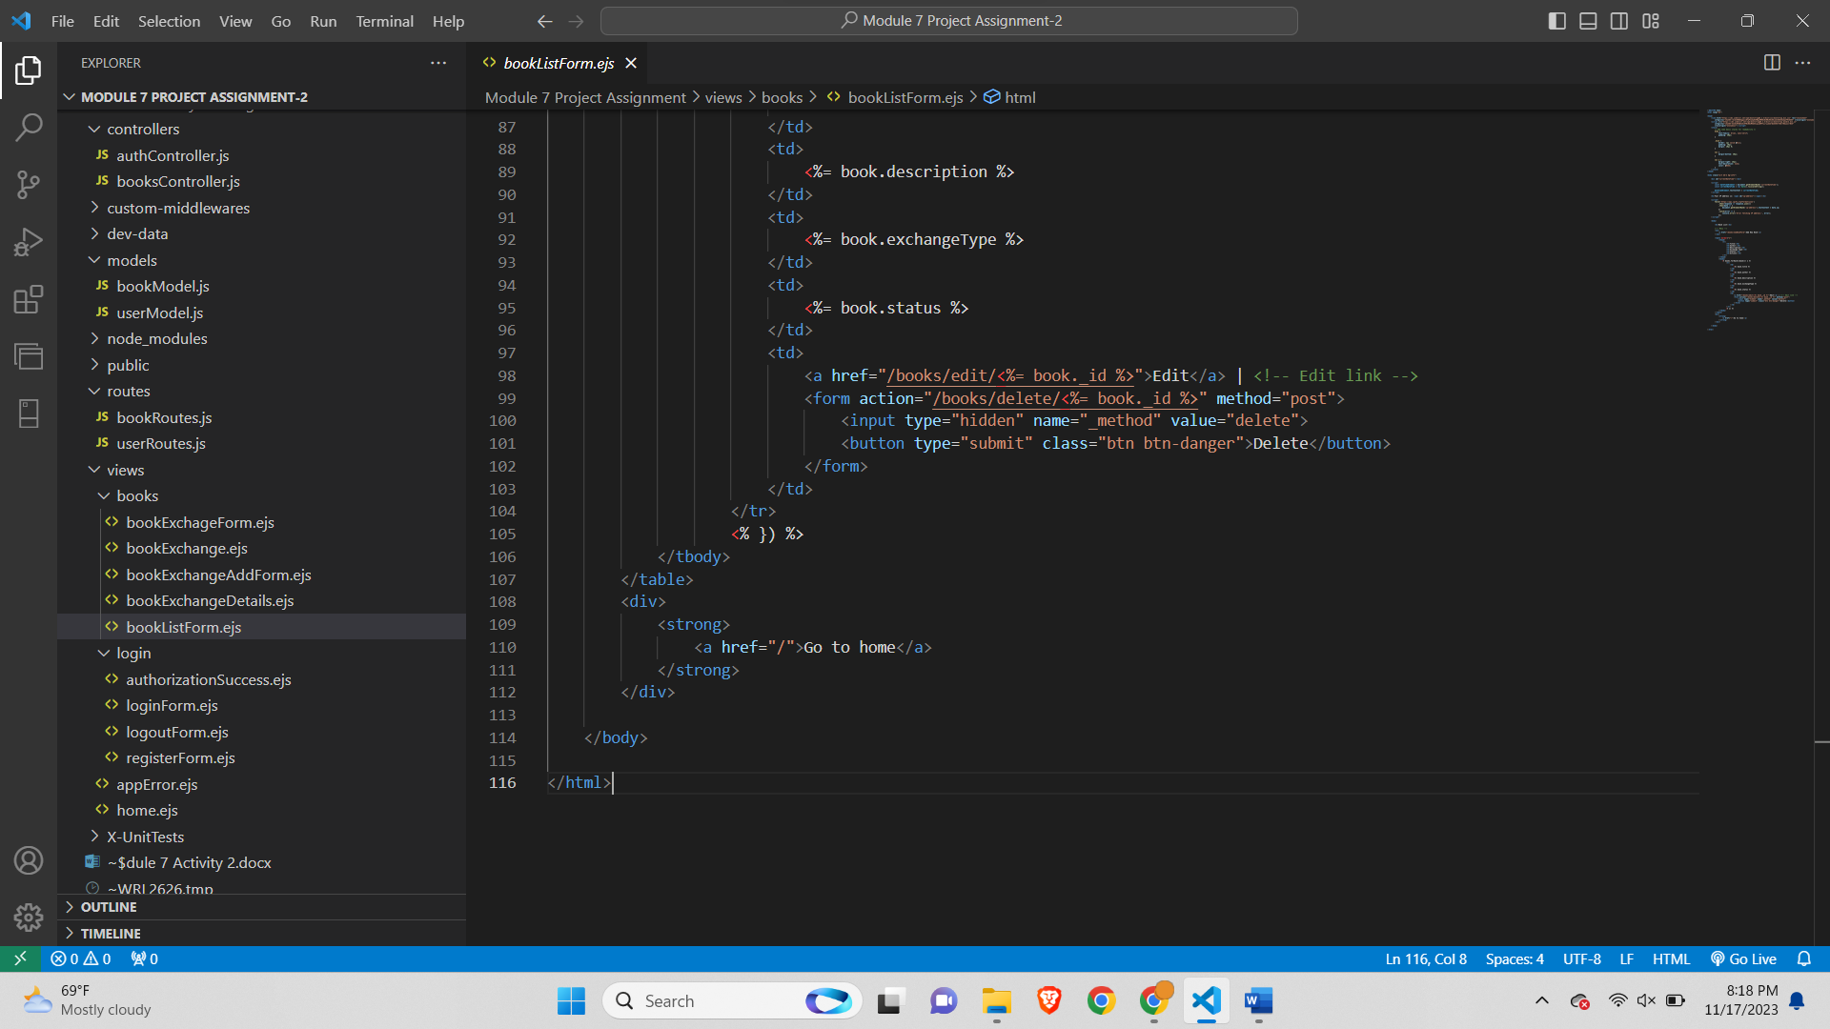

The HTML code represents a web page displaying a list of books on a Book Exchange Platform. The page incorporates Bootstrap for styling and includes scripts to dynamically display the current date and time, as well as fetch and display the user's IP address using the 'ipify' API. The main content of the page is organized within a Bootstrap-styled container. It features a header with the title "Book List" and a navigation menu with a link to add a new book. The book details are presented in a table with columns for title, author, description, exchange type, status, and actions. For each book, the title, author, description, exchange type, and status are dynamically inserted into the table rows. The "Actions" column includes links to edit a book's details and a form to delete the book. The delete form utilizes the POST method with an additional hidden field indicating the HTTP method override for DELETE. Additionally, there is a link to return to the home page. Overall, the page provides a user-friendly interface for viewing and managing a list of books on the Book Exchange Platform.

**Top of Form**

**Login Views-**

**authorizationSuccess.ejs-**

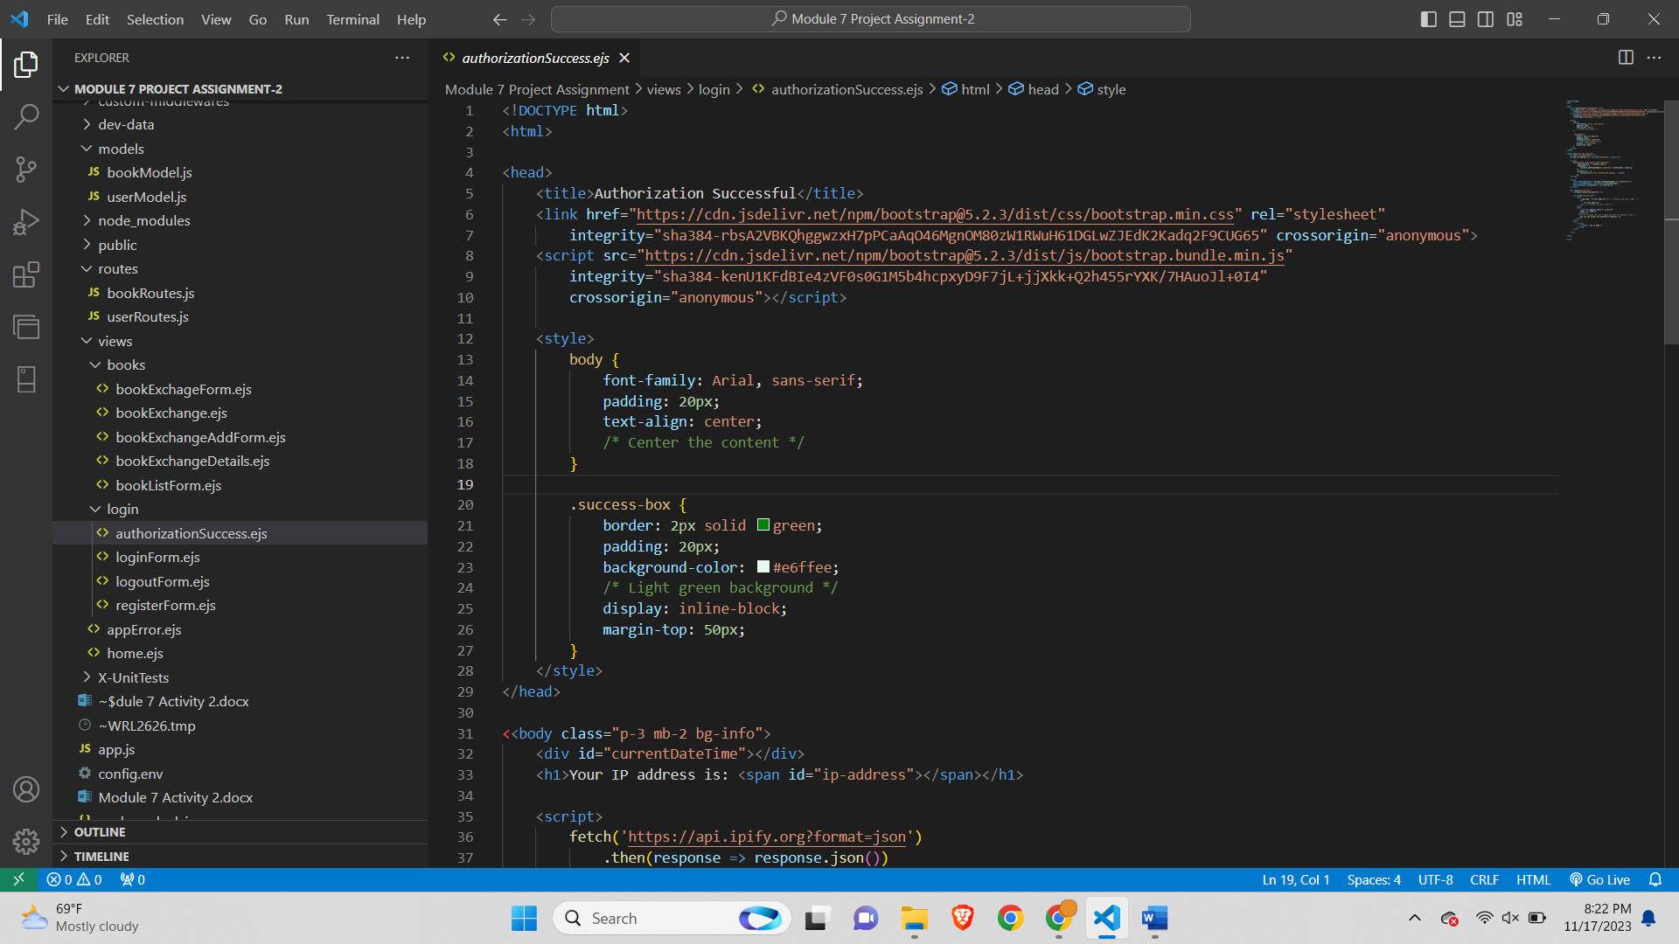

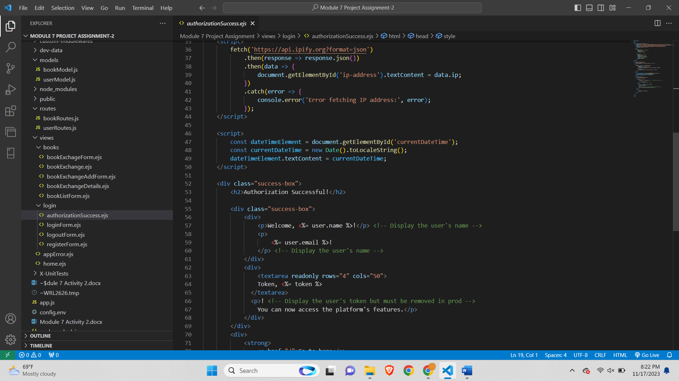

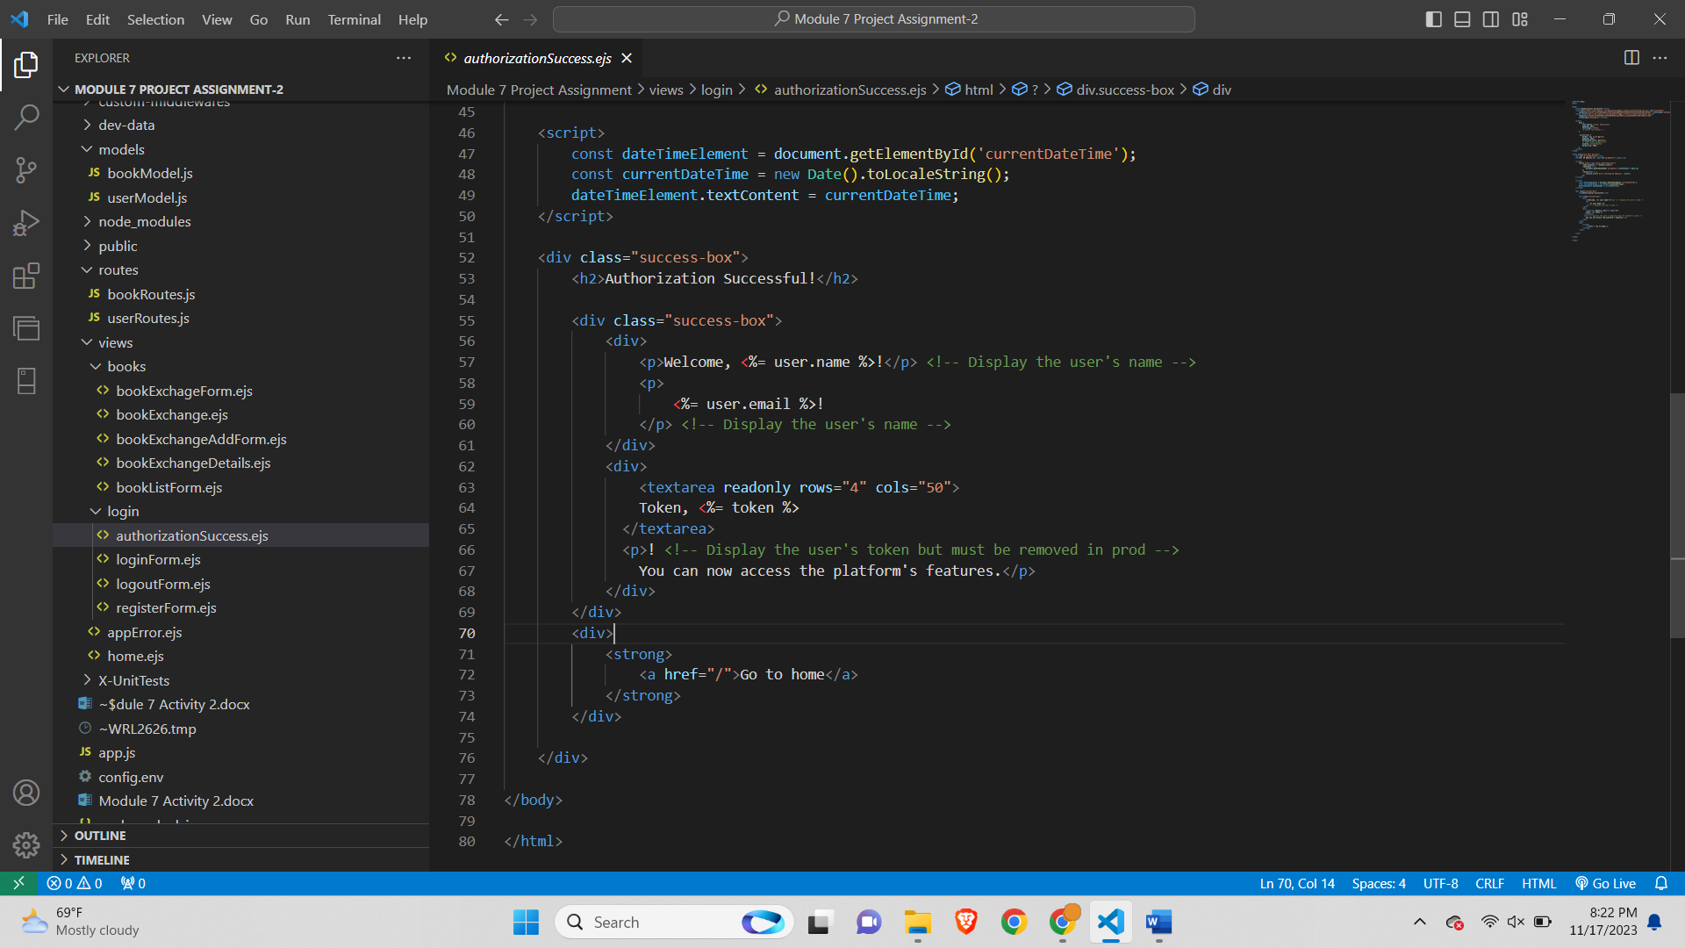

The HTML code represents a web page designed for displaying a success message after a user's authorization on a web platform. The page is styled using Bootstrap for a clean and responsive layout. The content of the page is centered within the body and includes the current date, the user's IP address, and a success message. The success message is encapsulated in a green-bordered box with a light green background, creating a visually distinct section. Inside this box, there is a header indicating that the authorization was successful, followed by a personalized welcome message addressing the user by name and displaying their email. Additionally, a textarea displays the user's authorization token, but a comment suggests that this information should be removed in a production environment for security reasons. The message informs the user that they can now access the platform's features. Finally, there is a link to navigate back to the home page. The use of Bootstrap ensures a consistent and visually appealing presentation of the success message and associated details.

**loginForm.ejs-**

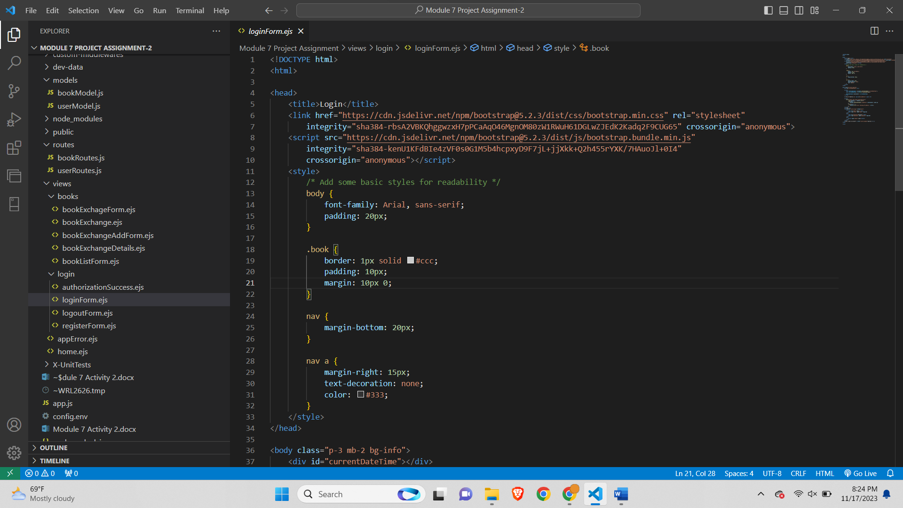

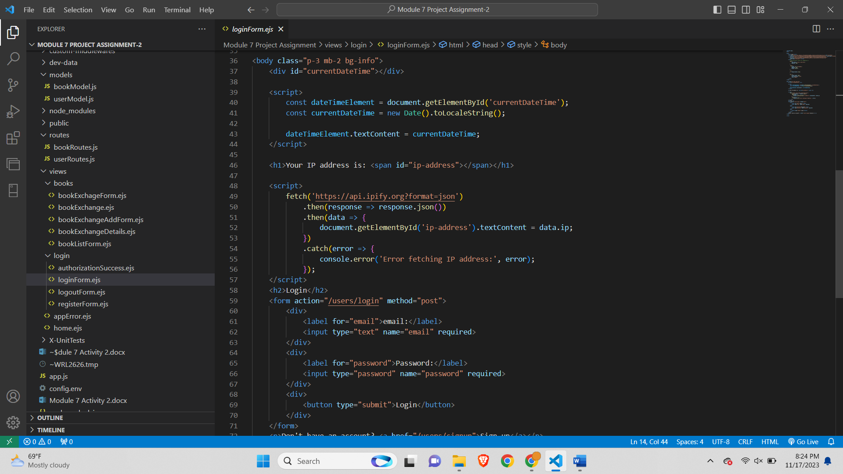

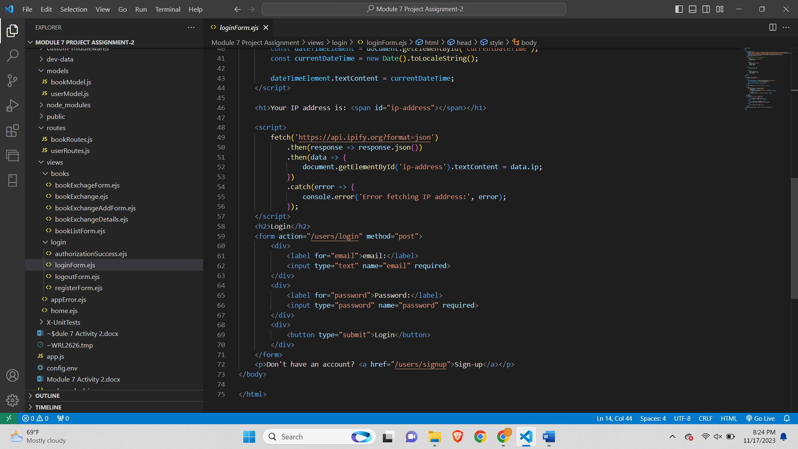

The HTML code represents a login page for a web application. The page is styled using Bootstrap for a clean and responsive design. The structure includes a header with the current date, the user's IP address, and the main title "Login." Below the header, there is a login form with fields for the user's email and password. The form uses the POST method to submit the login information to the "/users/login" endpoint. The email field is of type "text," and the password field is of type "password," both marked as required to ensure the user provides necessary information for login.

Additionally, there is a "Login" button within the form for submitting the login credentials. Below the form, there is a small message inviting users to sign up if they don't have an account, with a link leading to the sign-up page ("/users/signup").

JavaScript is used to display the current date and fetch the user's IP address from an external API (ipify.org), providing additional information on the page. The overall layout and styling are designed to enhance user readability and interaction, creating a user-friendly login interface for the web application.

**logoutForm.ejs-**

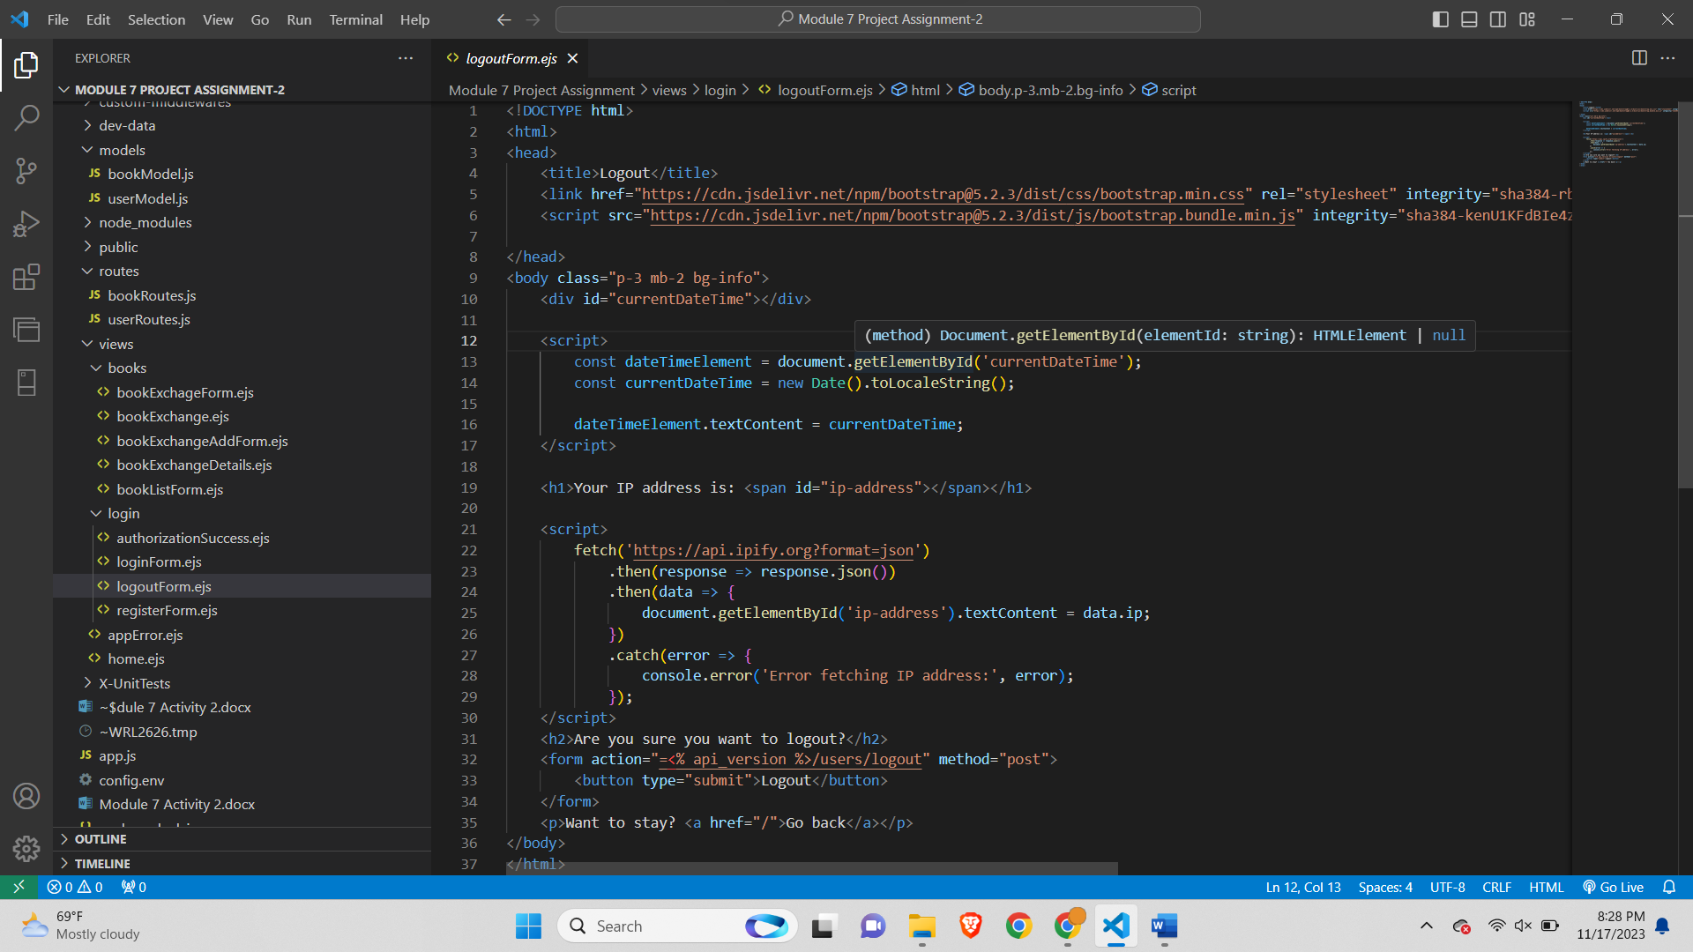

The HTML code represents a logout confirmation page for a web application. The page is styled using Bootstrap for a clean and responsive design. The structure includes a header with the current date, the user's IP address, and the main title "Are you sure you want to logout?" Below the header, there is a confirmation message asking the user if they are sure they want to log out.

A form is included with a single button for logging out. The form uses the POST method to submit the logout action to the "/<% api_version %>/users/logout" endpoint, where "<% api_version %>" is a placeholder for a dynamic value that would be replaced with the actual API version. The "Logout" button triggers the form submission, leading to the user's logout from the application.

Additionally, there is a message inviting users to stay and providing a link to go back to the home page ("/"). JavaScript is used to display the current date and fetch the user's IP address from an external API (ipify.org), enhancing the informational content on the page. The overall layout and styling aim to create a user-friendly and visually appealing interface for the logout confirmation page

**registerForm.ejs-**

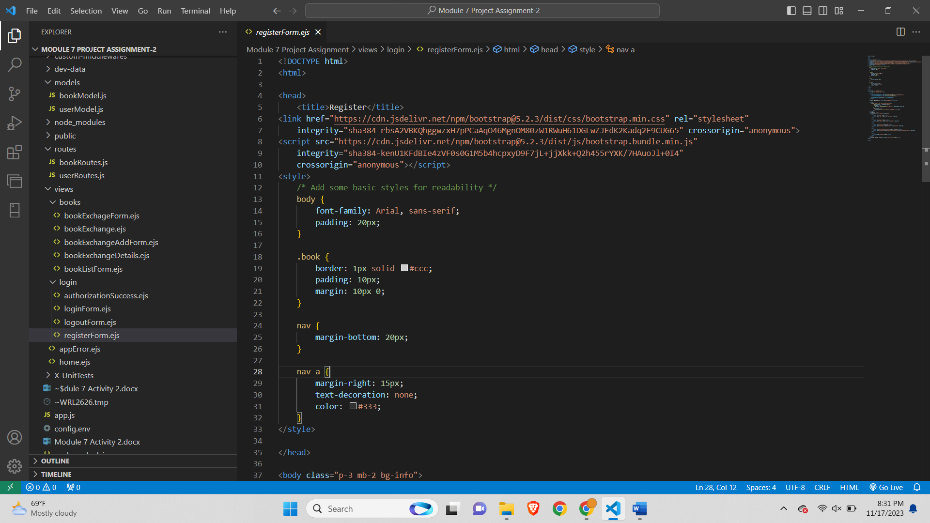

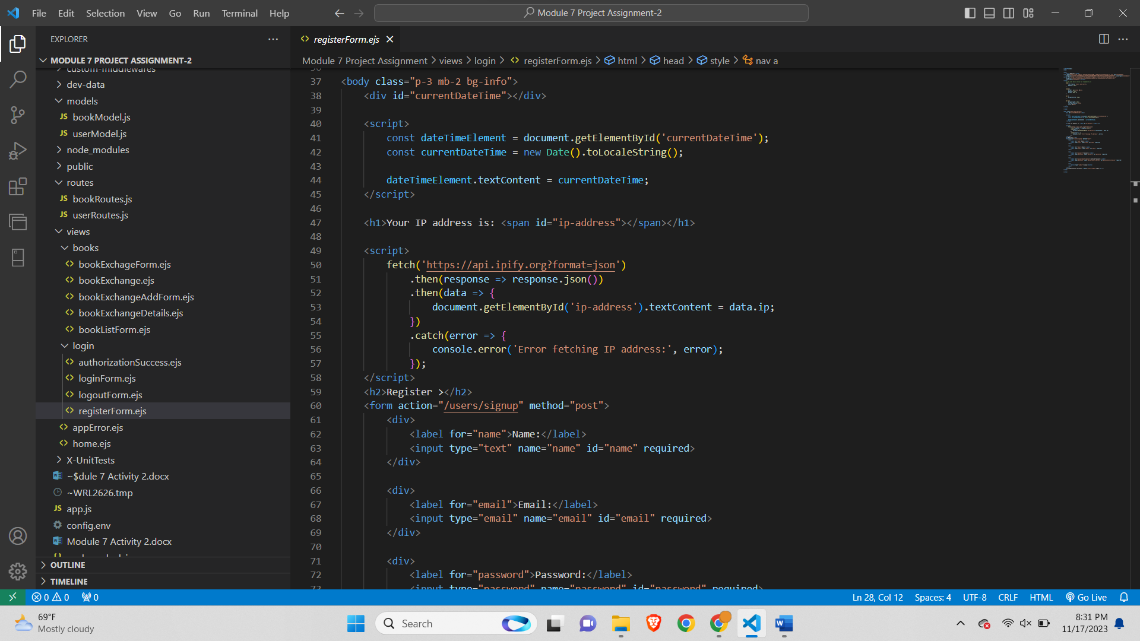

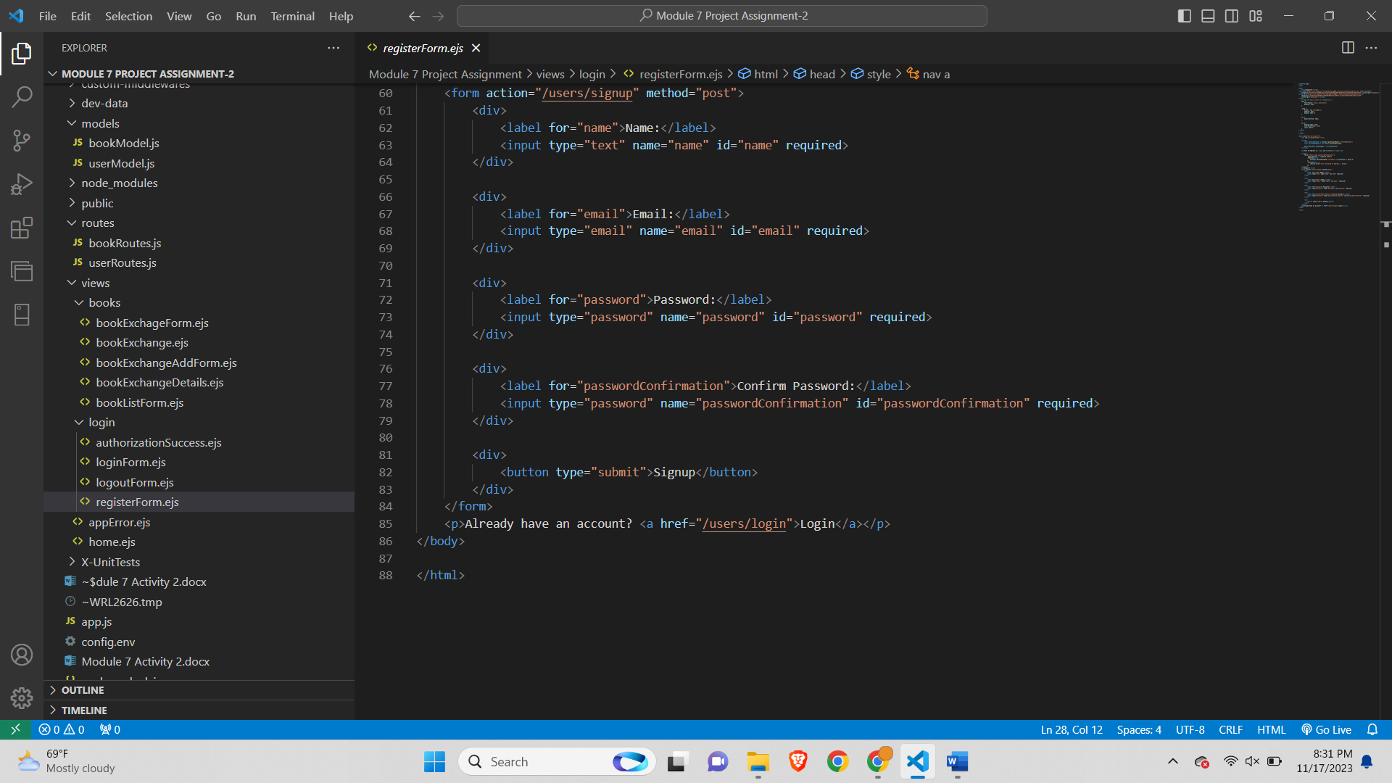

The HTML code defines a user registration page with Bootstrap styling, incorporating dynamic elements such as real-time date display and IP address retrieval using JavaScript. The page features a registration form with fields for the user's name, email, password, and password confirmation, submitting data to "/users/signup" upon clicking the "Signup" button. The use of Bootstrap ensures a visually appealing and responsive layout. Additionally, a link is included to redirect users who already have an account to the login page ("/users/login"). Overall, the code creates a user-friendly and well-designed registration interface for a web application.

**appError.ejs-**

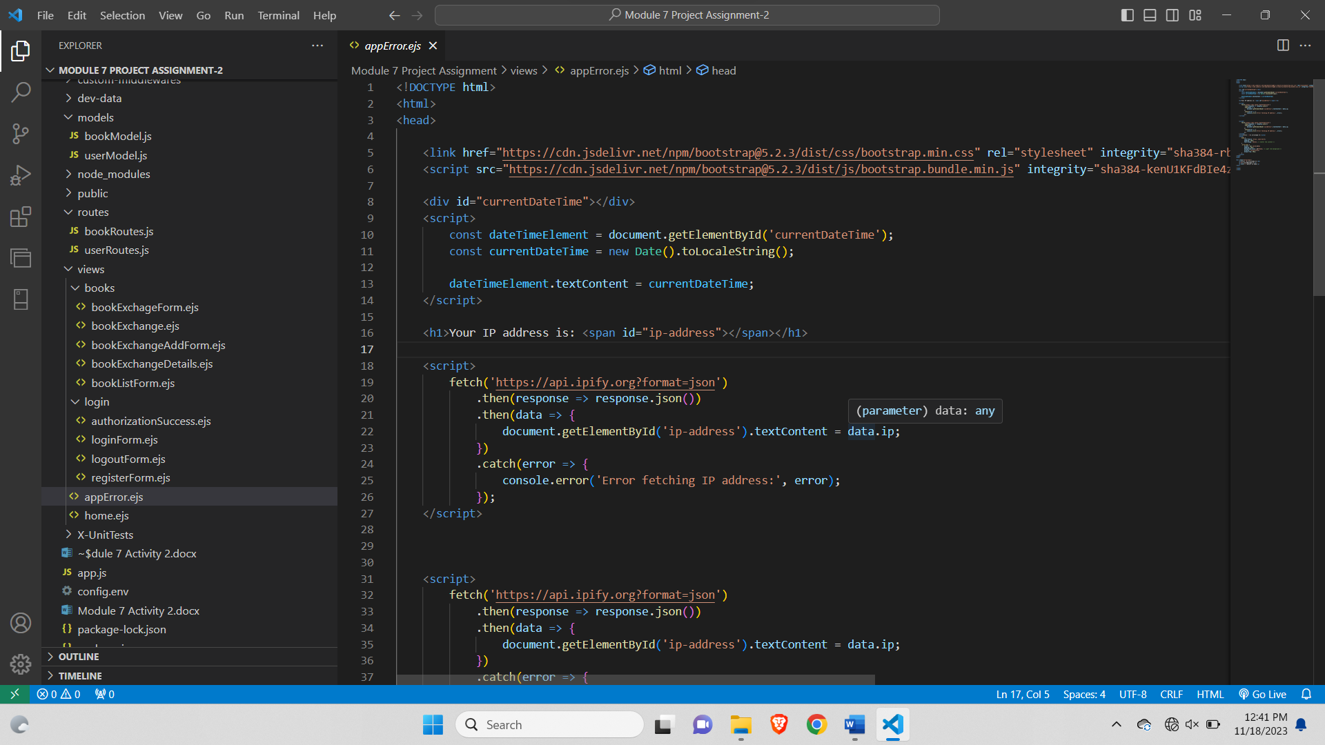

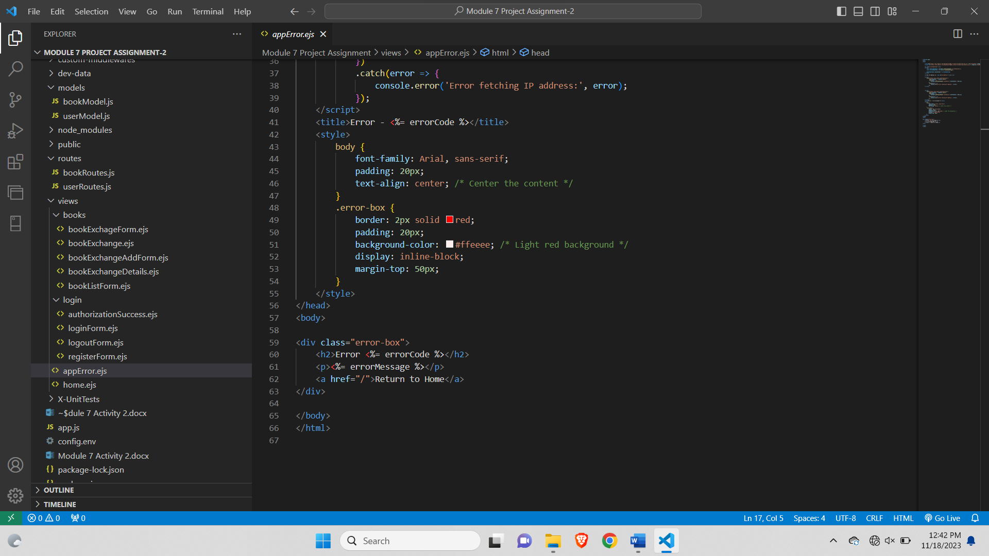

The document includes a link to Bootstrap's CSS and JavaScript files from a Content Delivery Network (CDN). The main body of the HTML contains three script sections for dynamic content generation. The first script displays the current date and time using JavaScript's Date object. The second and third scripts fetch the user's IP address from the '[https://api.ipify.org](https://api.ipify.org/)' API and display it on the webpage. The IP address is retrieved in two separate script blocks, which seems redundant and could be consolidated. Additionally, the document includes a title tag with an embedded code snippet '<%= errorCode %>' which suggests the use of a server-side template engine (like EJS for Node.js) to dynamically insert an error code into the title. The body of the document includes a styled error box with a heading, error message, and a link to return to the home page. The styles for the error box are defined in an embedded CSS section. It's worth noting that the code snippet '<%= errorMessage %>' in the error box suggests another dynamic content insertion point that would typically be populated by server-side logic.

**home.ejs-**

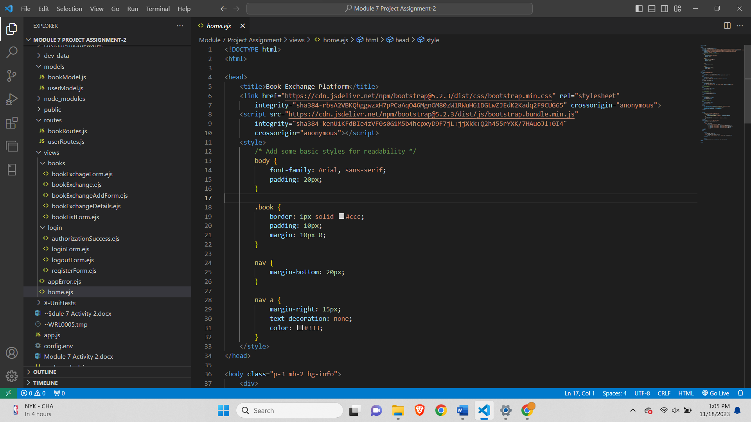

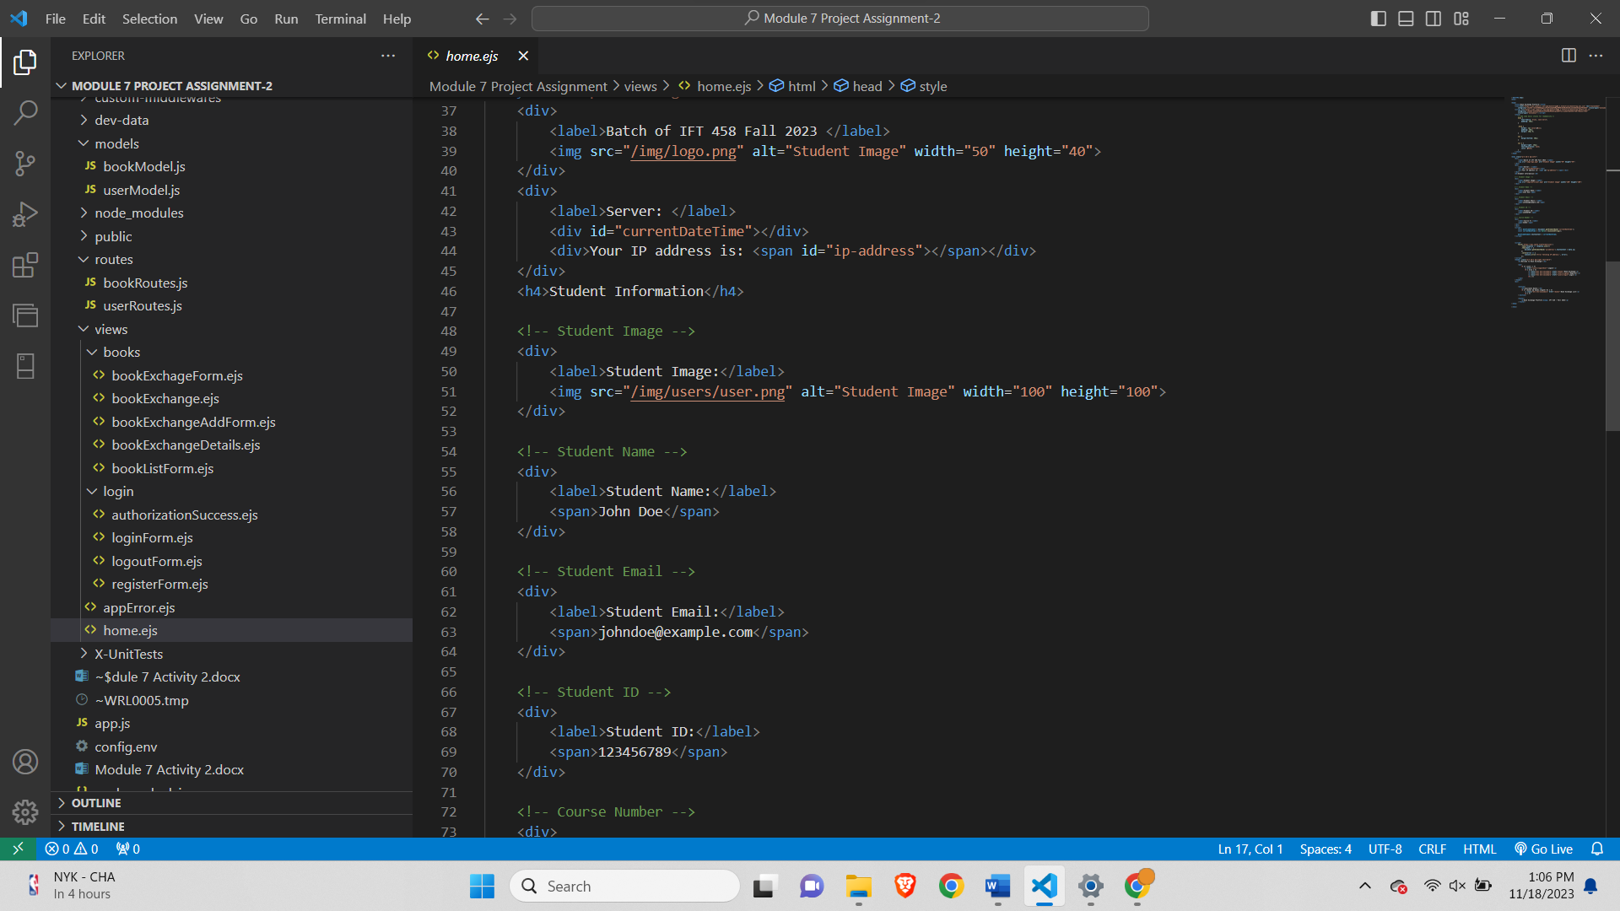

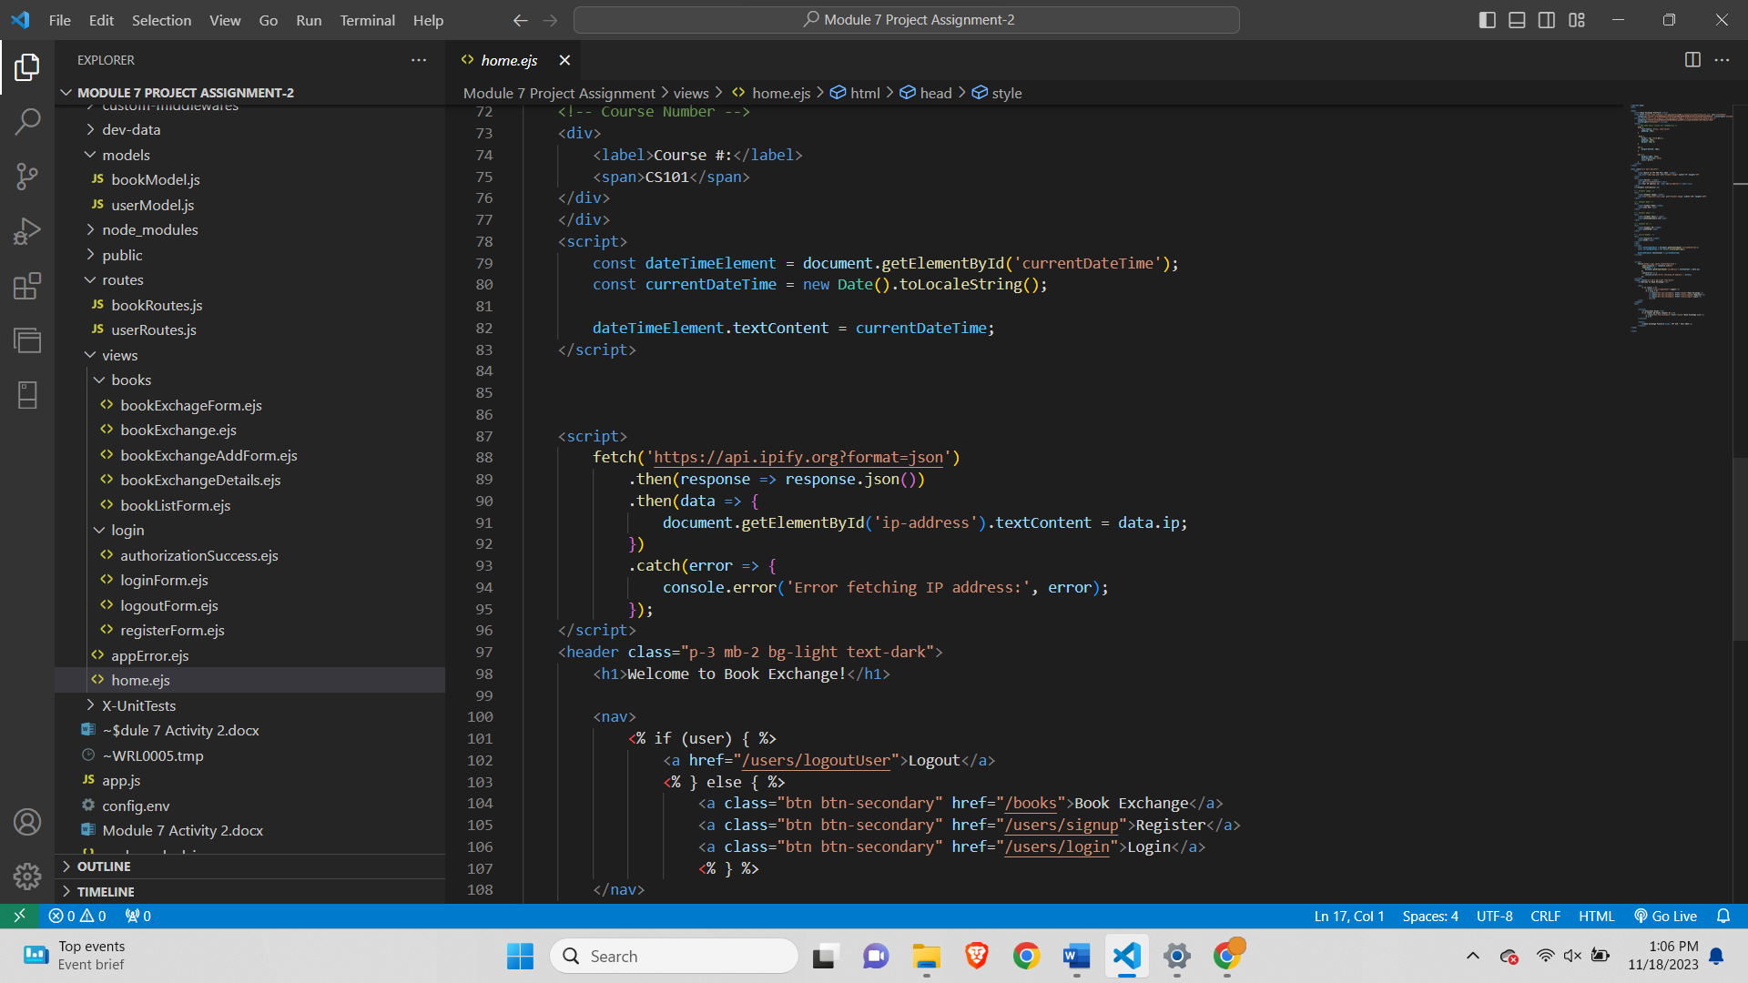

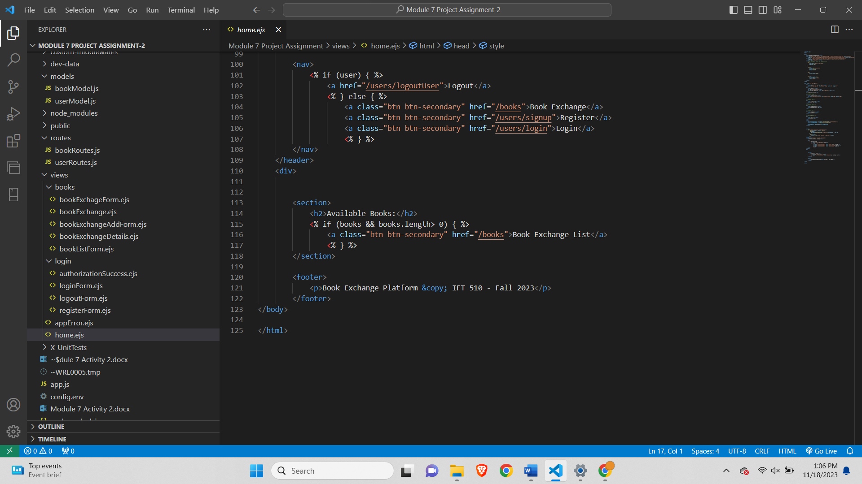

The document includes links to Bootstrap's CSS and JavaScript files from a CDN to apply styling and enhance the page's responsiveness. The body of the HTML contains student information, including an image, name, email, ID, and course number. It also displays the current date and time and the user's IP address using JavaScript. The header section contains a welcome message and a navigation bar that dynamically adjusts based on whether a user is logged in or not. If a user is logged in, a "Logout" link is displayed; otherwise, links for book exchange, registration, and login are presented. The main content section shows available books and provides a link to the Book Exchange List if there are books available. The footer includes a copyright notice for the Book Exchange Platform. The page is designed with basic styles for readability, and it incorporates Bootstrap's classes for layout and styling elements. The code appears to be part of a larger web application, likely using a server-side template engine (indicated by '<%= %>' syntax) to inject dynamic content and handle user authentication.

**Step 7: Execute the application-**

**Updated config.env-**

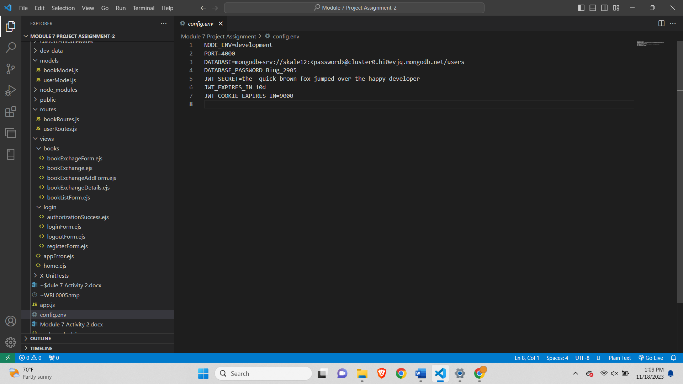



**Executed the application-**

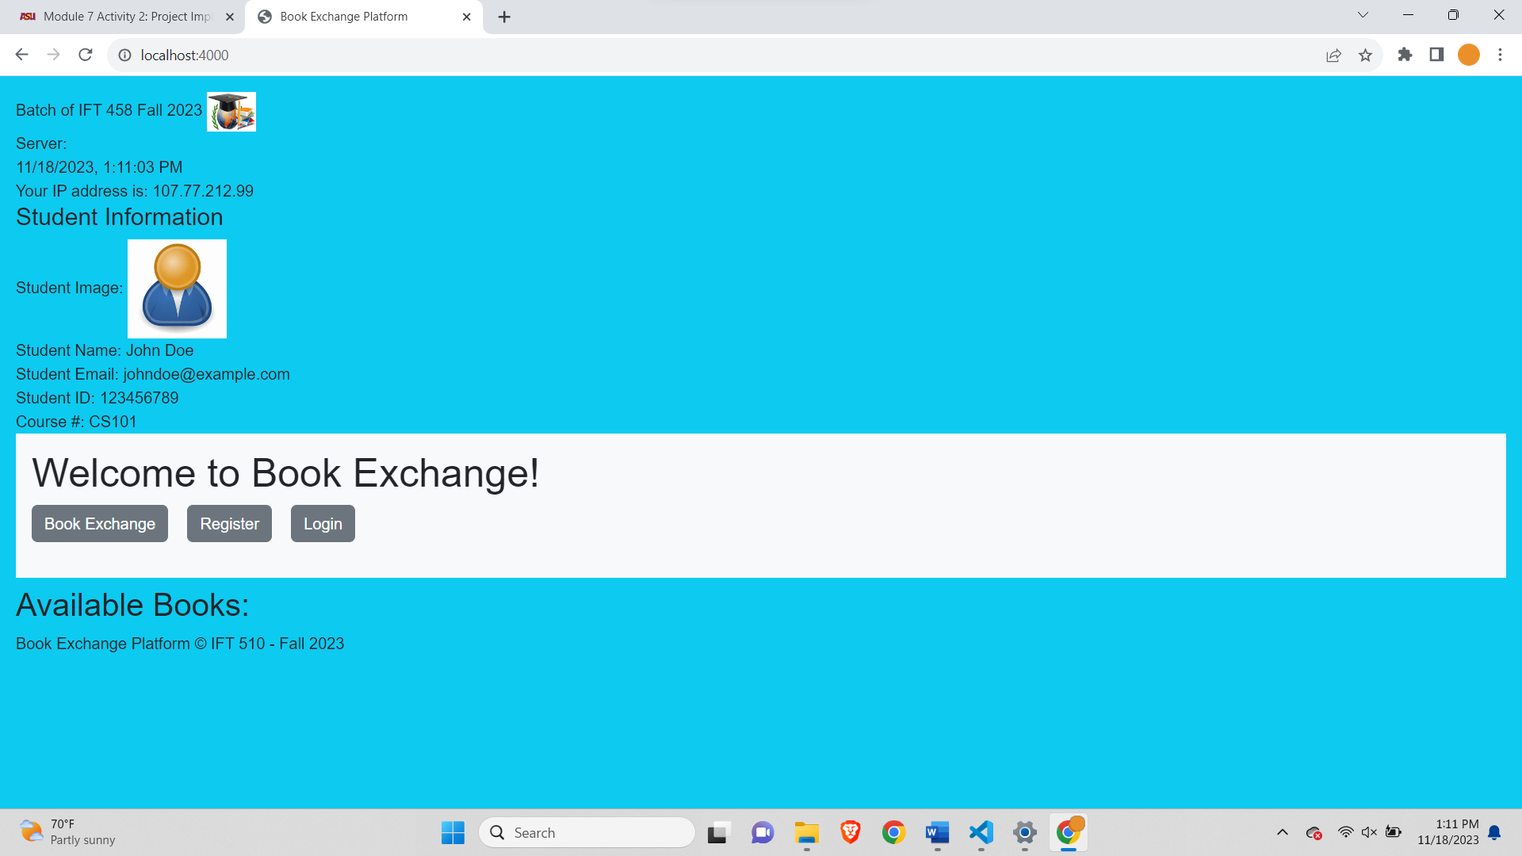

**Step 8: You are required to add your user information, and your pictures to all the UI pages**

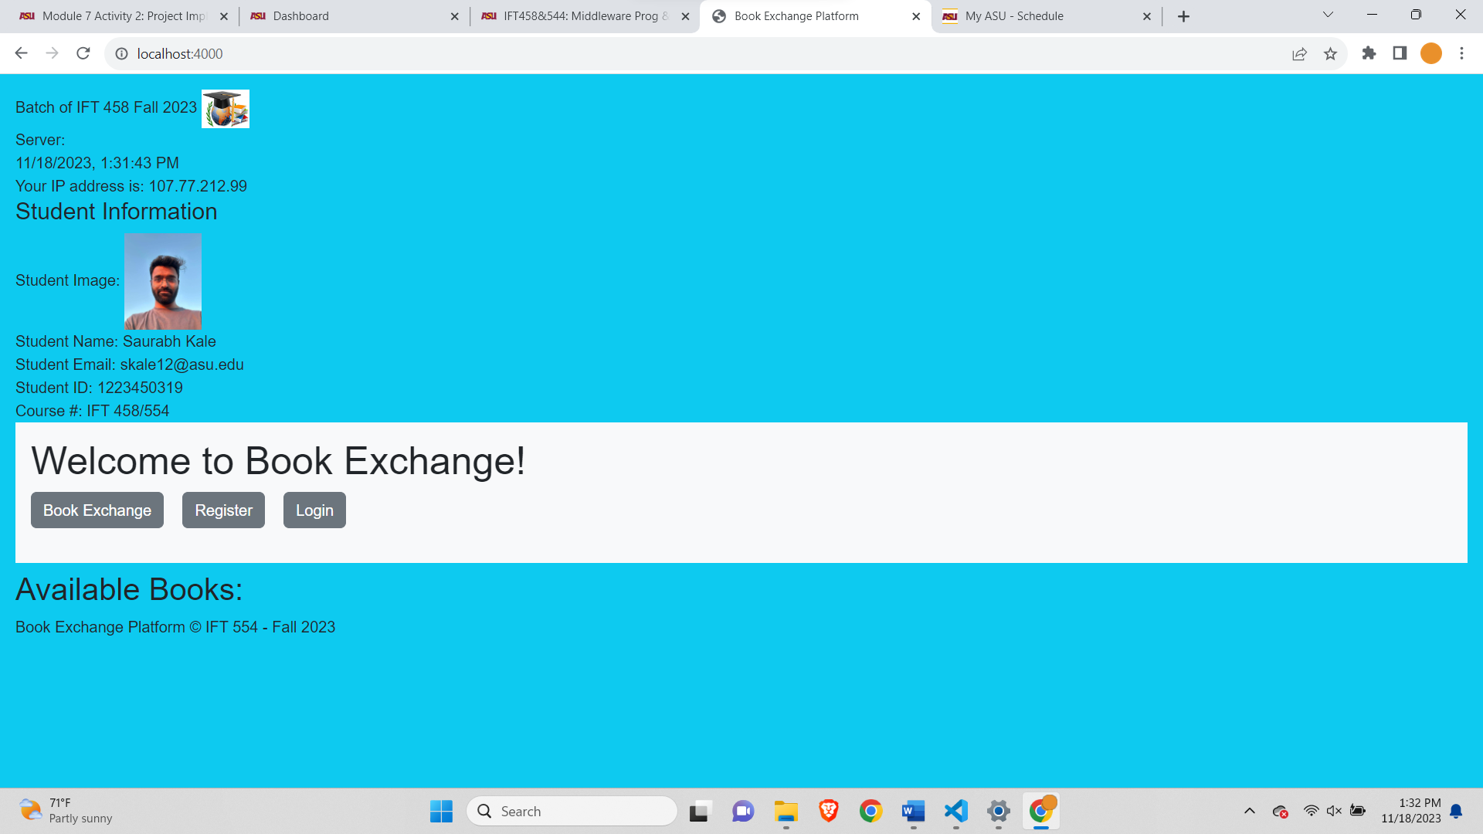

**Changes made in home.ejs-**

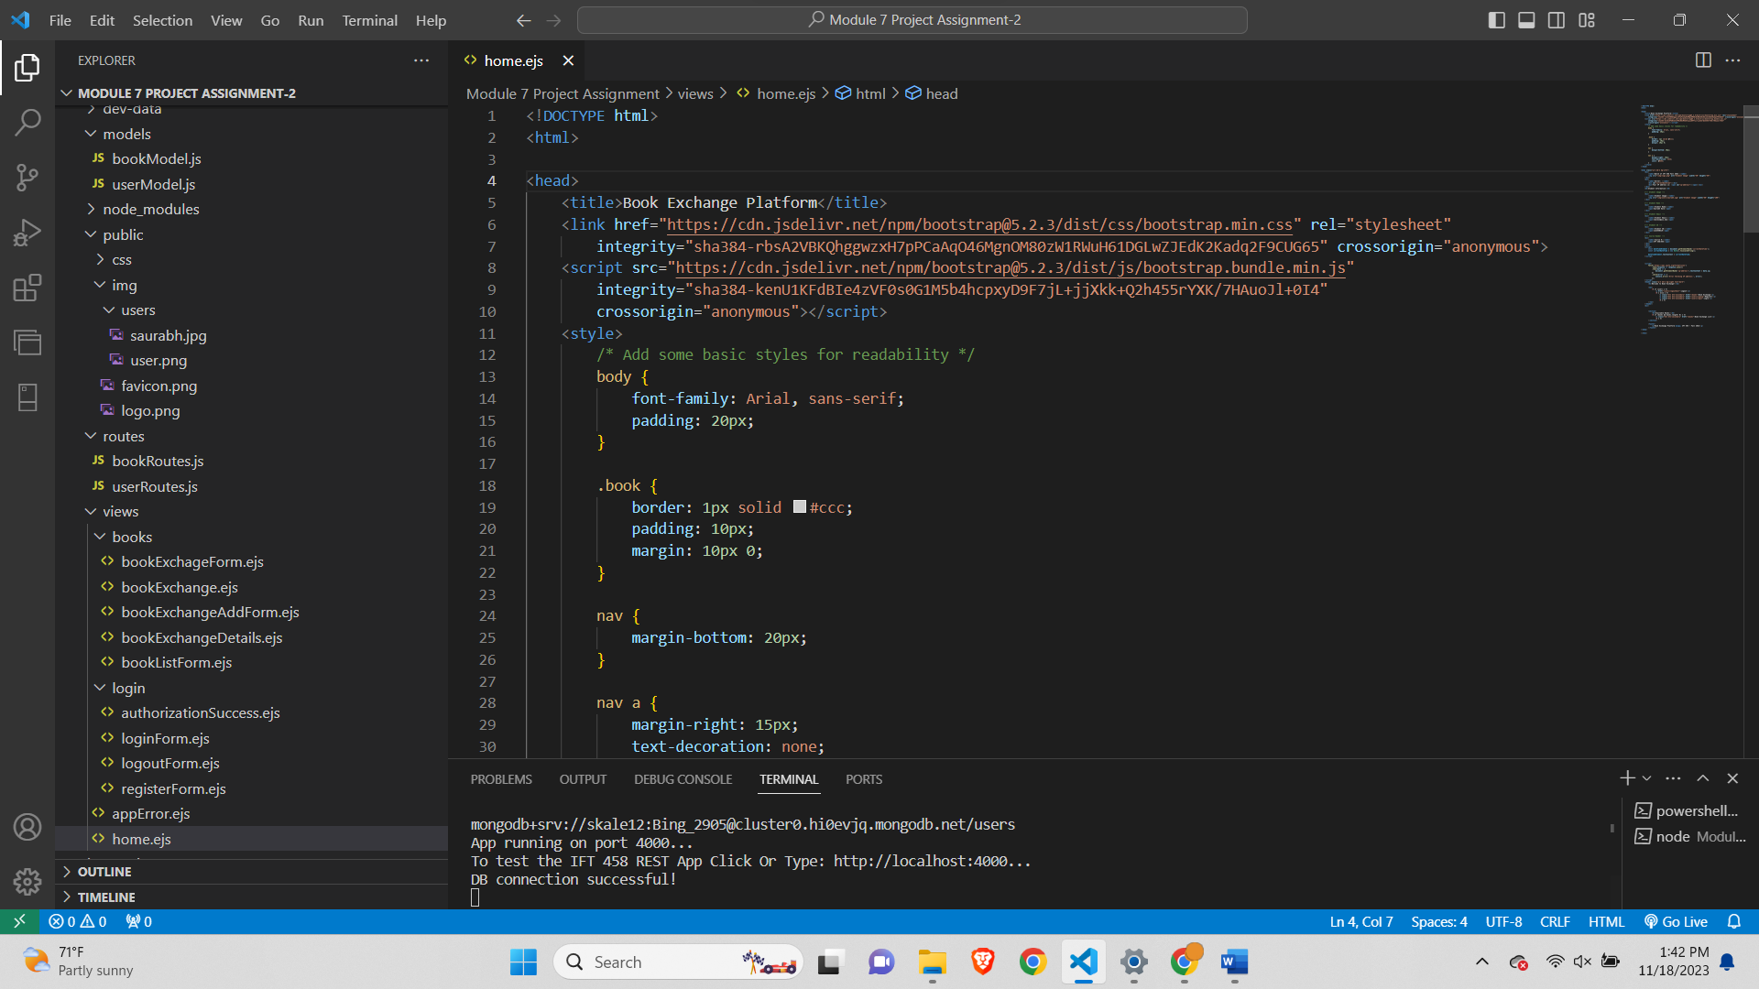

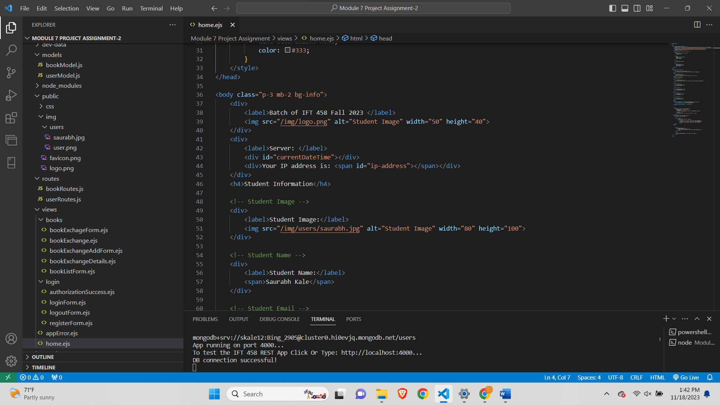

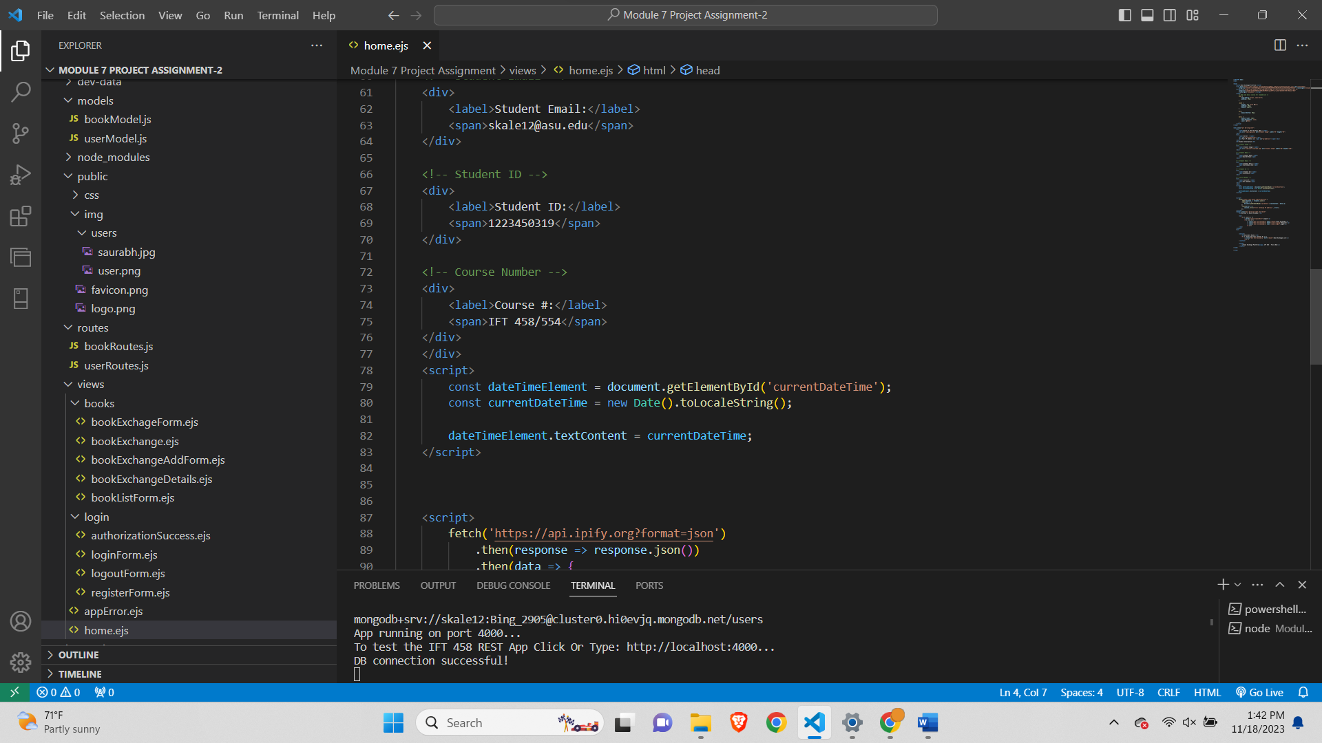

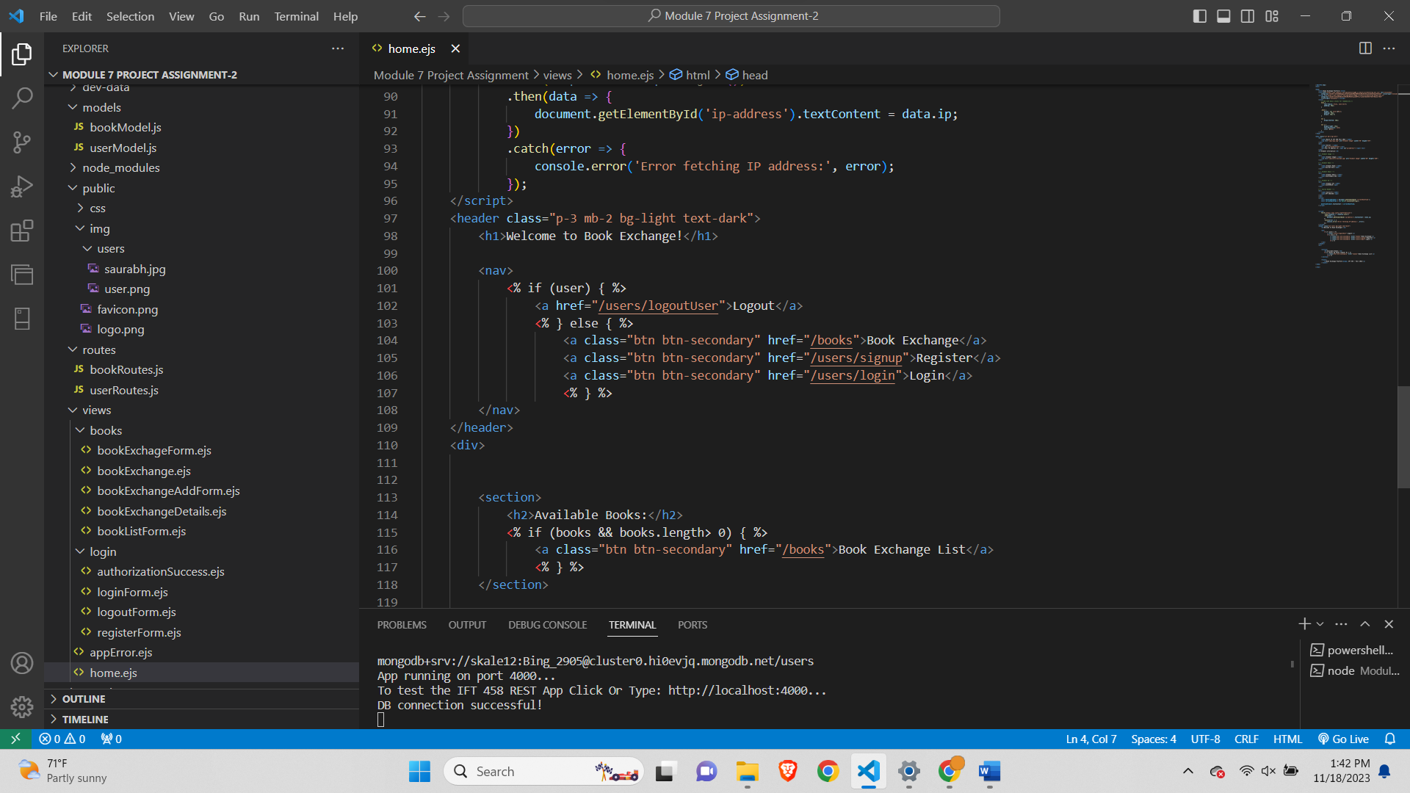

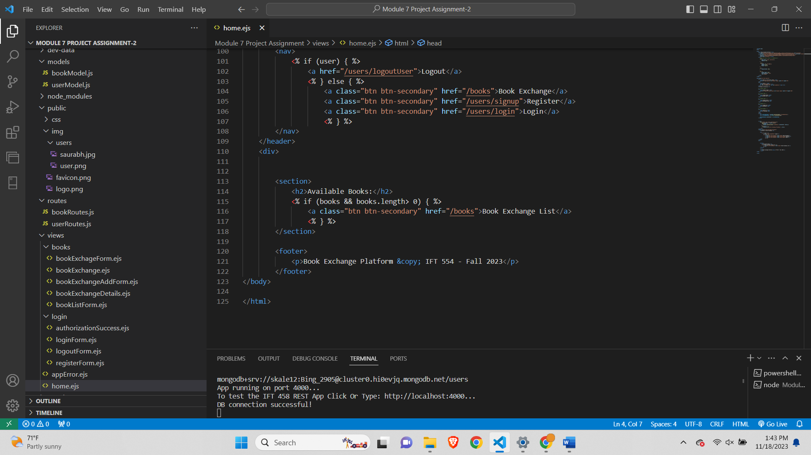

**Cleared Database-**

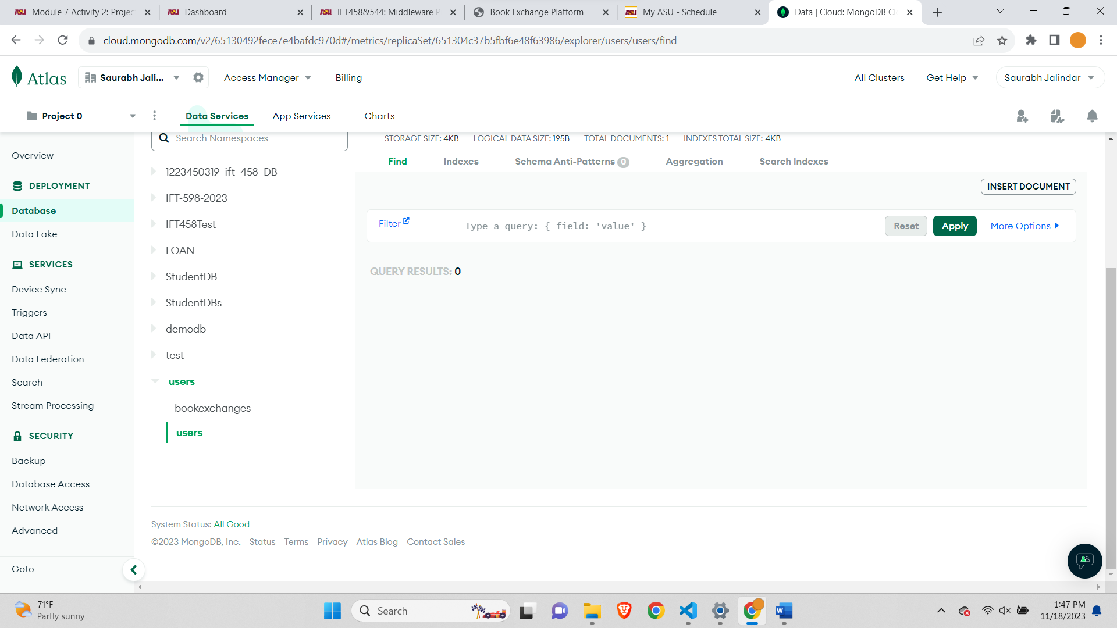

**Cleared Token-**

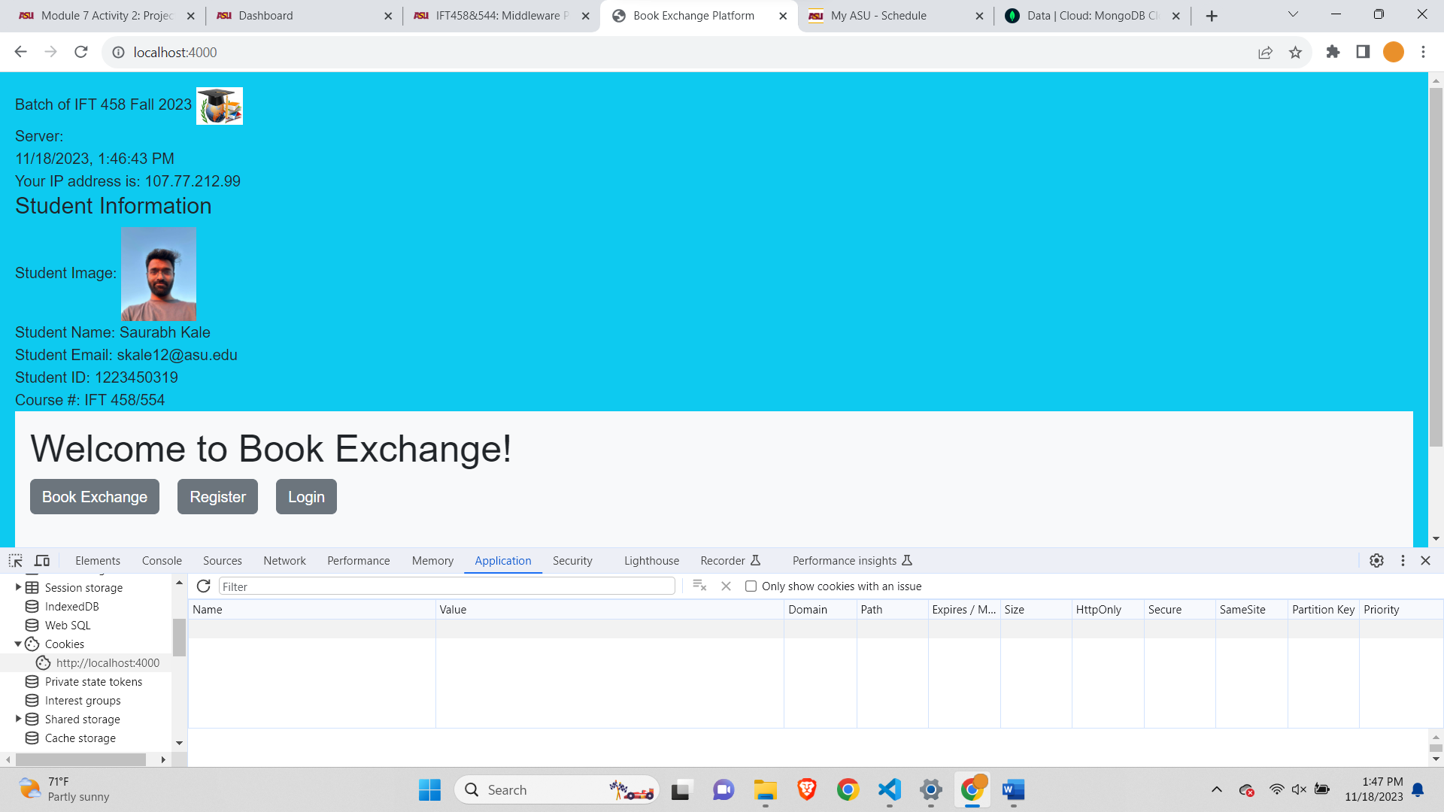

**Signing Up-**

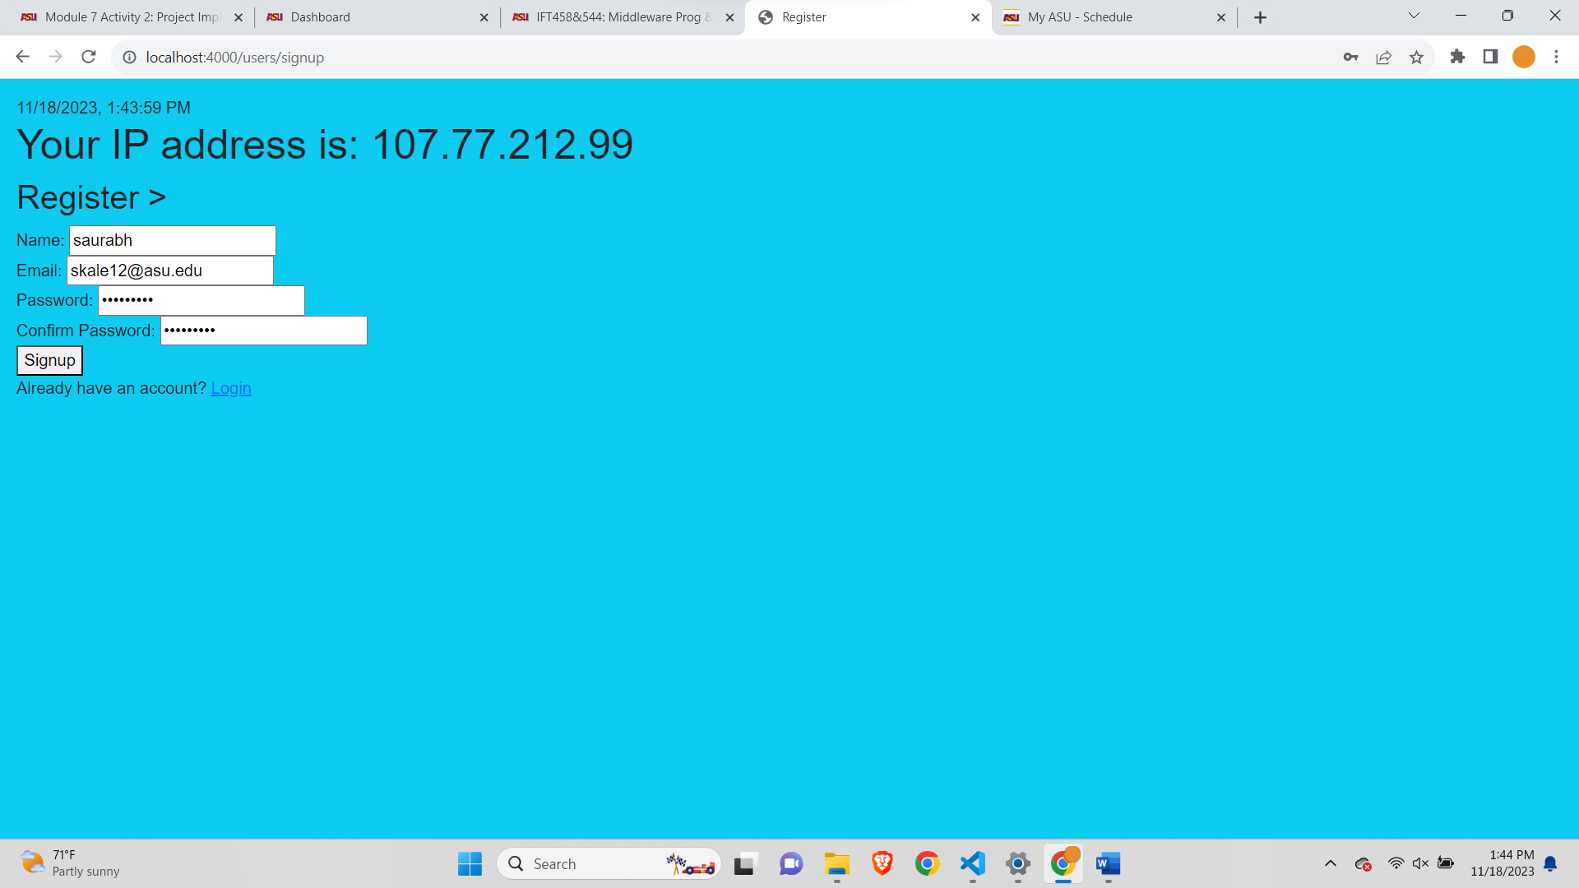

**After successful sign up-**

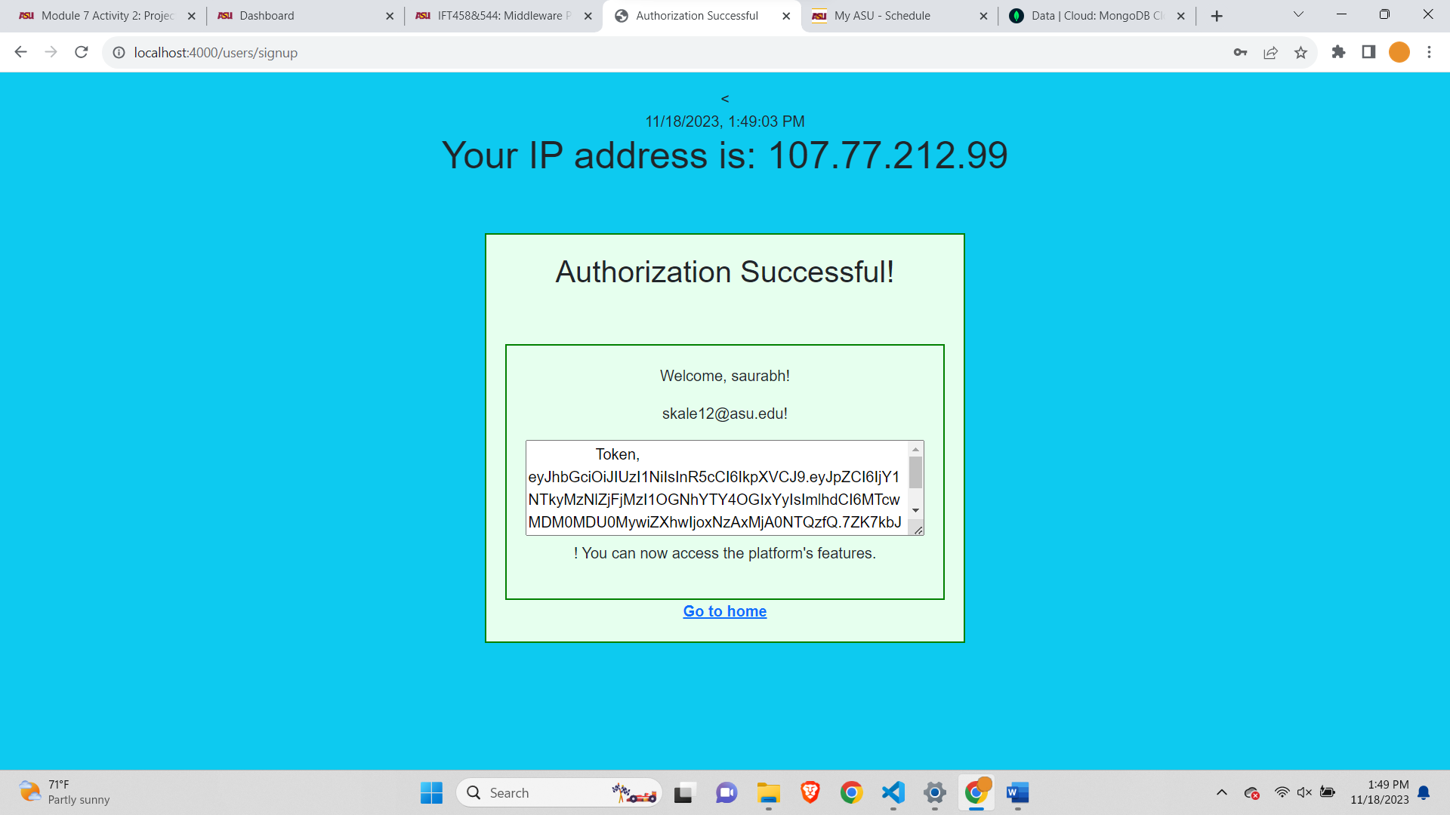

**Created Book Exchange with 5 line Items-**

Before Adding the books-



Added books-

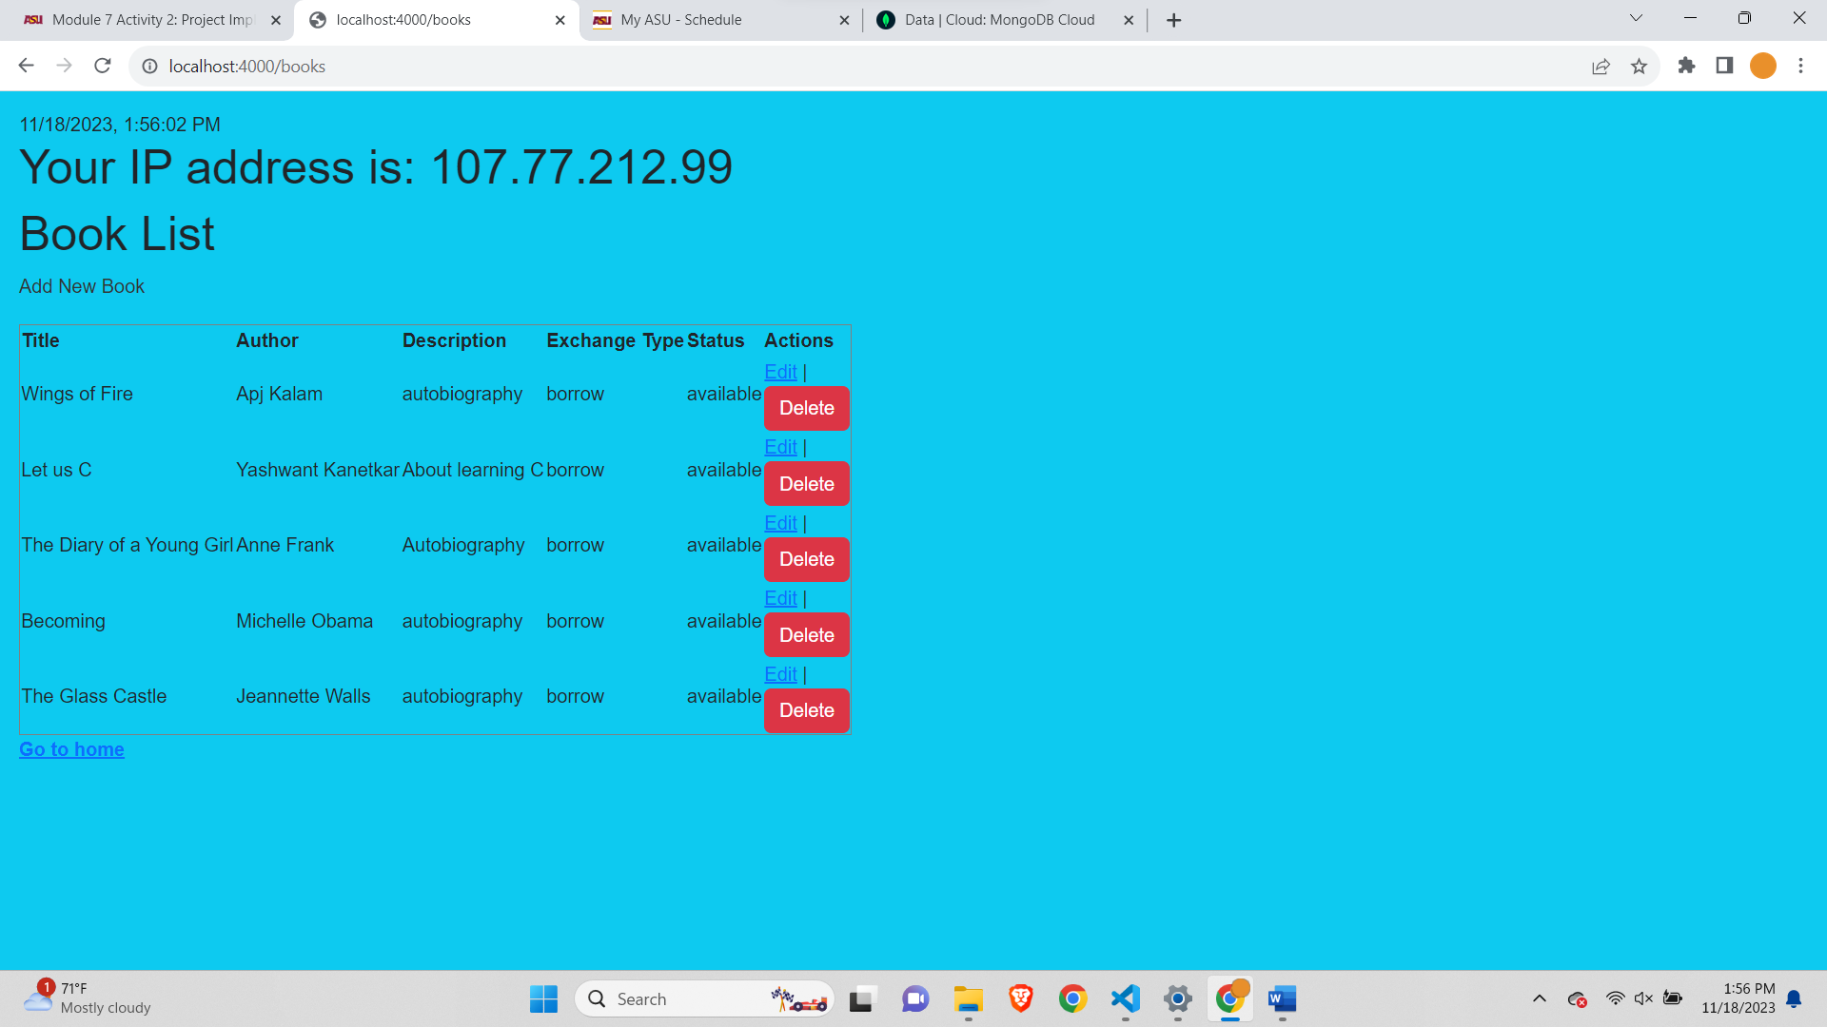

After adding the books the database view-

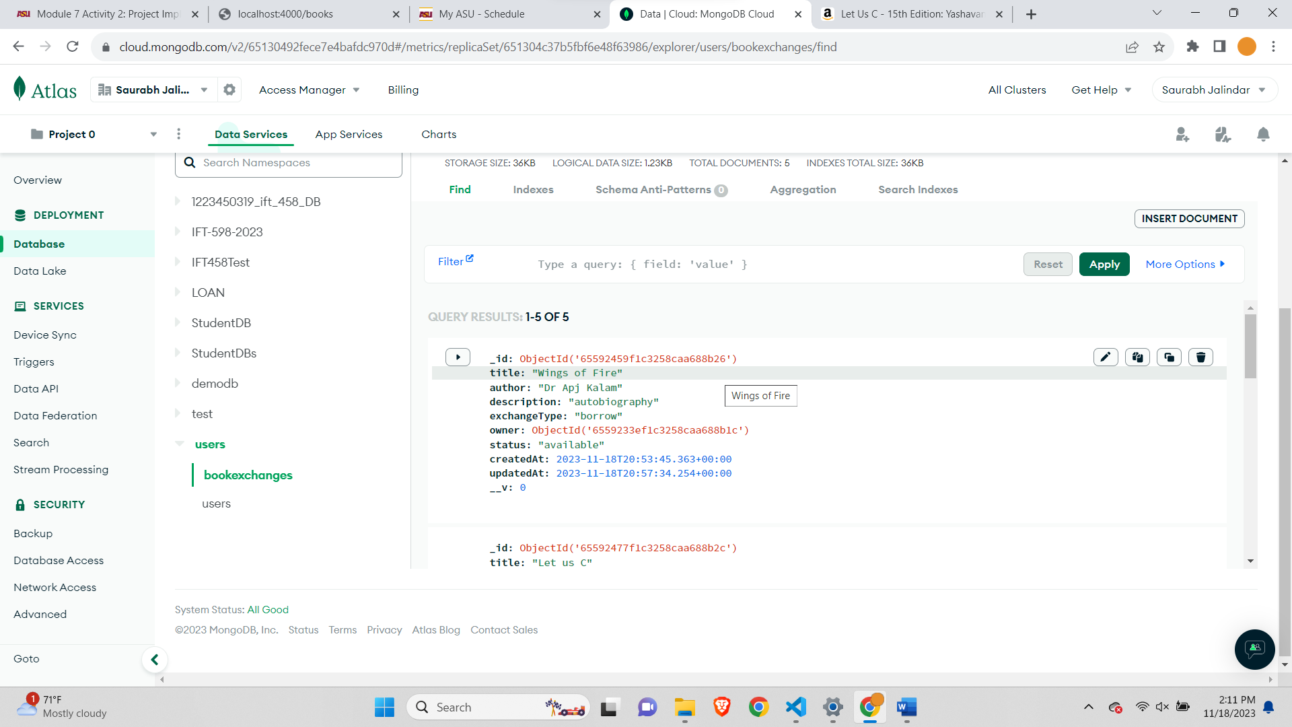

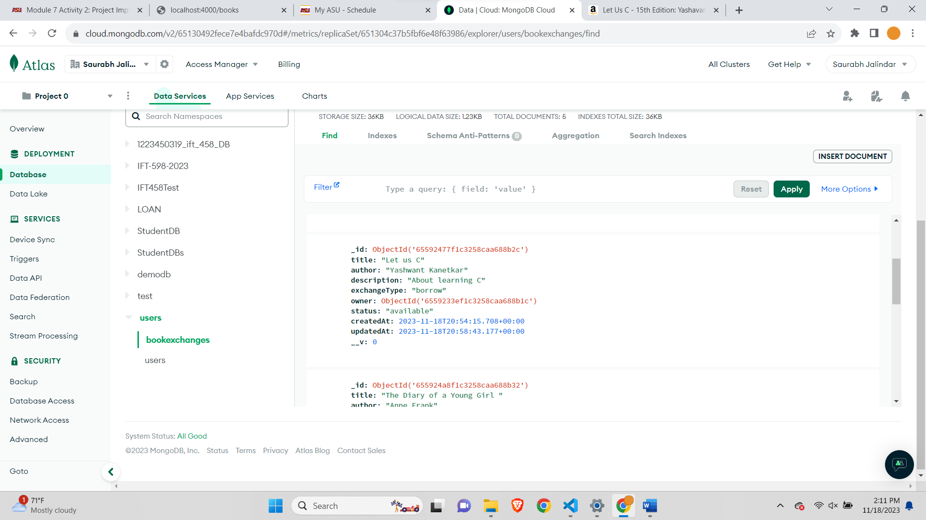

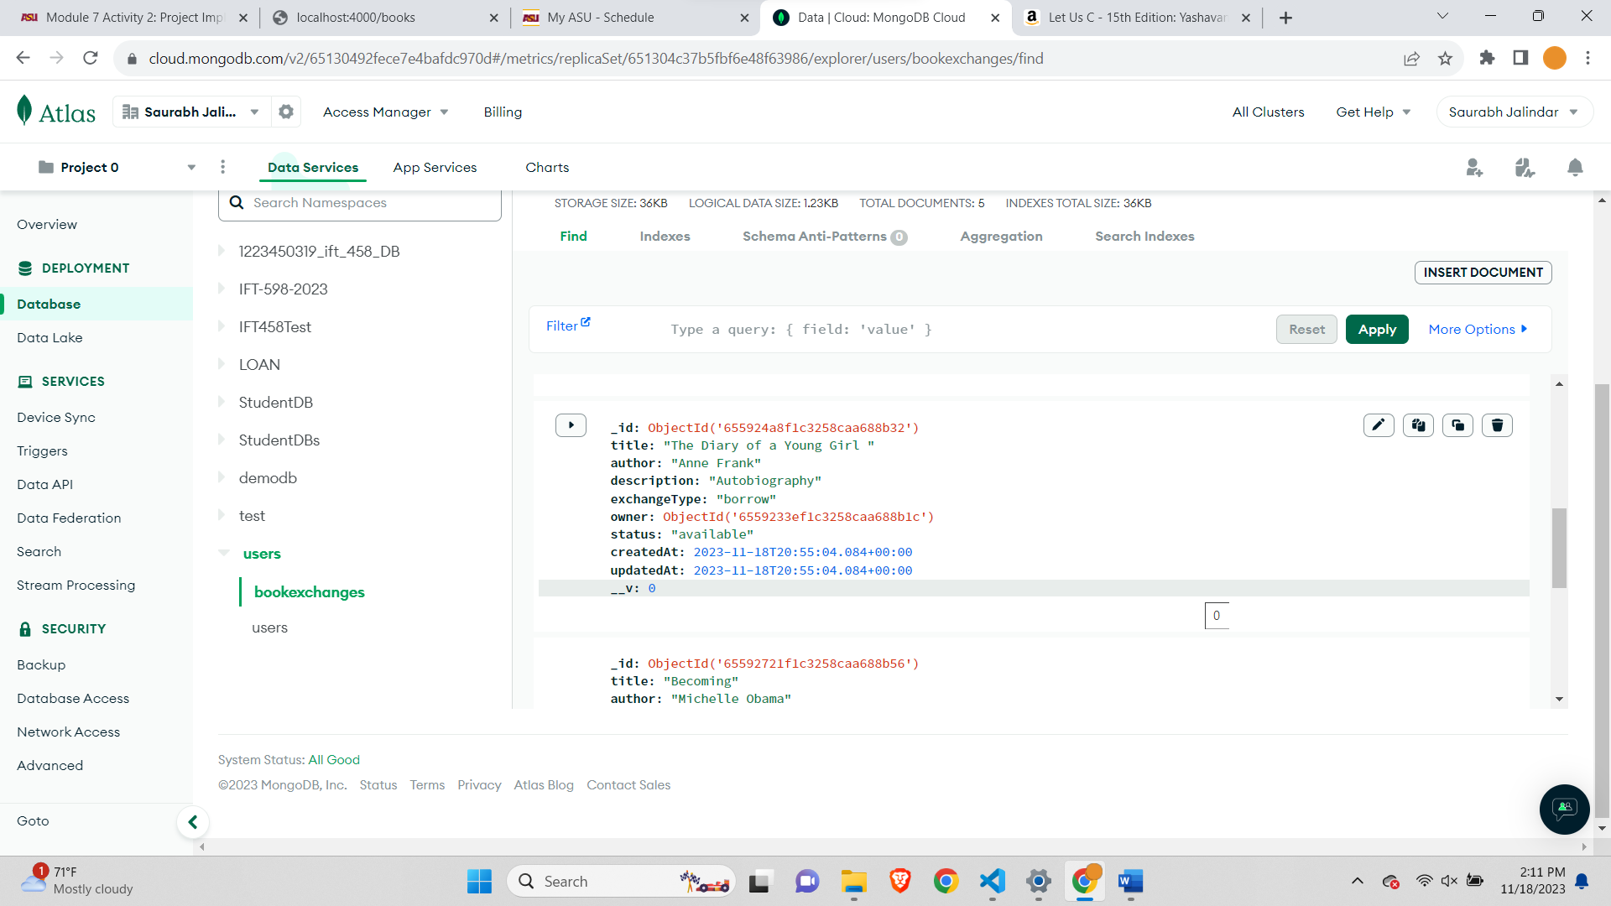

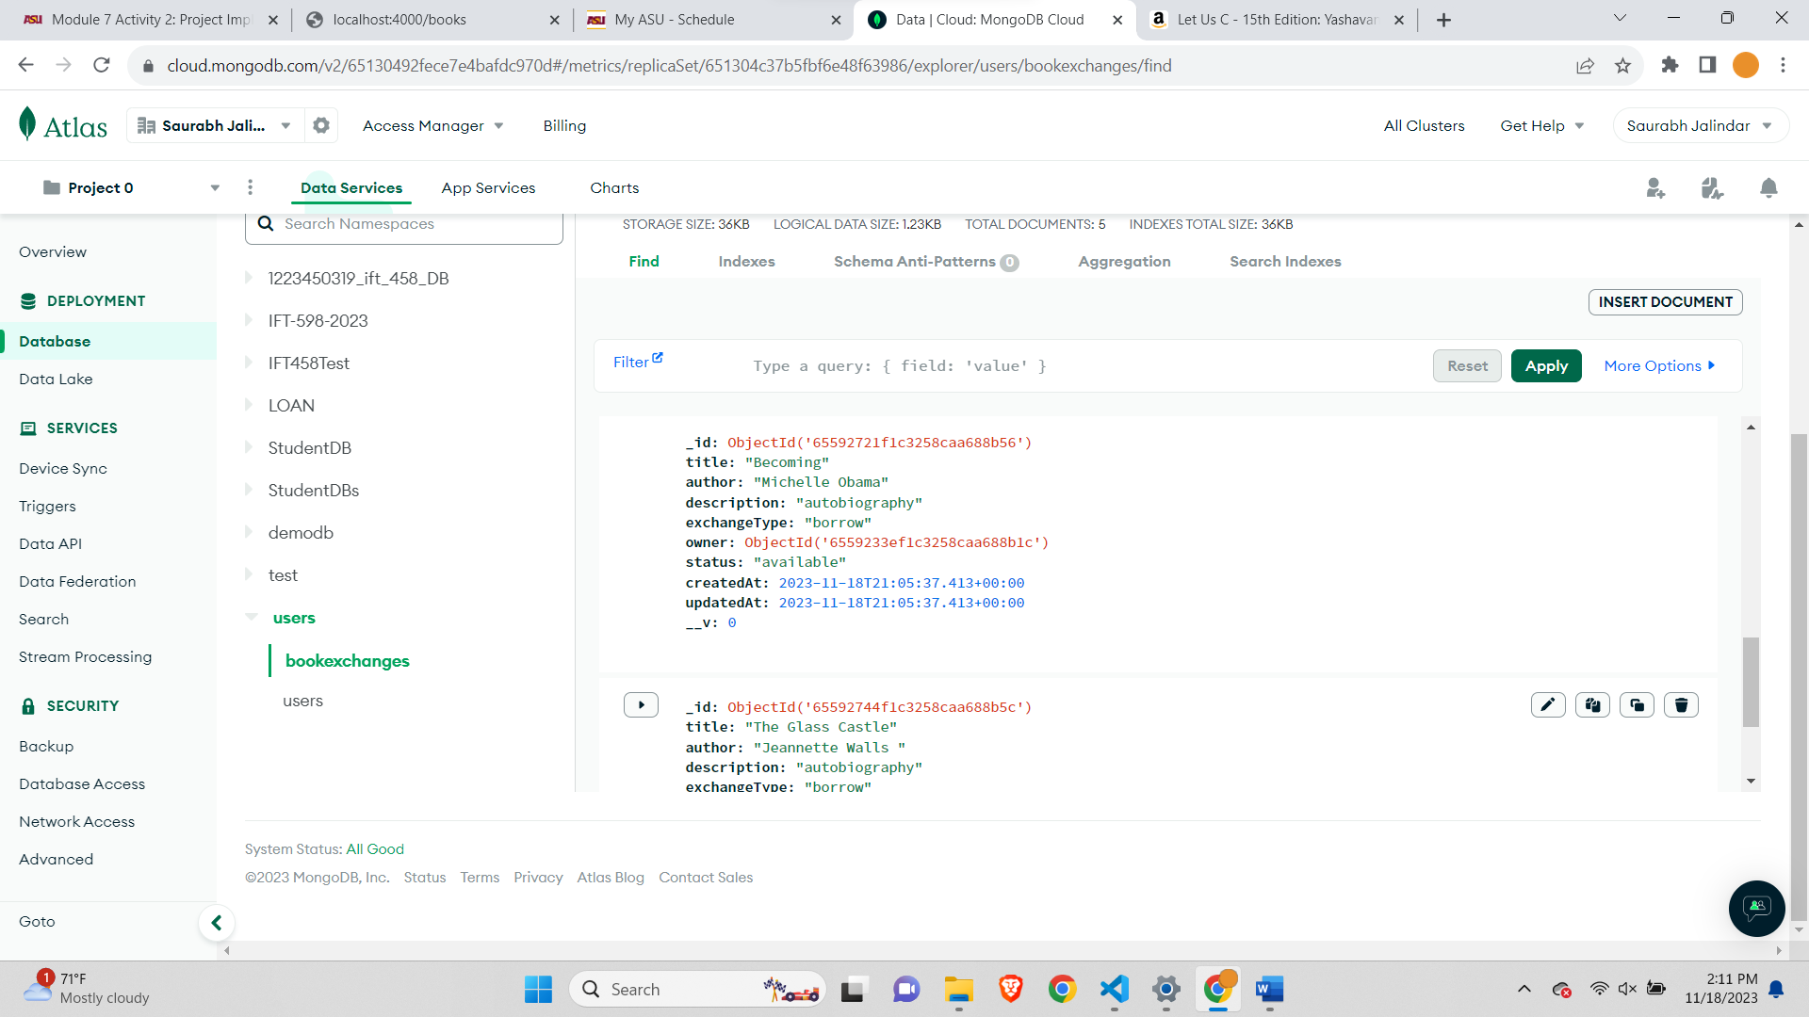

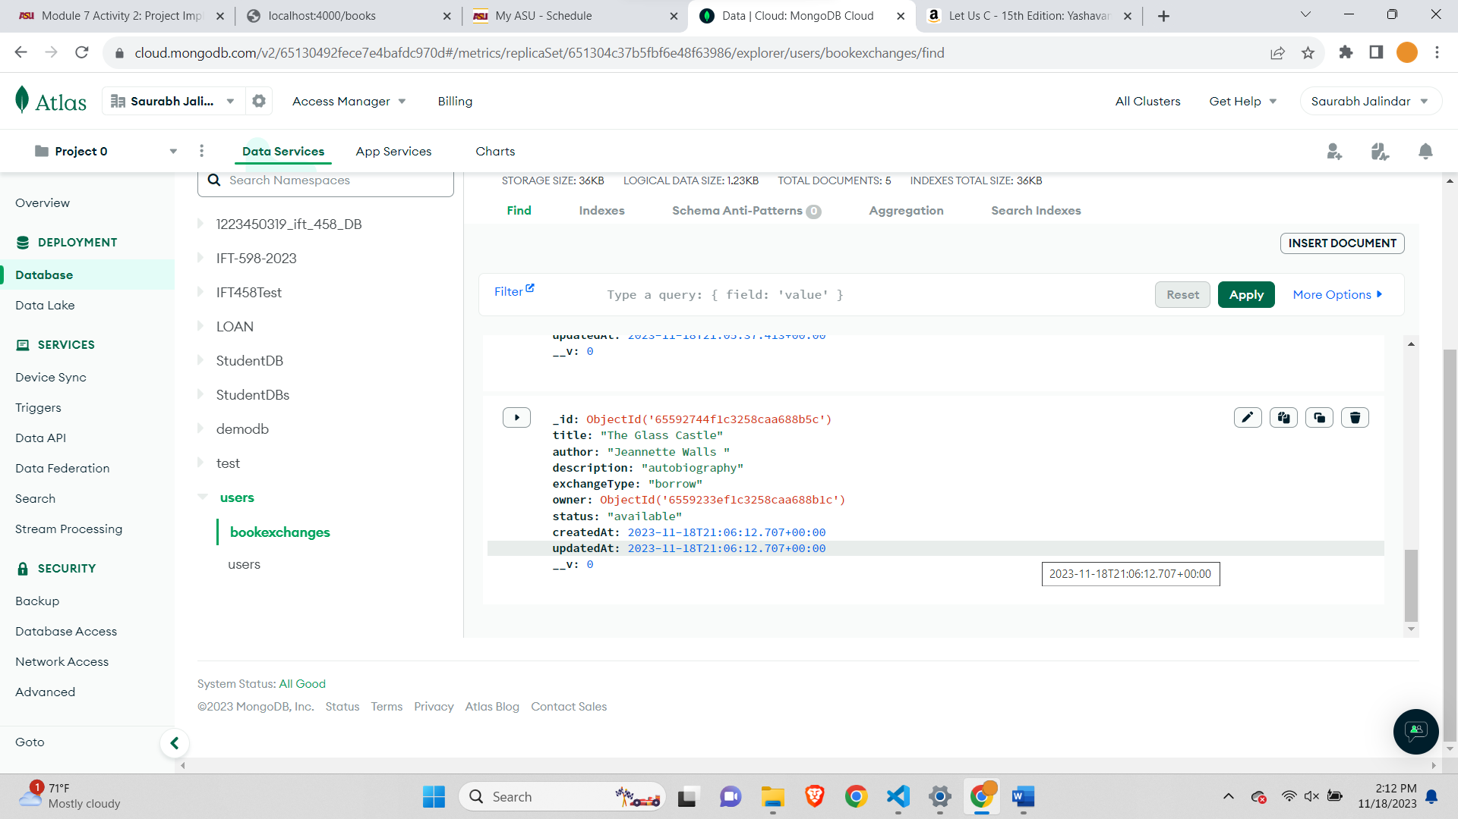

**Updating Books-**

Before updating books the database view-

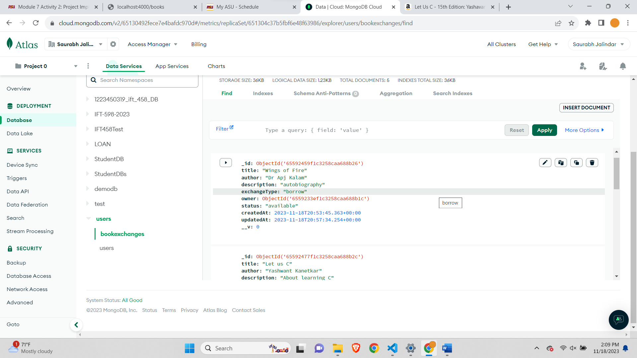

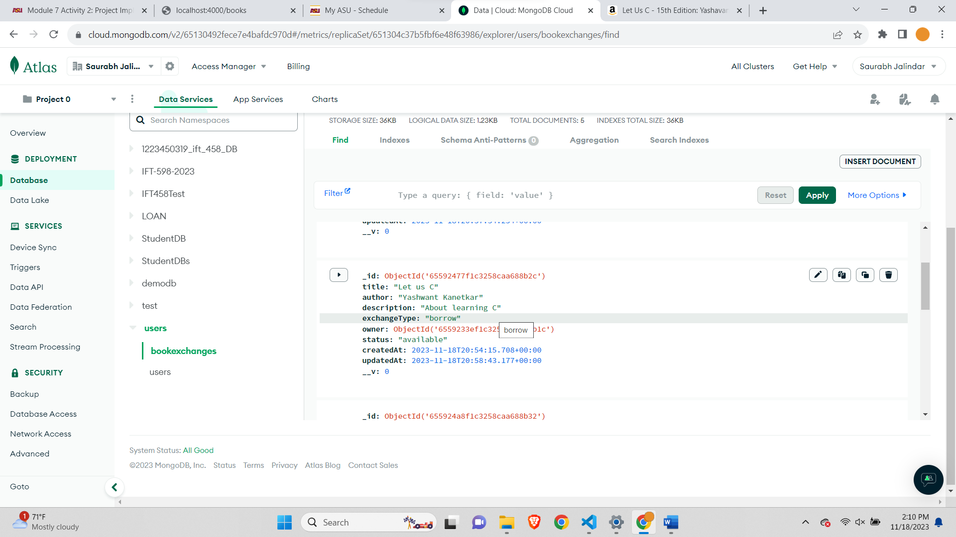

Updating books-

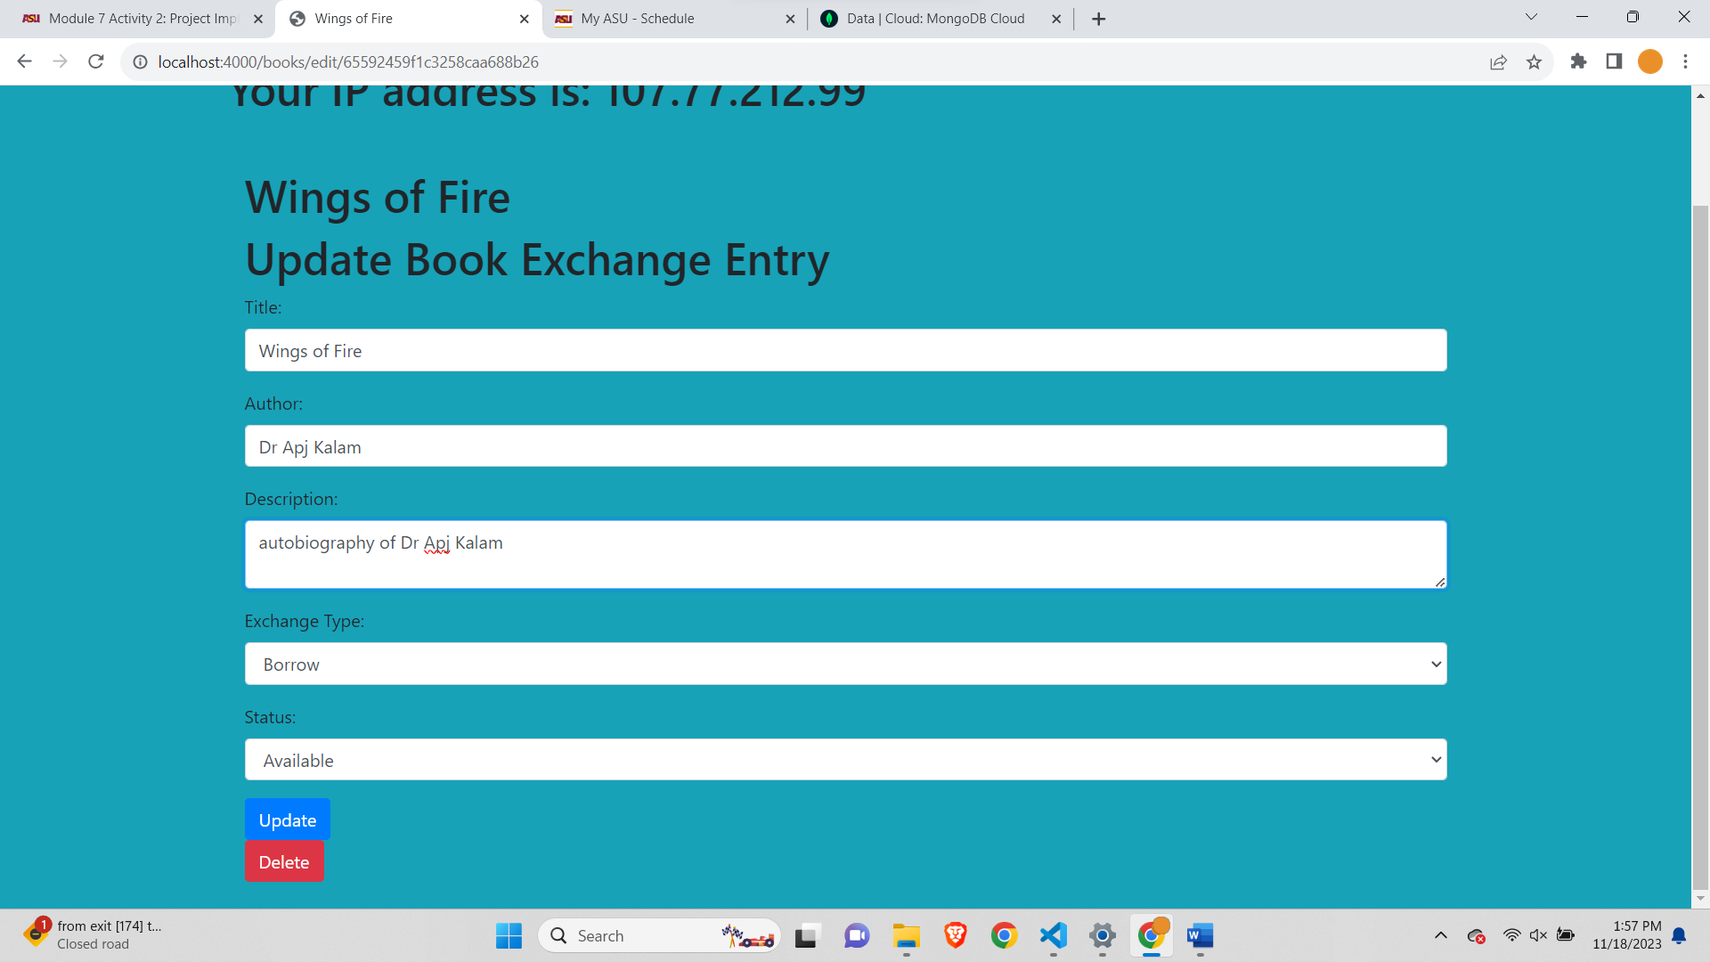

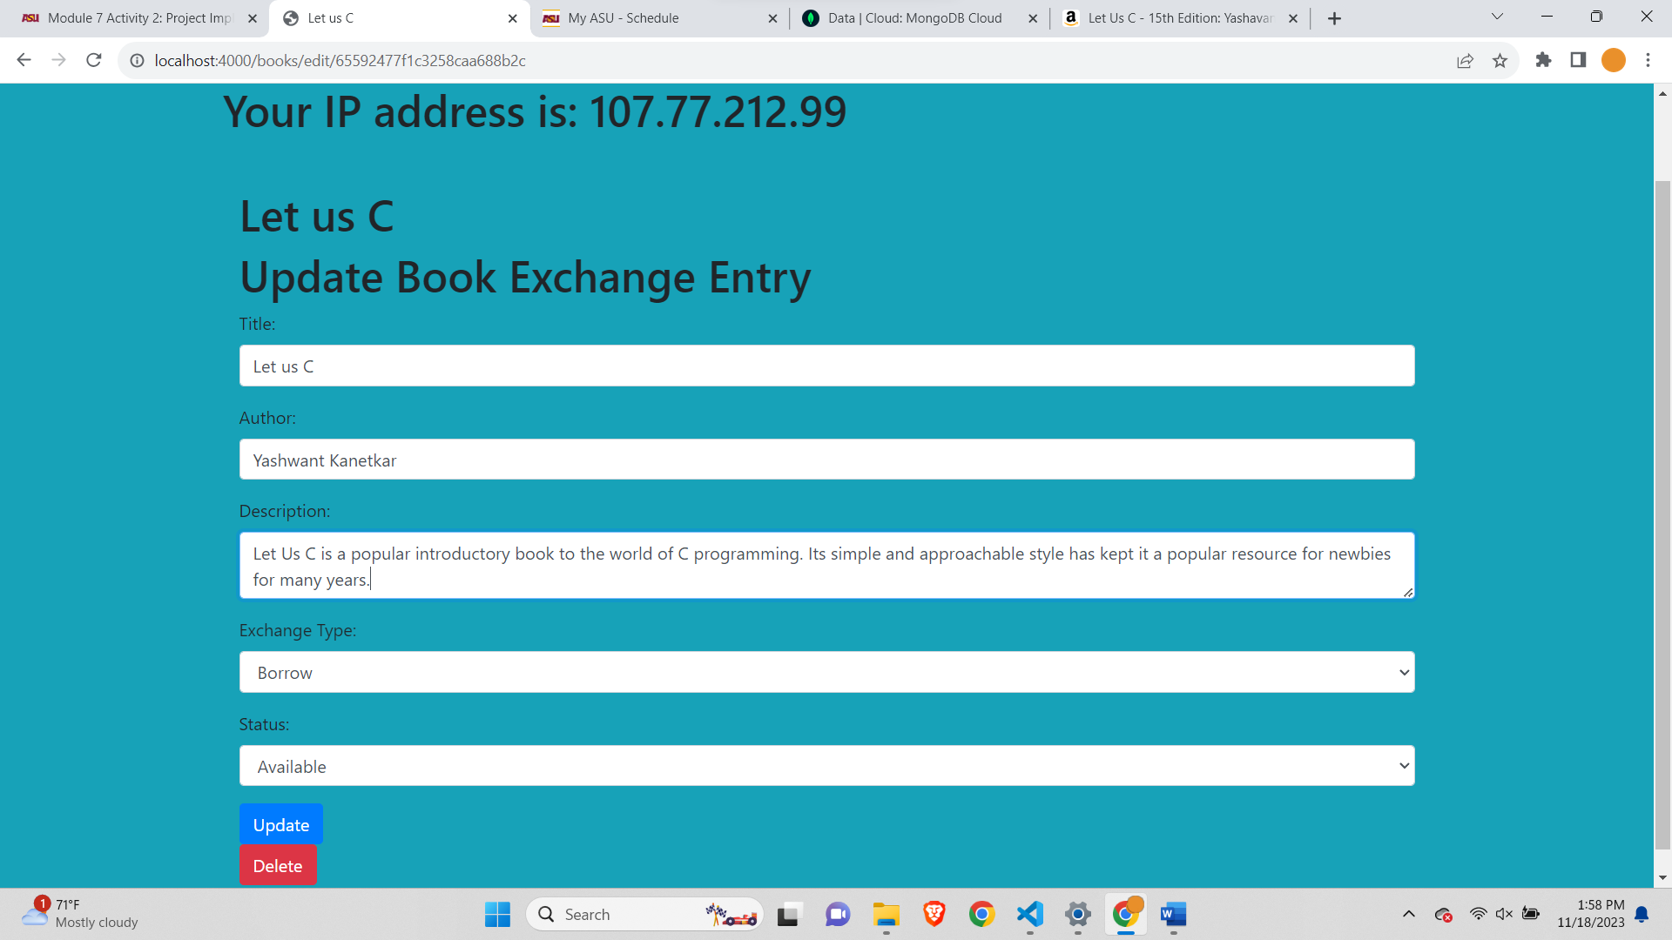

**After updating 2 Books-**

Database Before Updating 2 books-

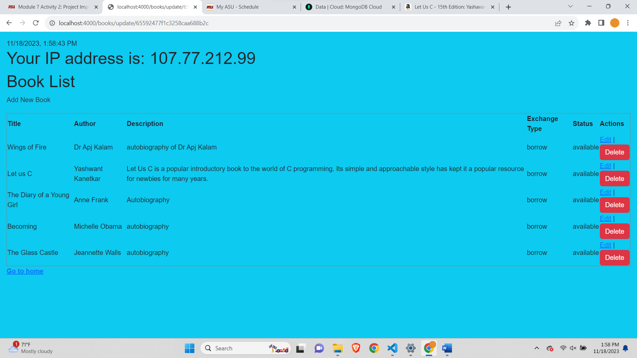

Database After updating two Books-

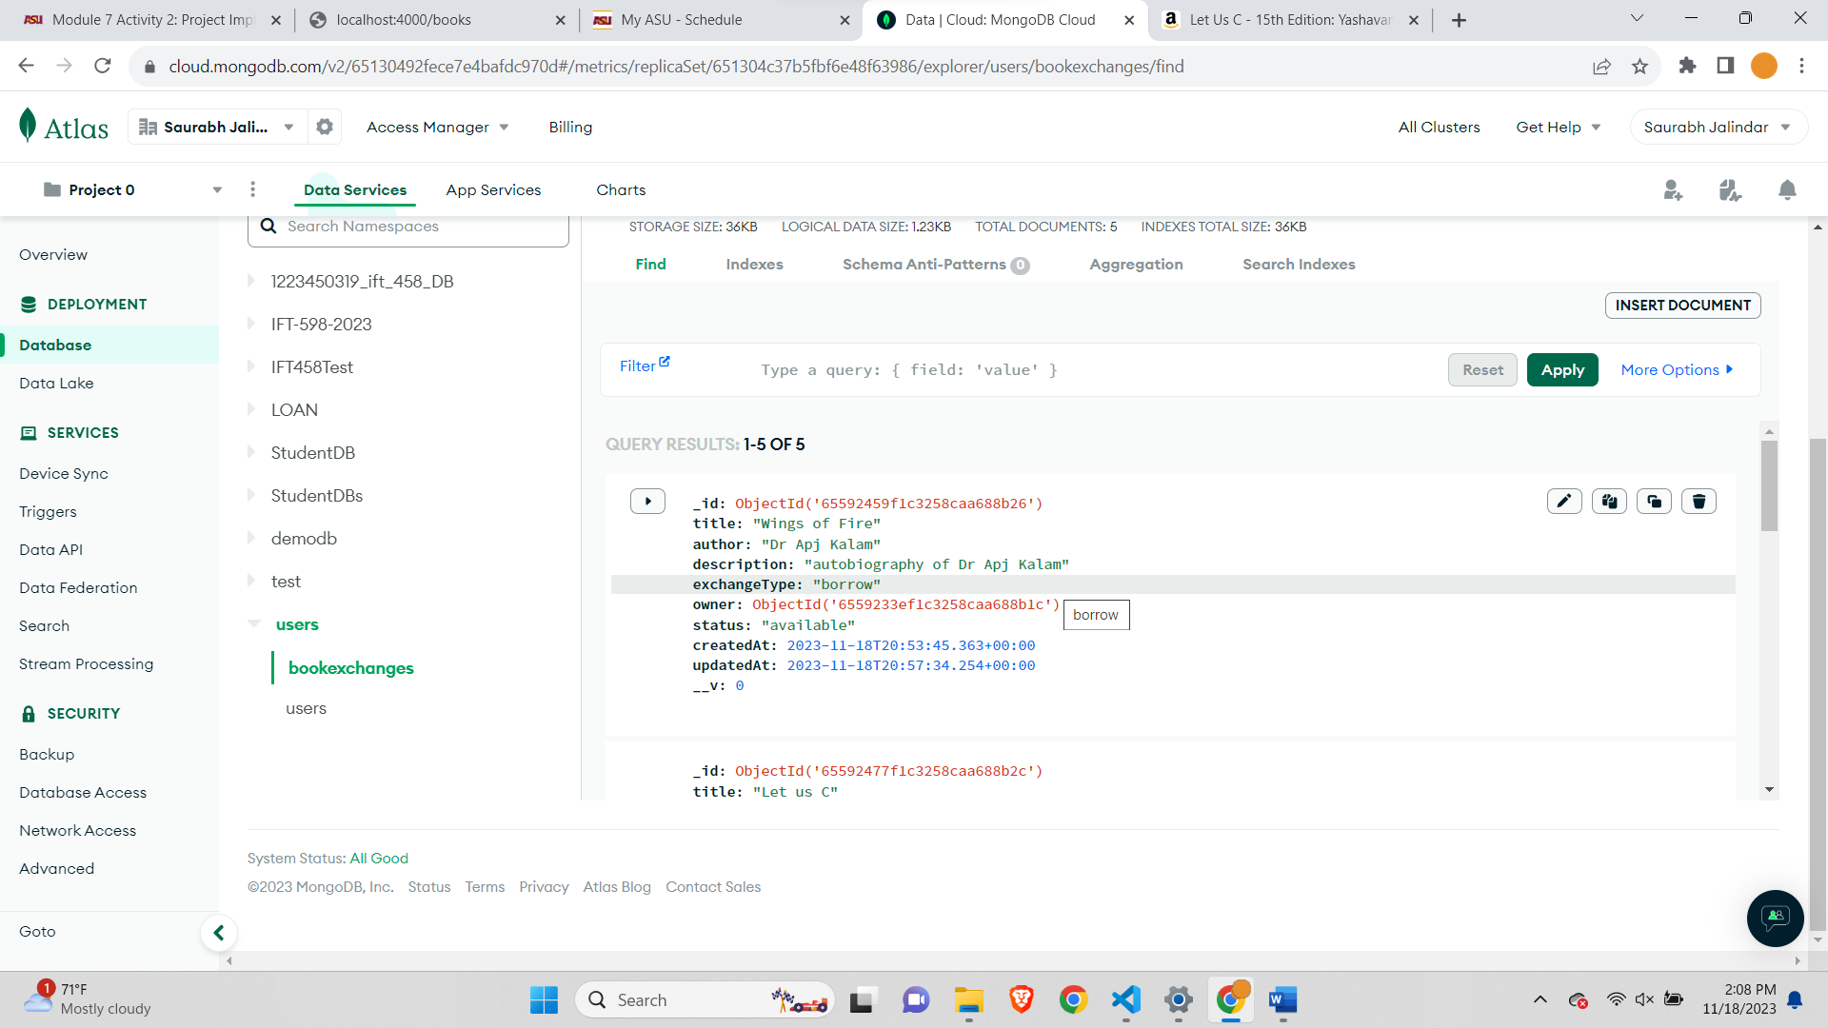

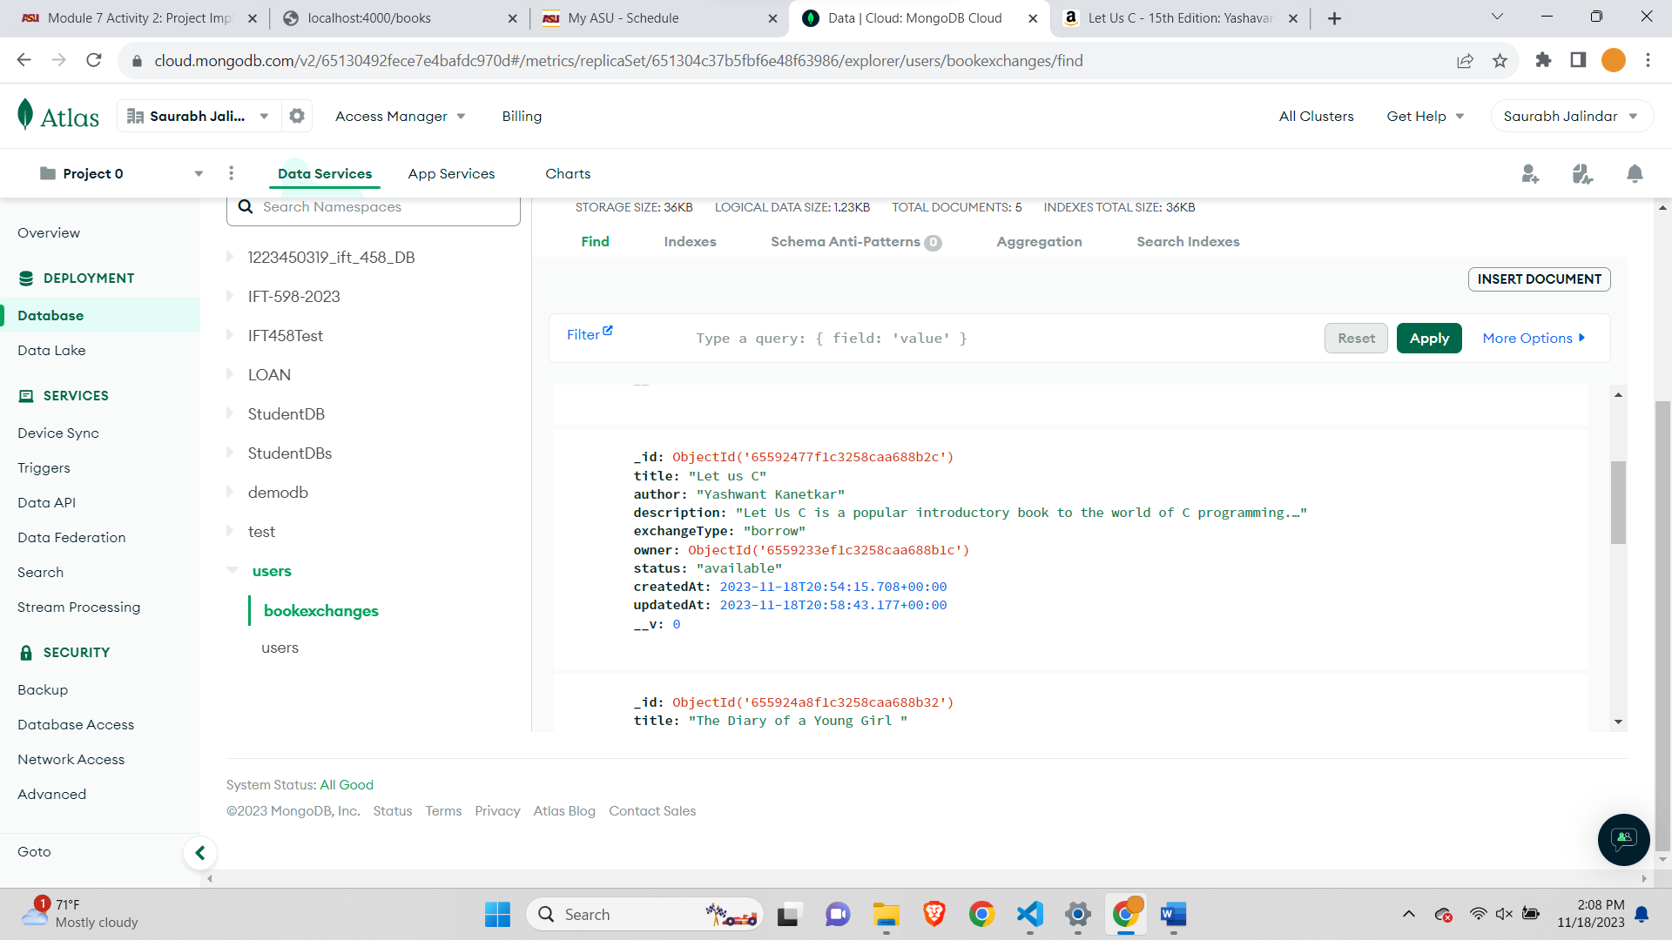

**Delete Two Books-**

Before deleting books the database record-

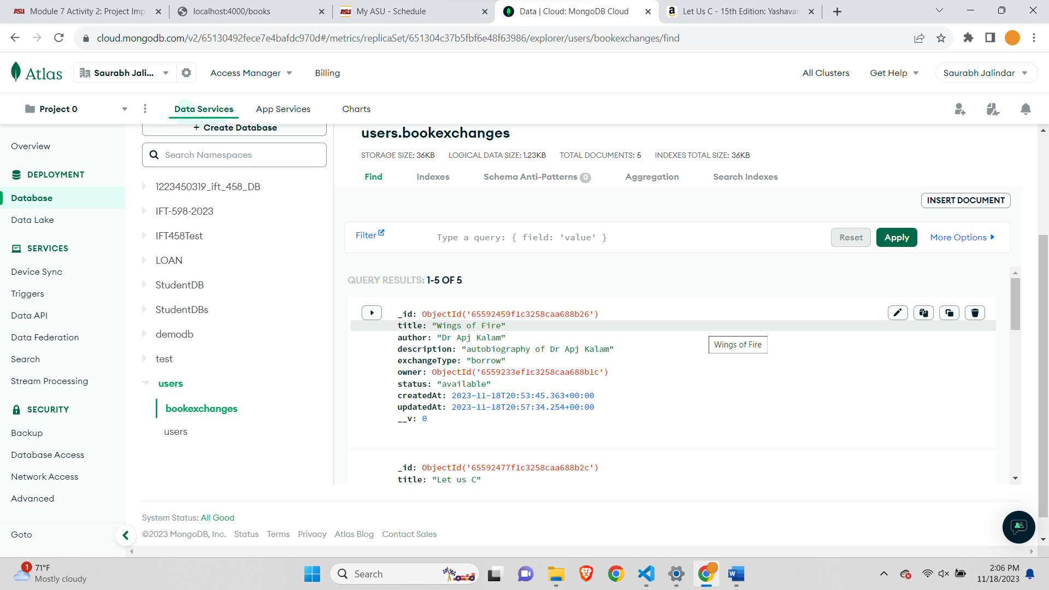

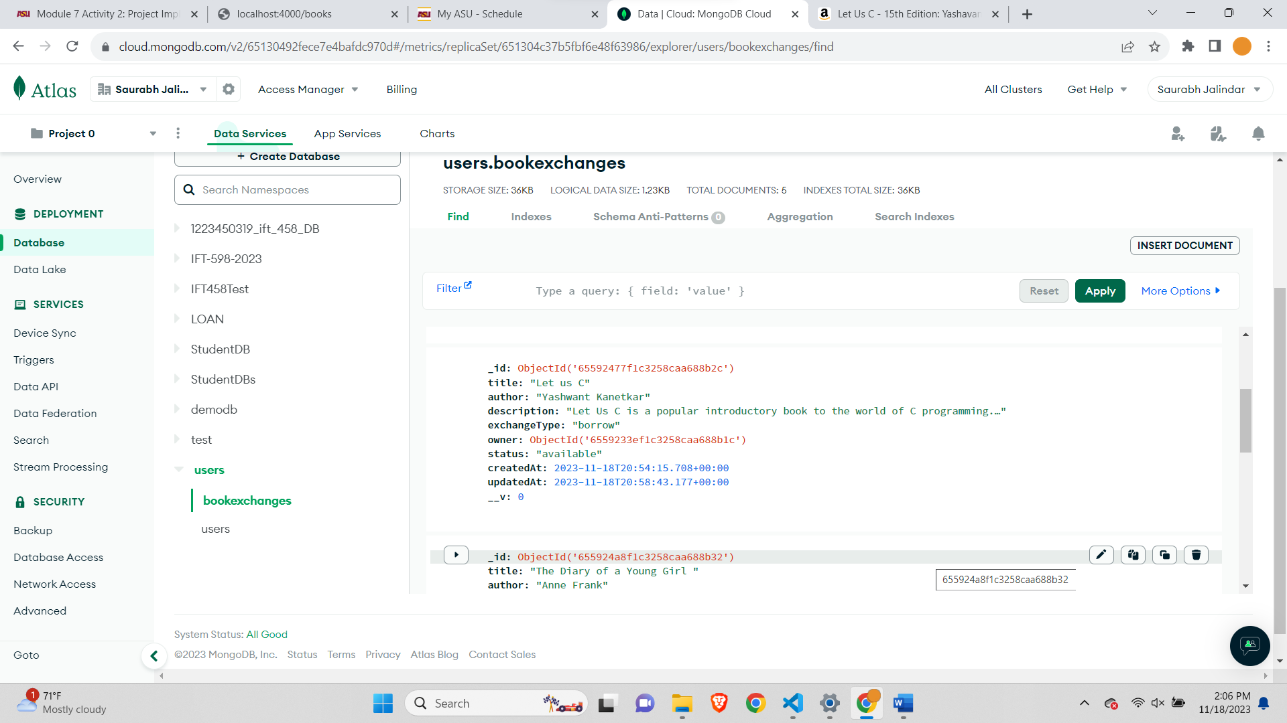

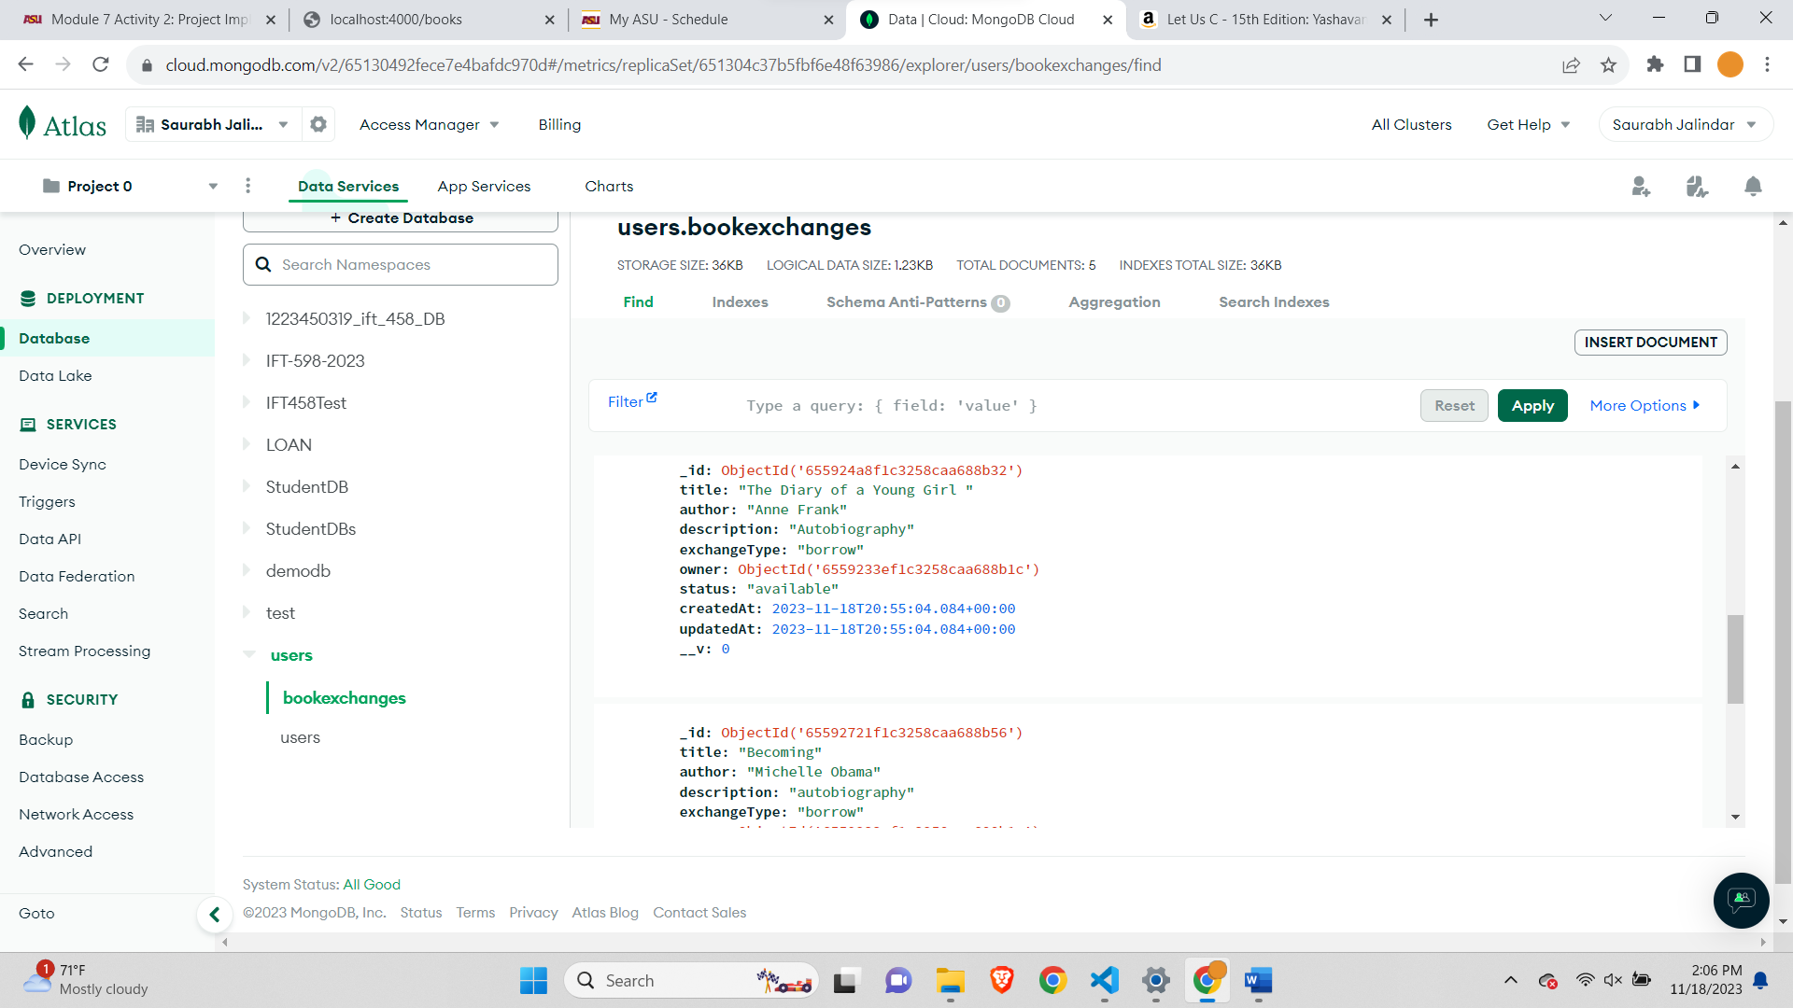

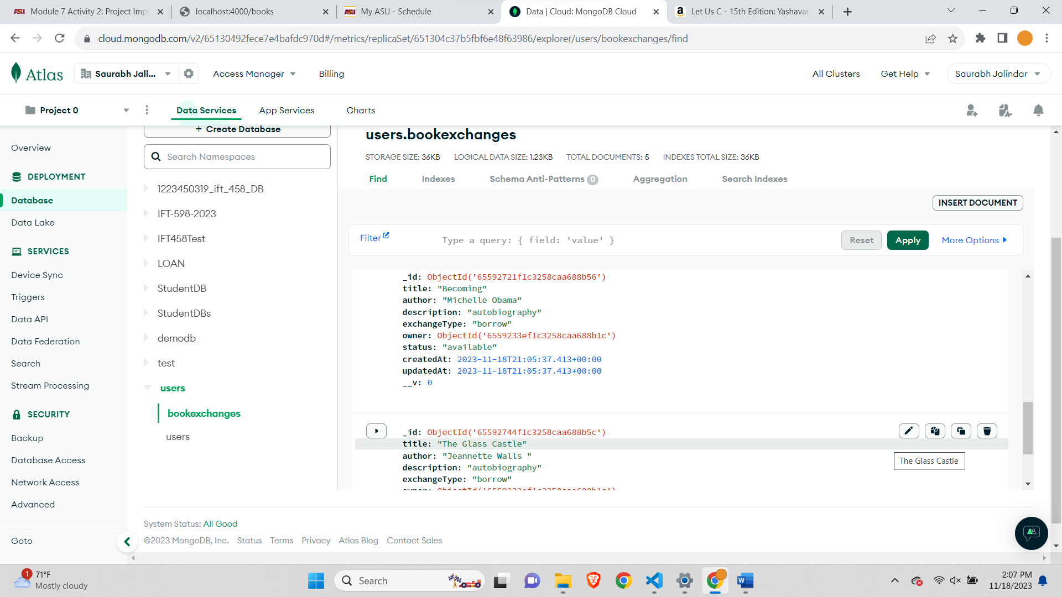

After deleting two books-

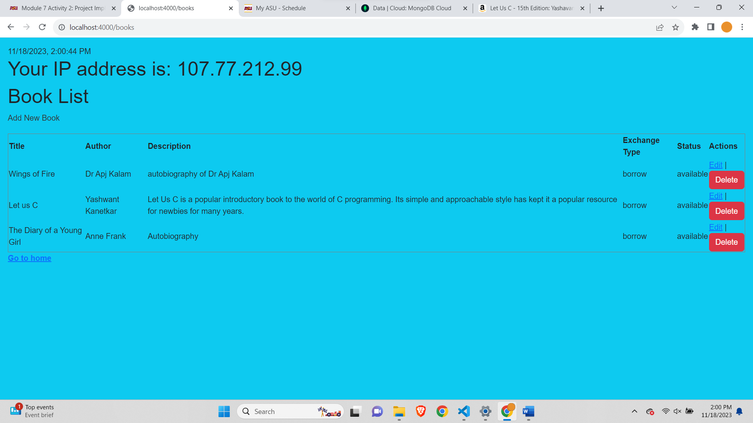

After deleting records the updated database-

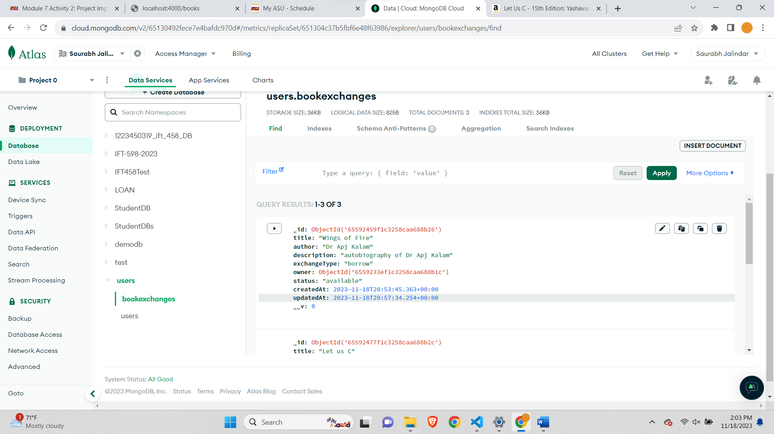

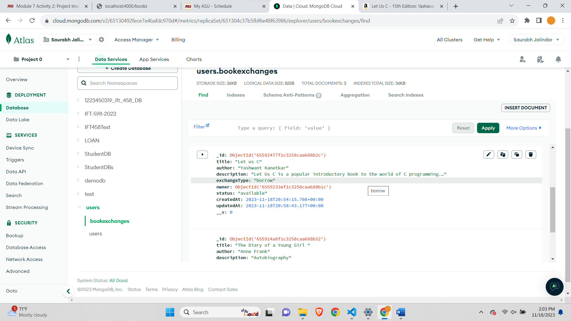

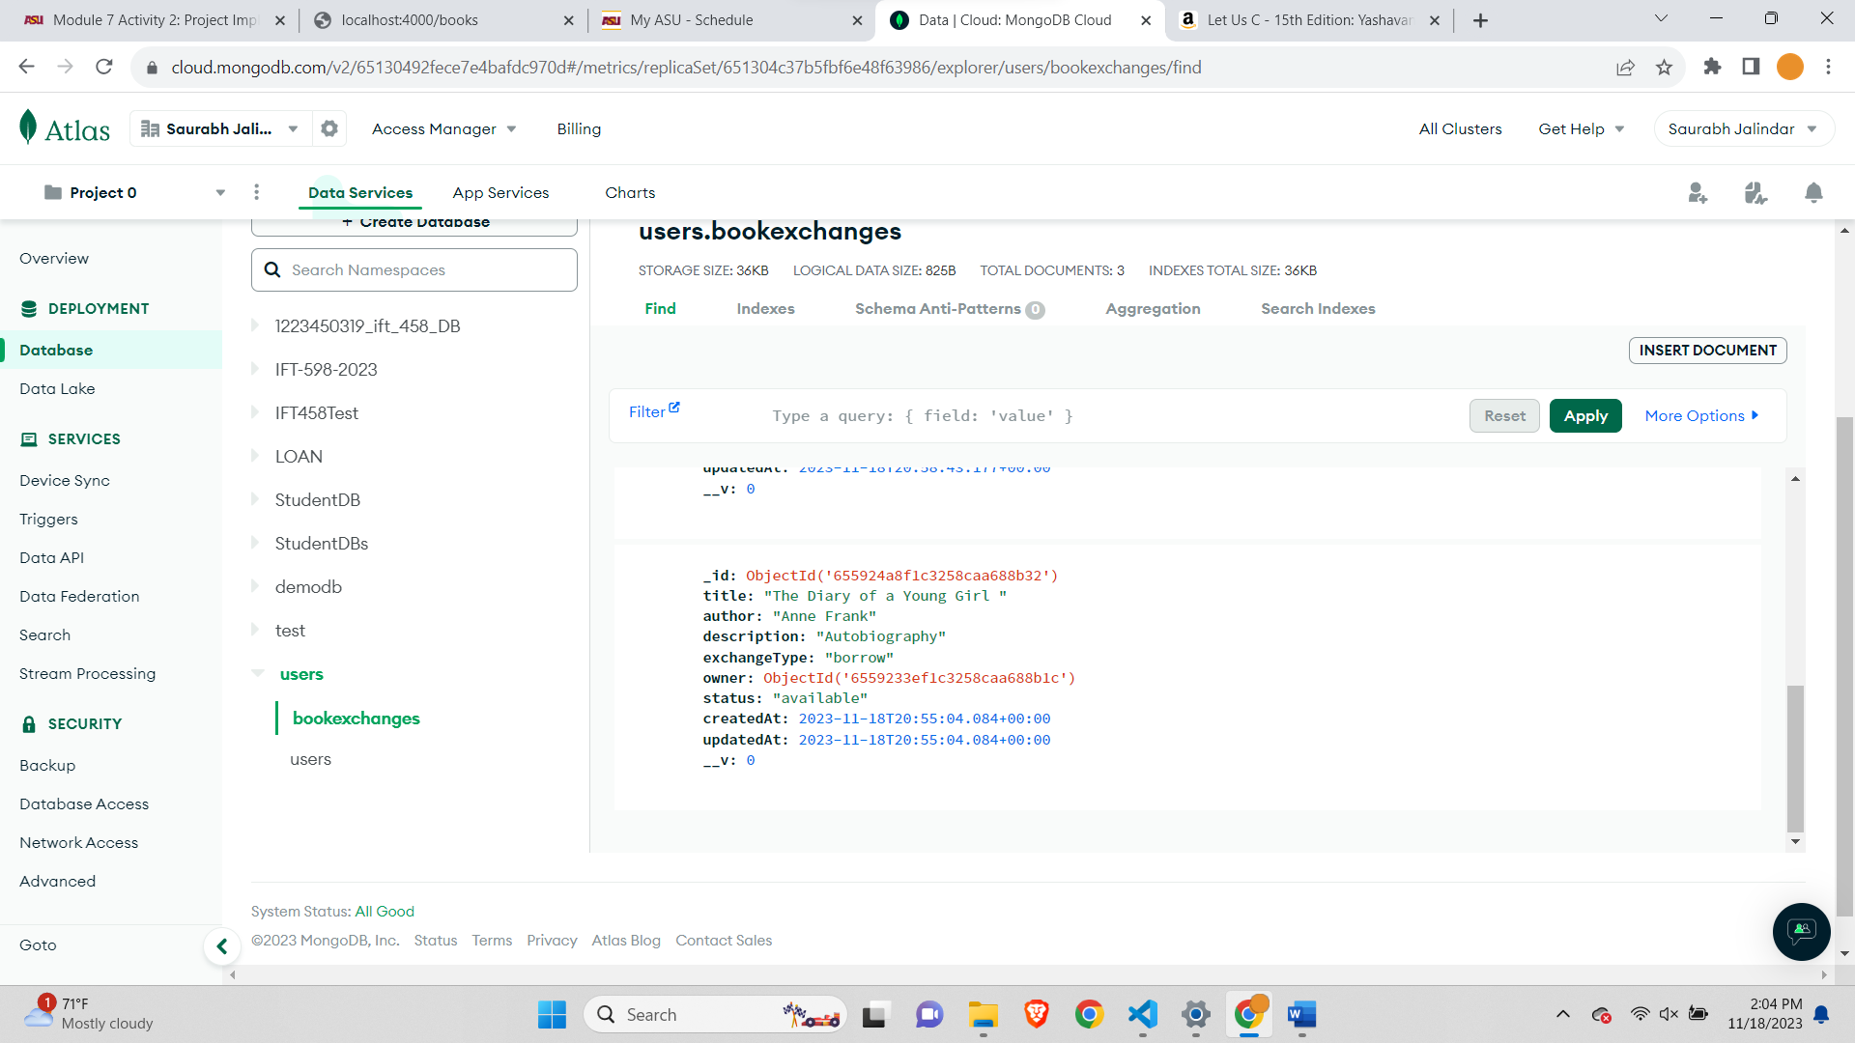

**Step 9: Review and Update the Table of API Specifications:**

|  |  |  |
| --- | --- | --- |
| Feature | Method | URL End Point (the following are just the sample) You must update the URLs with the correct endpoints) |
| Register / Sign up | POST | <http://localhost:4000/users/signup> |
| Login | POST | <http://localhost:4000/users/login> |
| View All Books | GET | <http://localhost:4000/books> |
| Add Book Exchange | POST | <http://localhost:4000/books> |
| Update Exchange | POST | <http://localhost:4000/books/update/:id> |
| Delete Exchange | POST | <http://localhost:4000/books/delete/:id> |

**Signup Test-**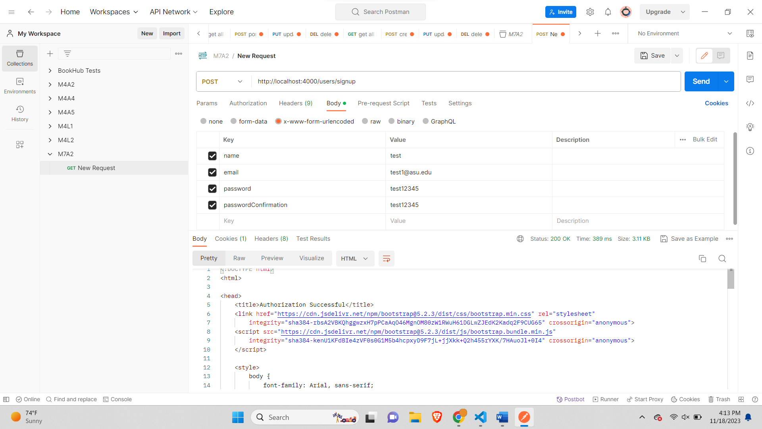

**Login Test-**

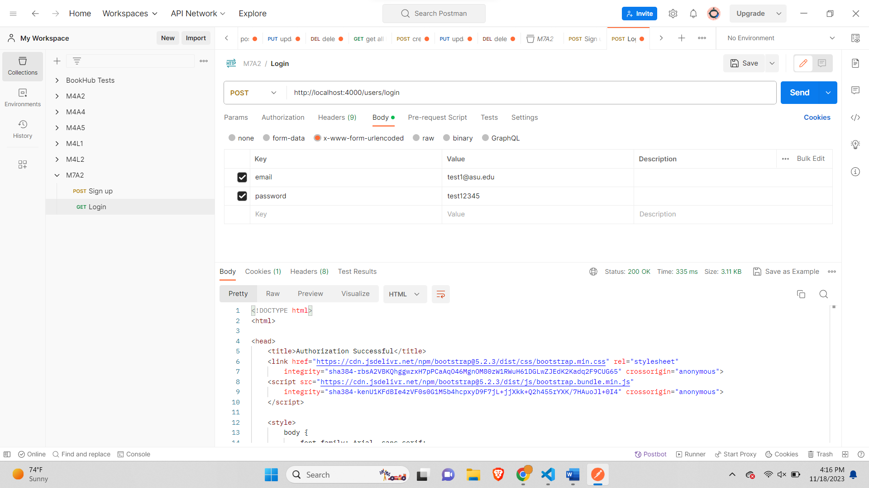

**Get Books-**

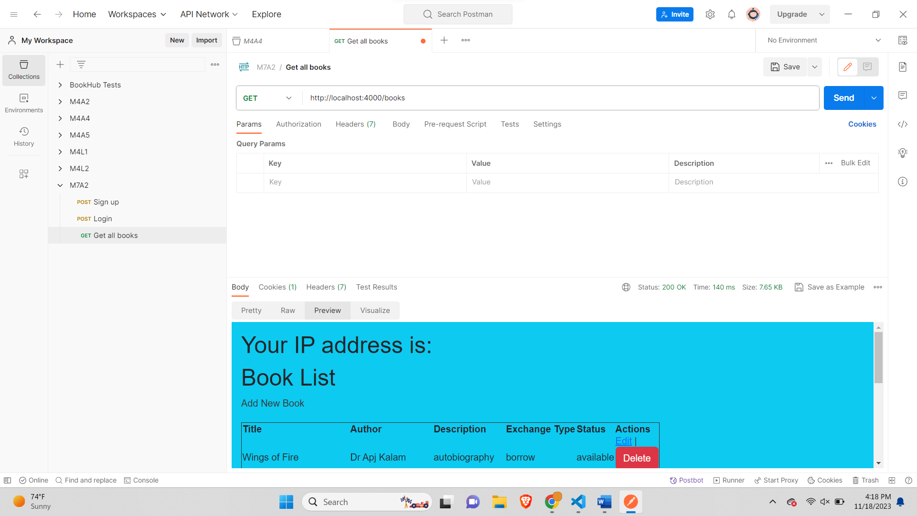

**Add Book-**

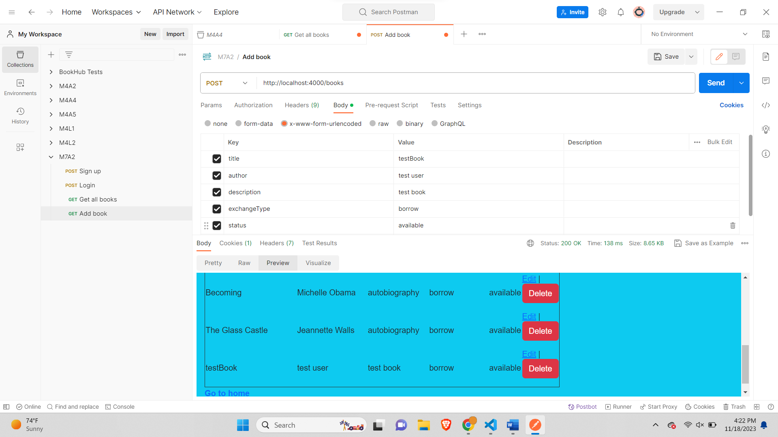

**Update Book-**

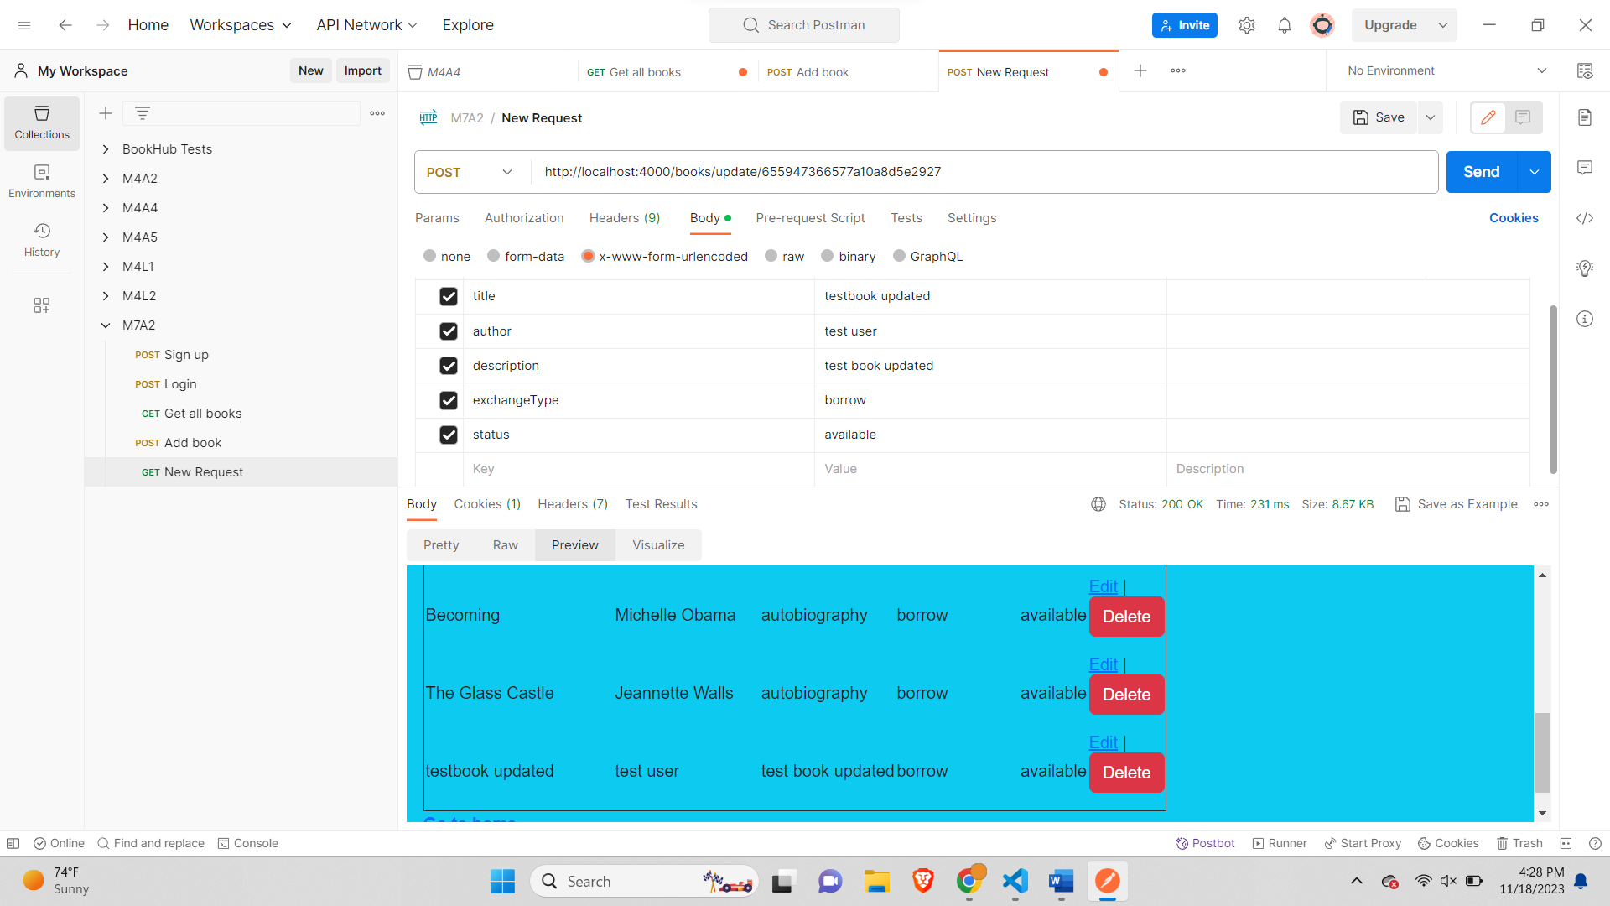

**Testing Book Exchange API with Visual Studio Code's HTTP Client:**

**1. Setting Up:**

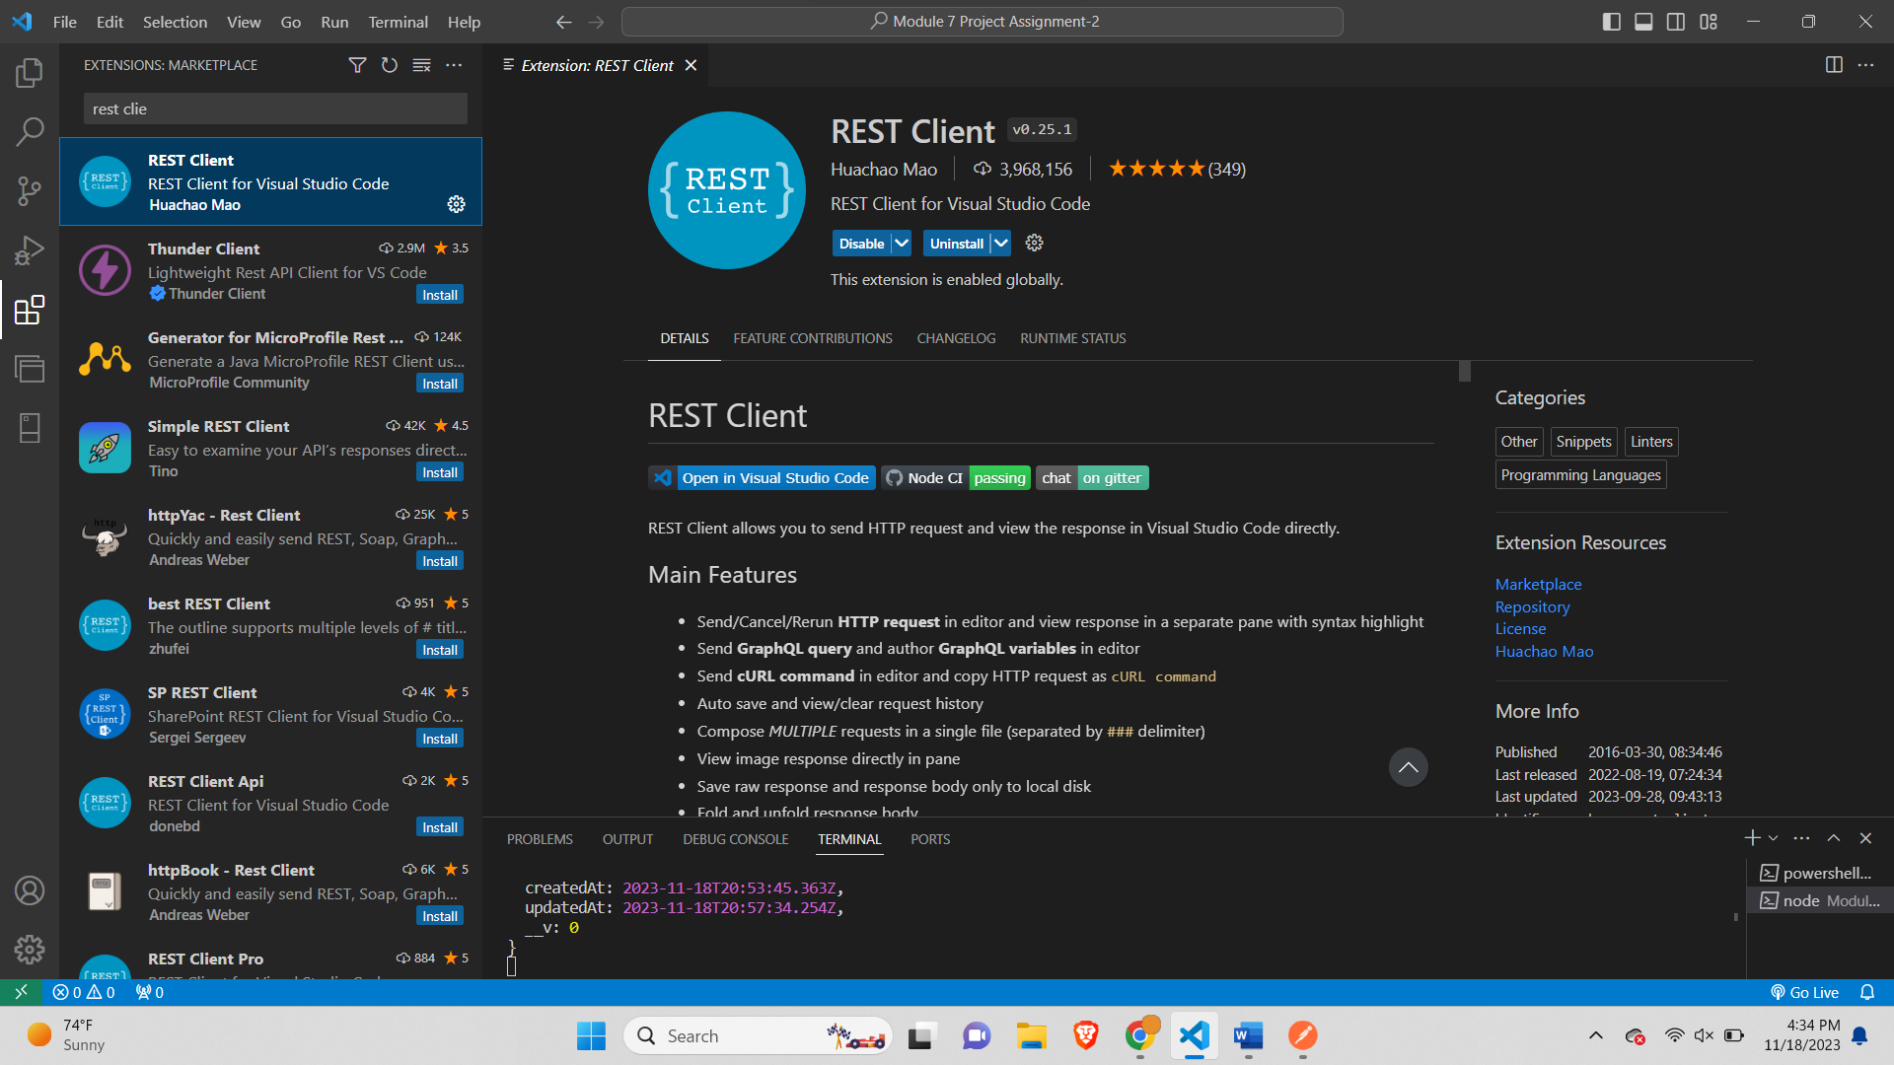

**2. Initiating a New Request File:**

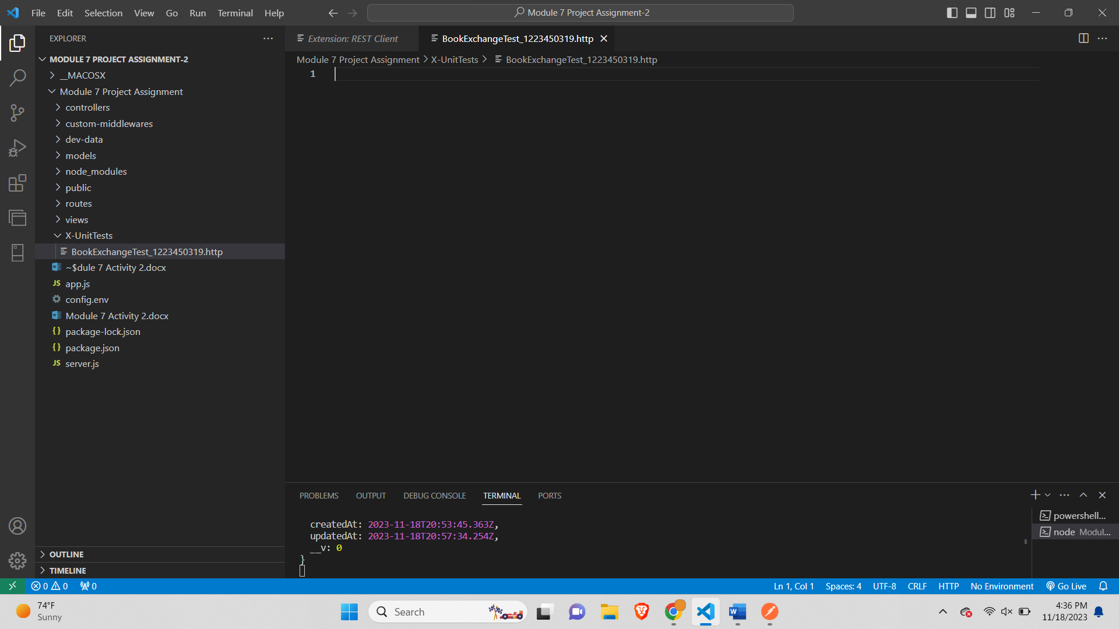

**3. POST Request: Adding a New Book:**

Before adding books-

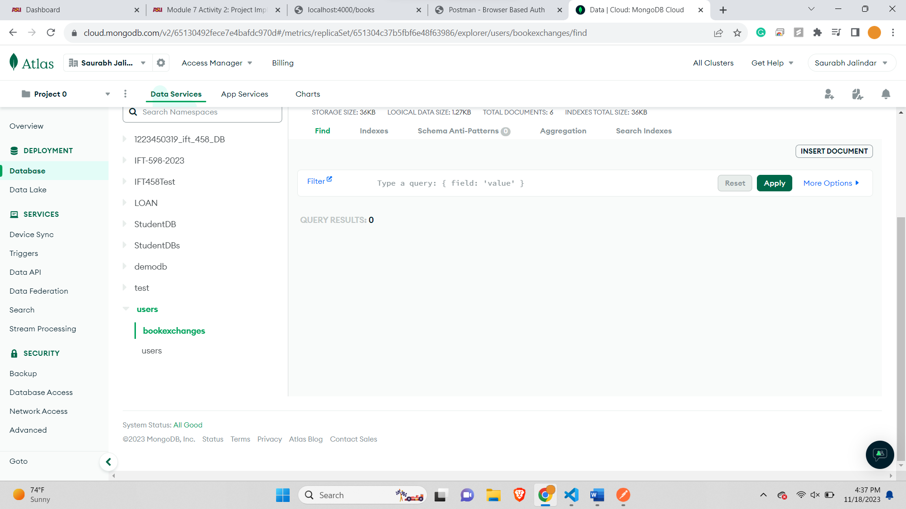

Get All books-

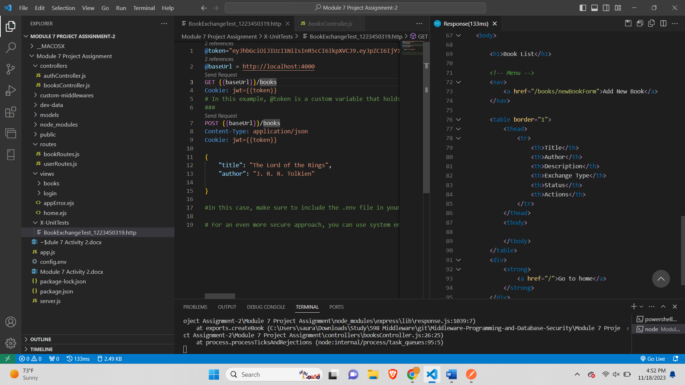

Add book 1-

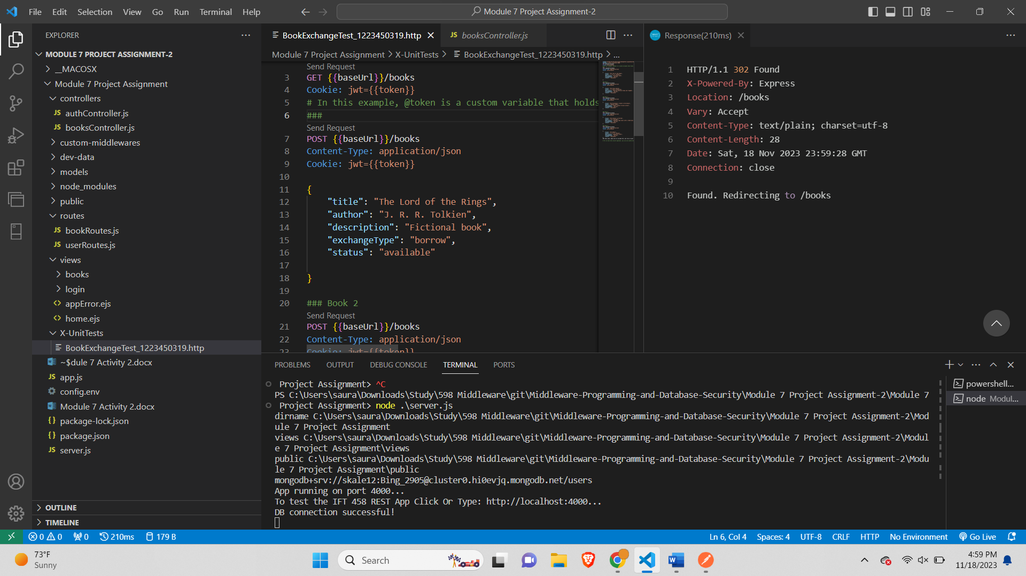

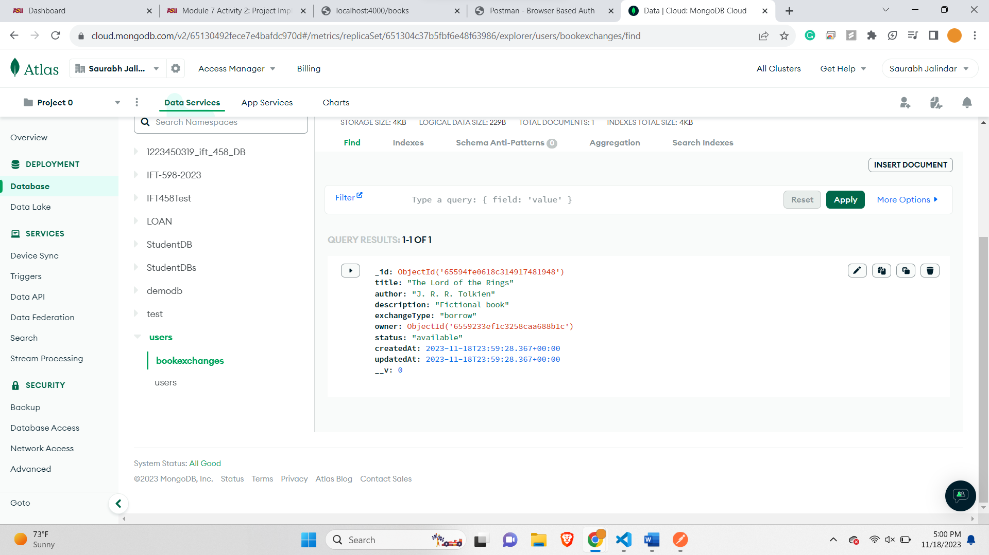

Adding book 2-

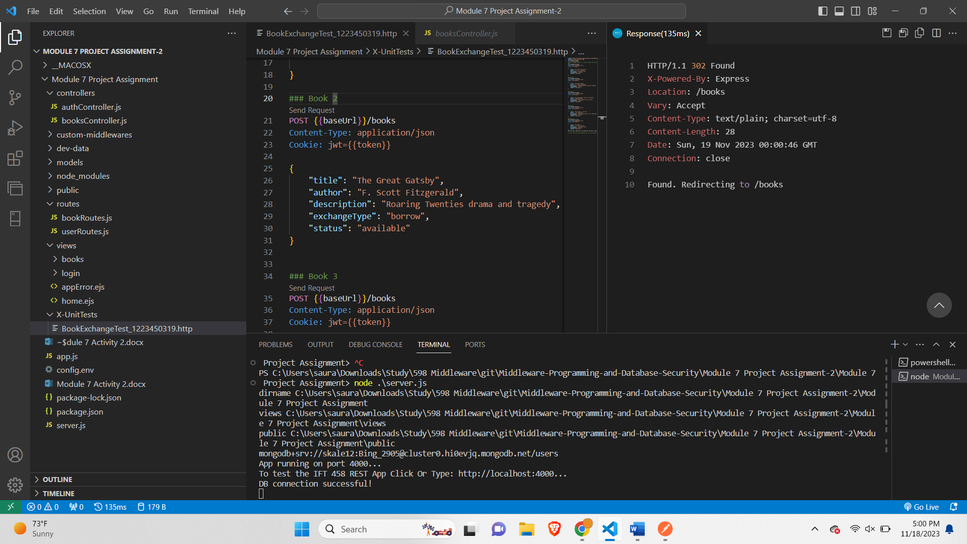

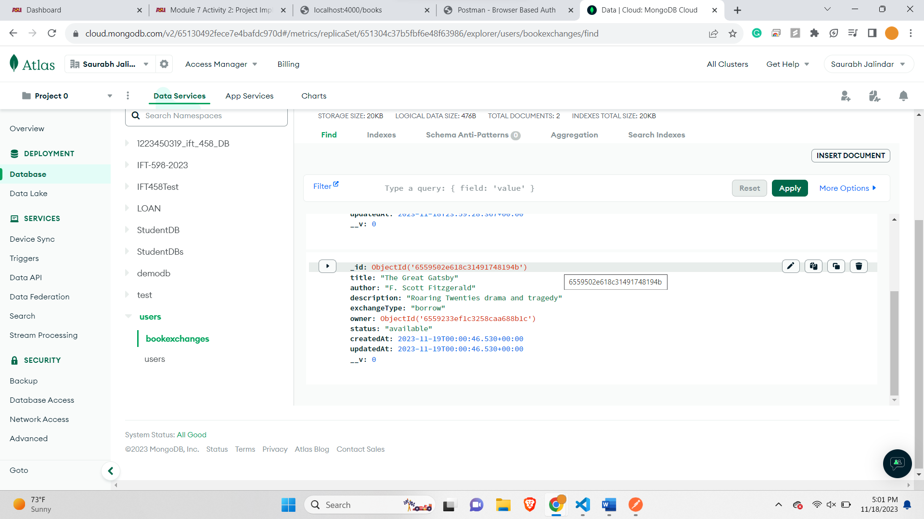

Adding Book 3-

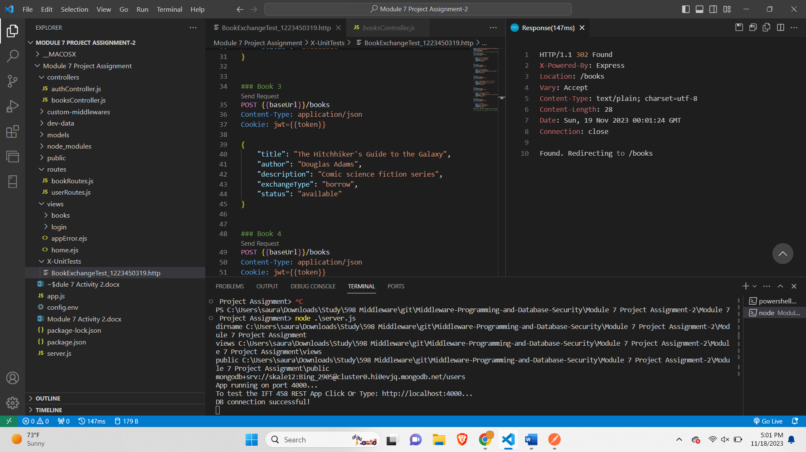

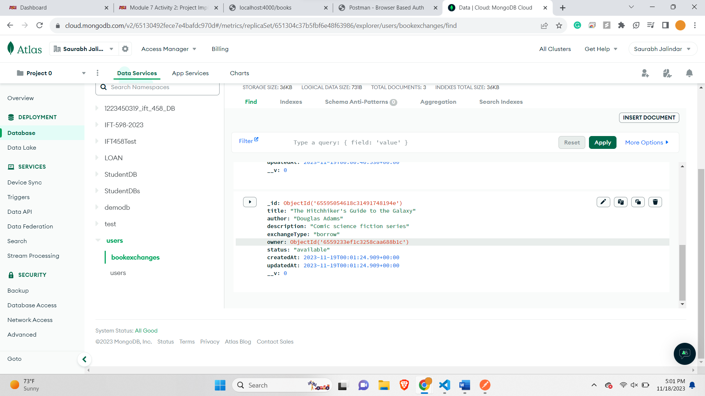

Adding Book 4-

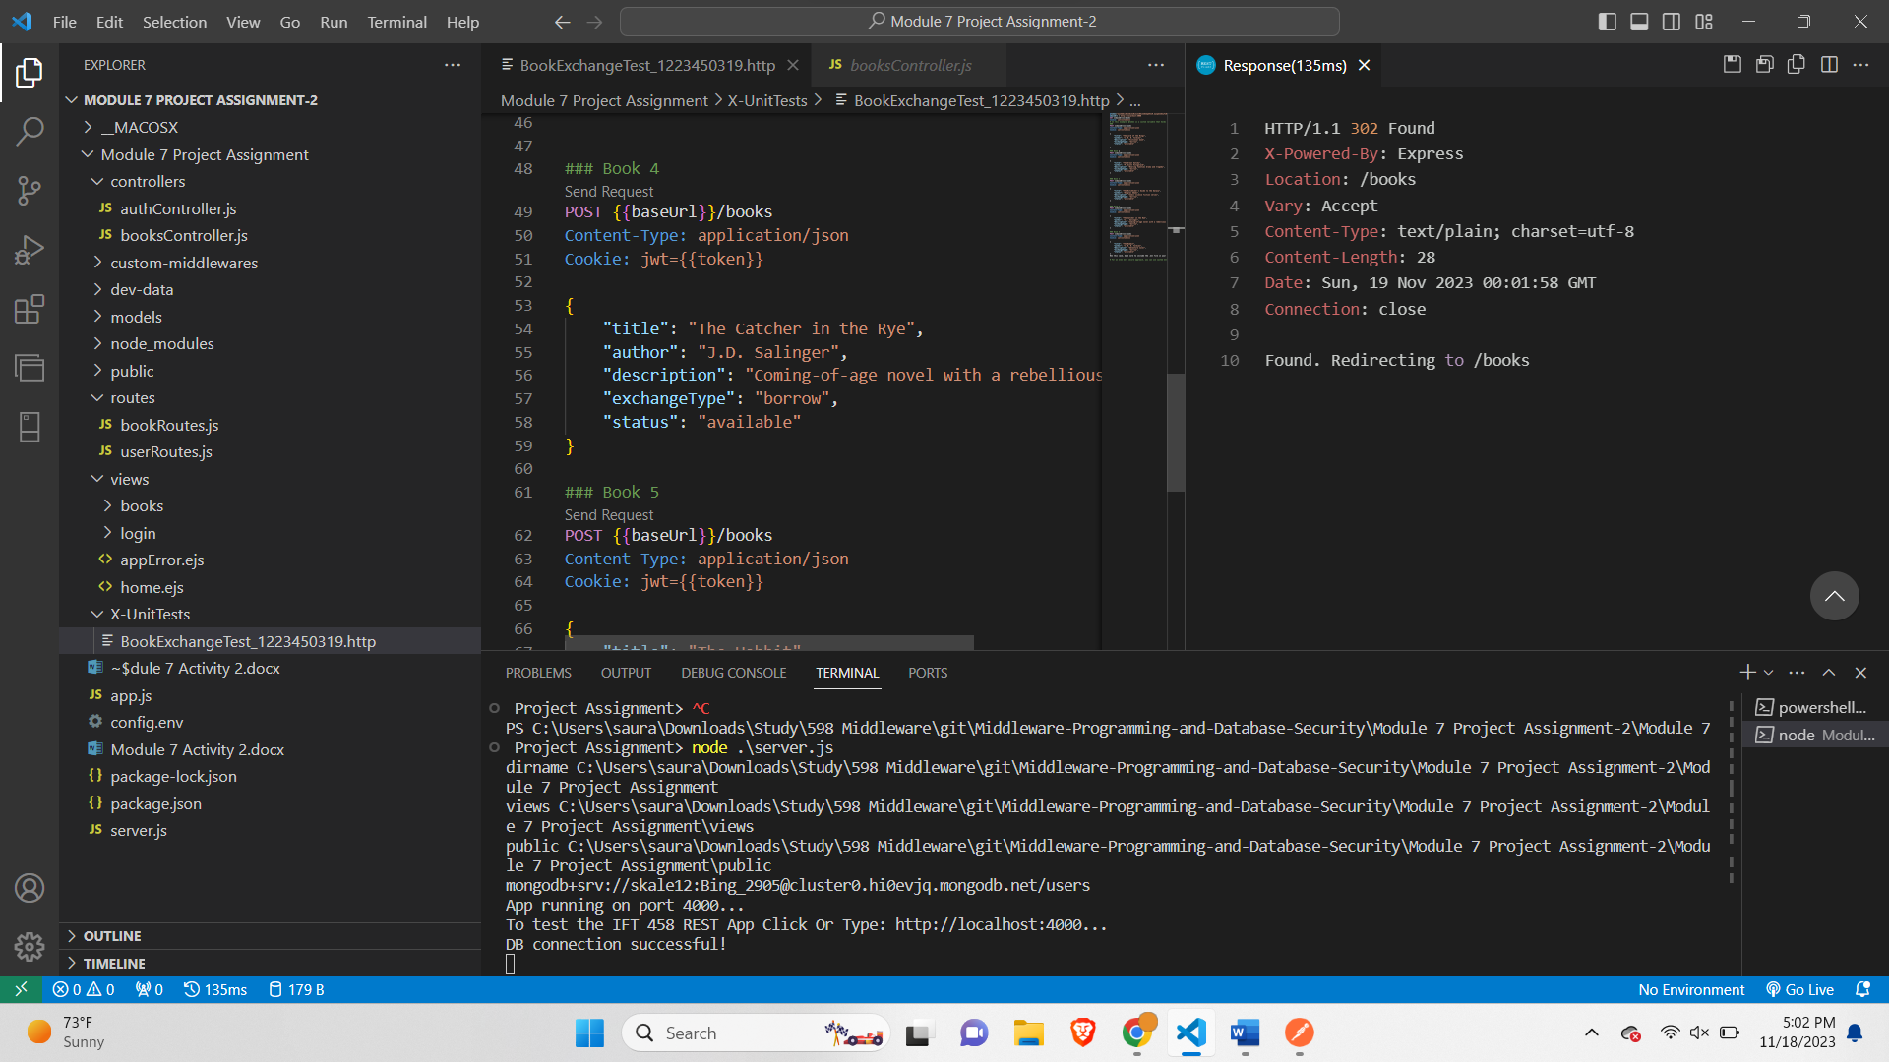

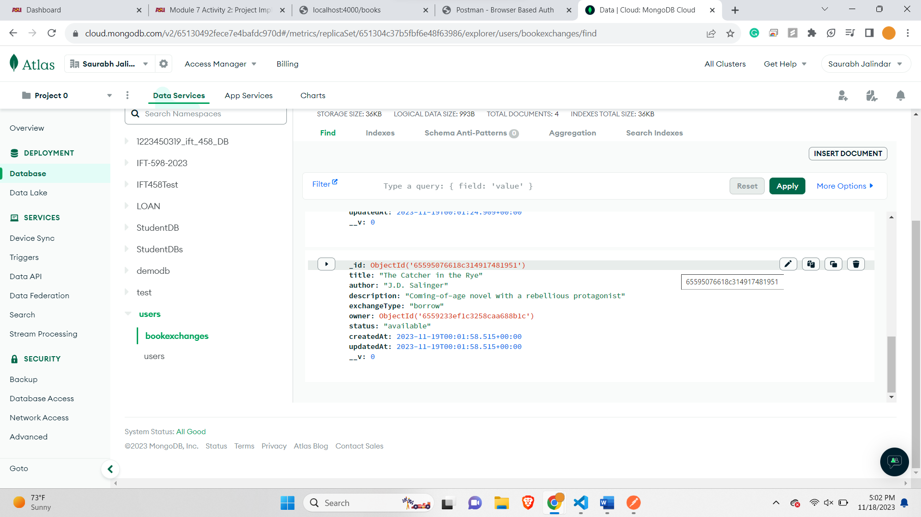

Adding book 5-

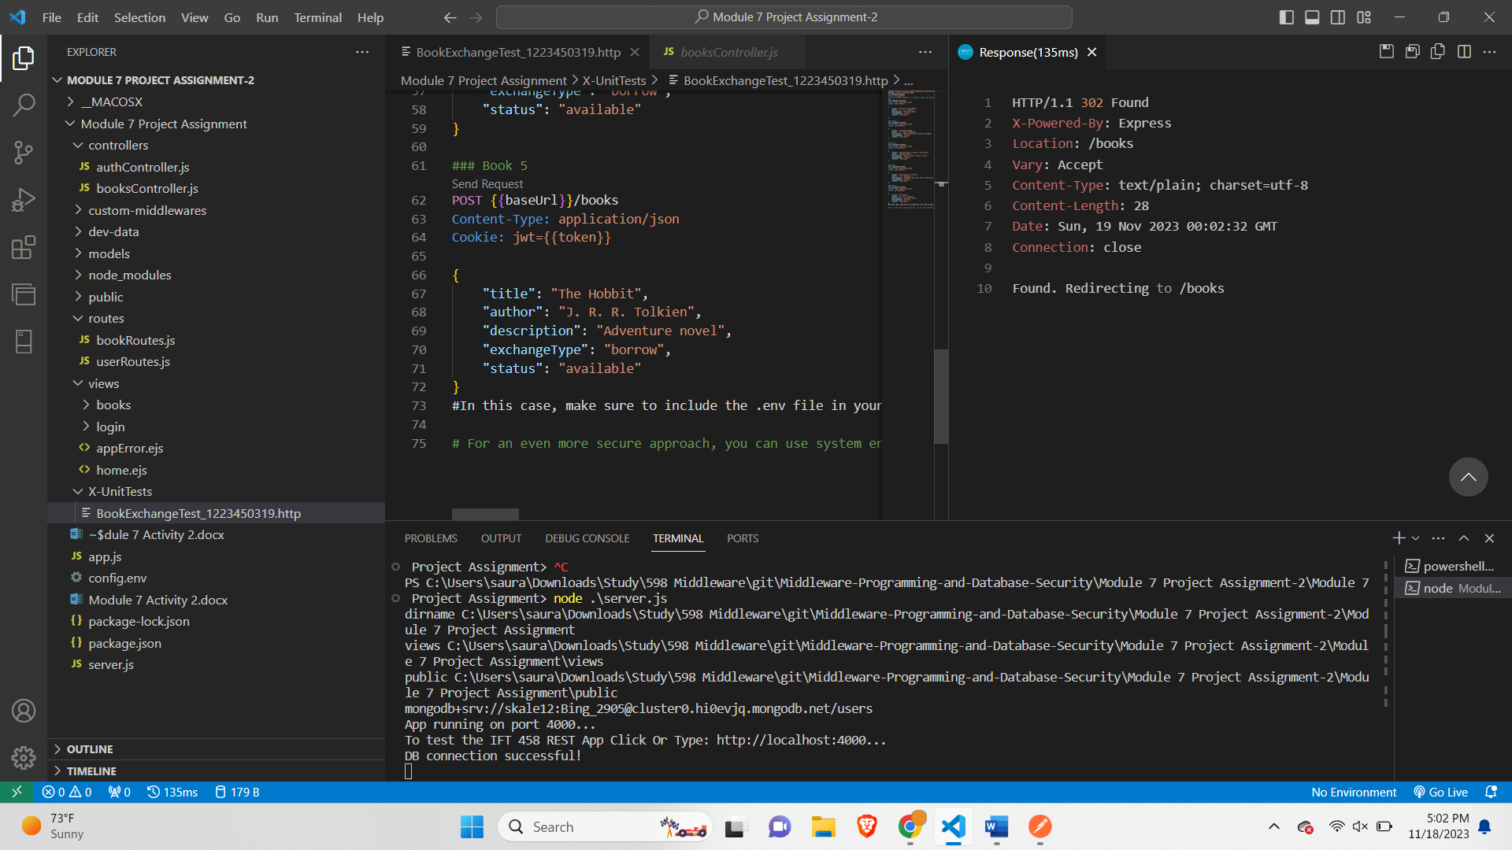

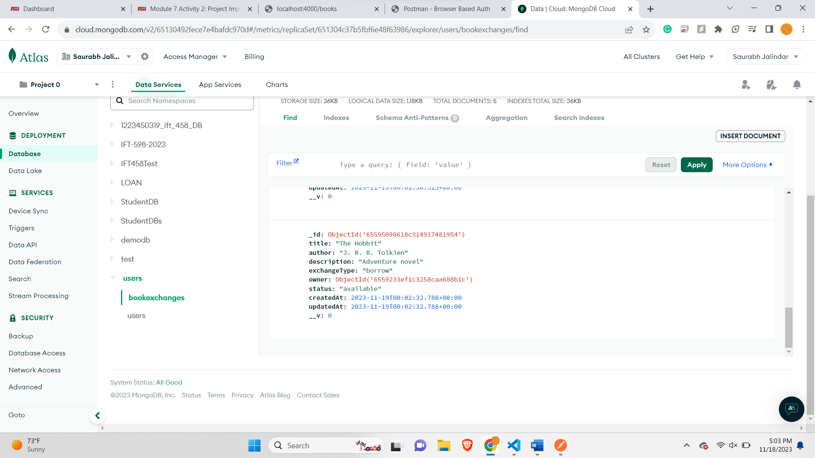

**4. GET Request: Retrieve All Books:**

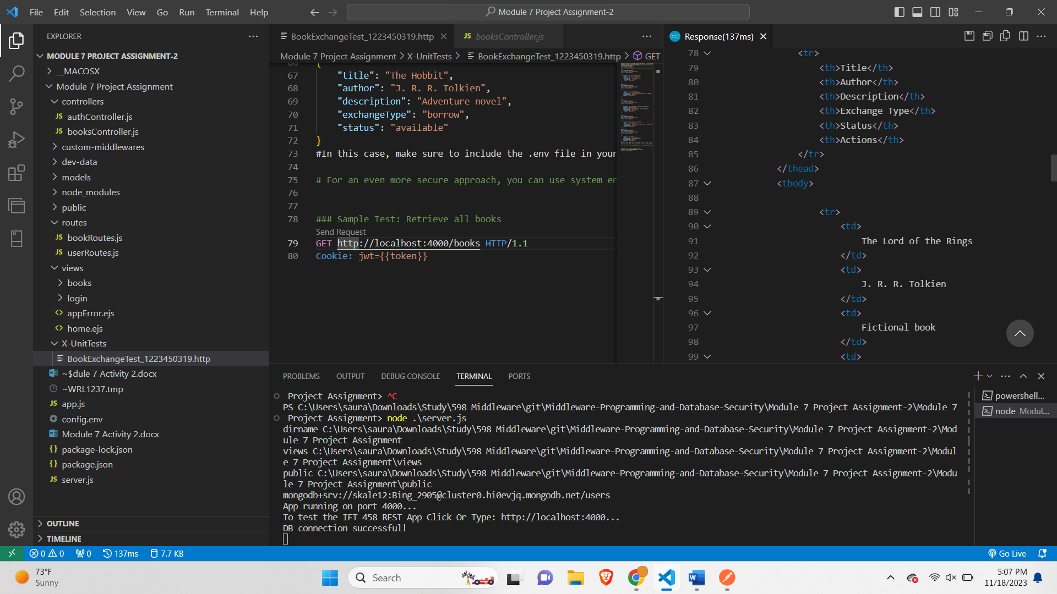

**5. GET Request: Fetch Specific Book by ID:**

Book 1-

Book in MongoDb-

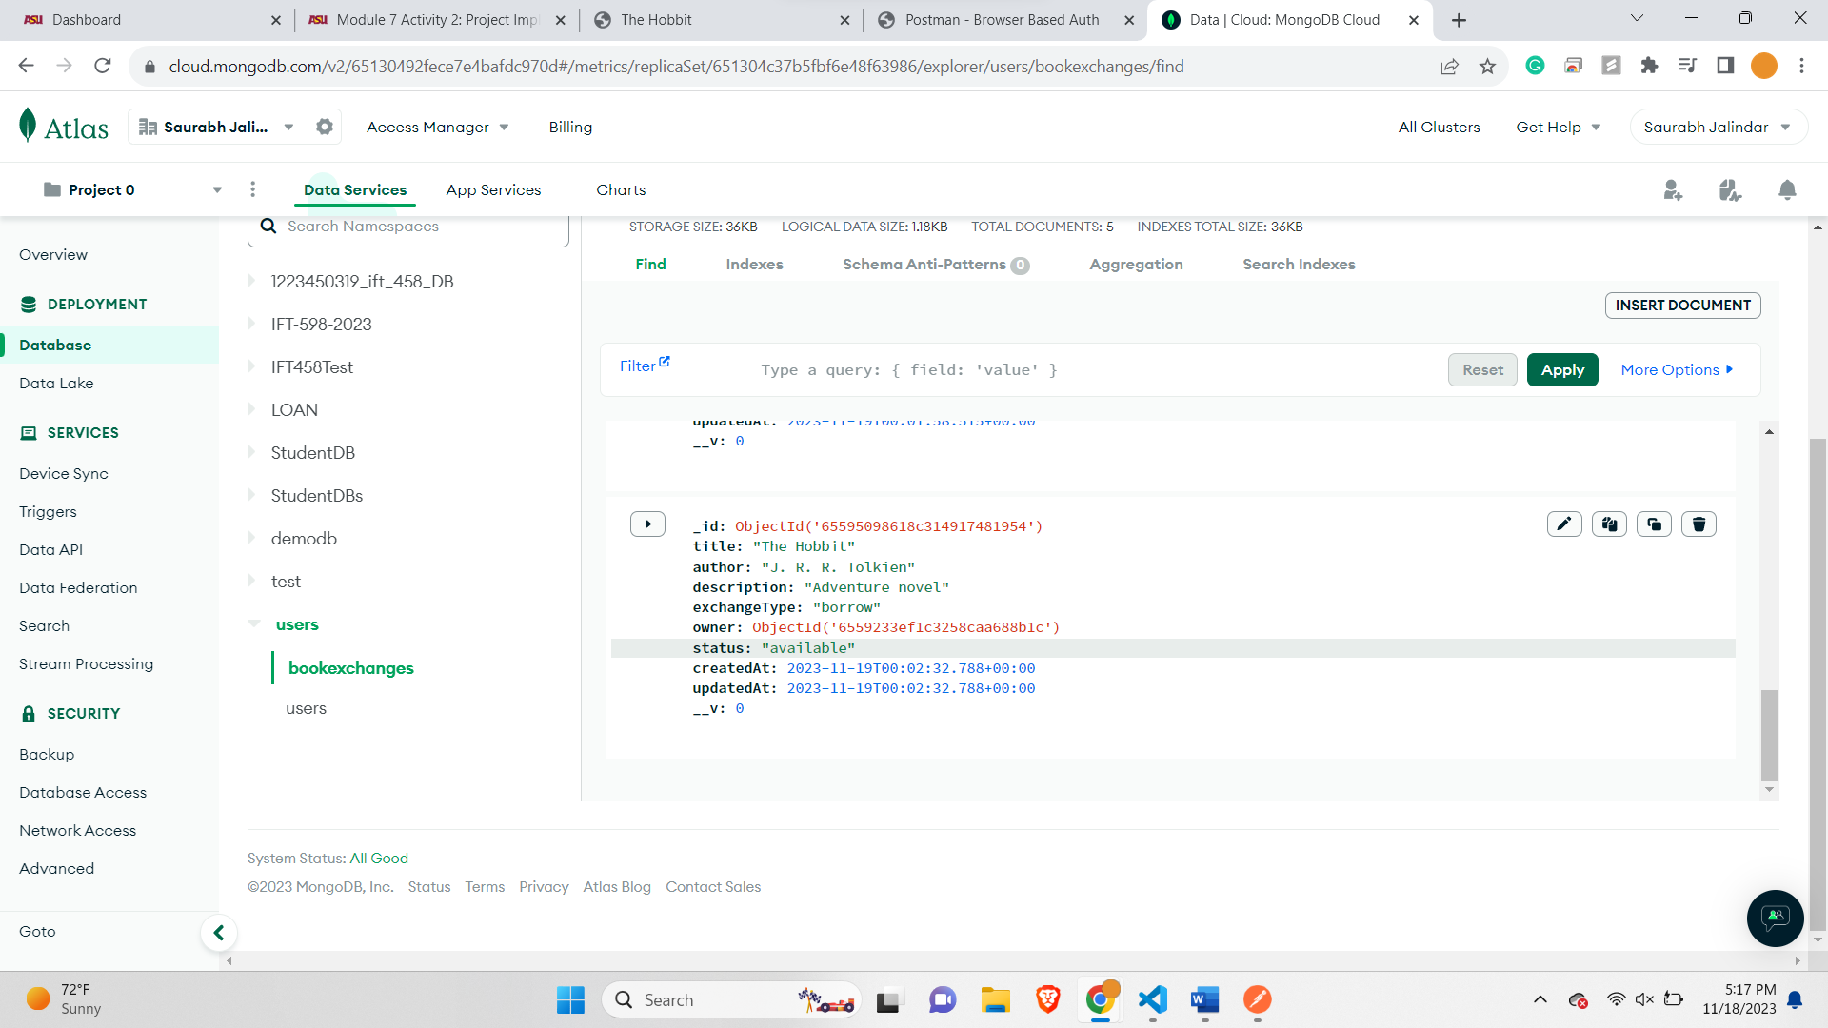

Book

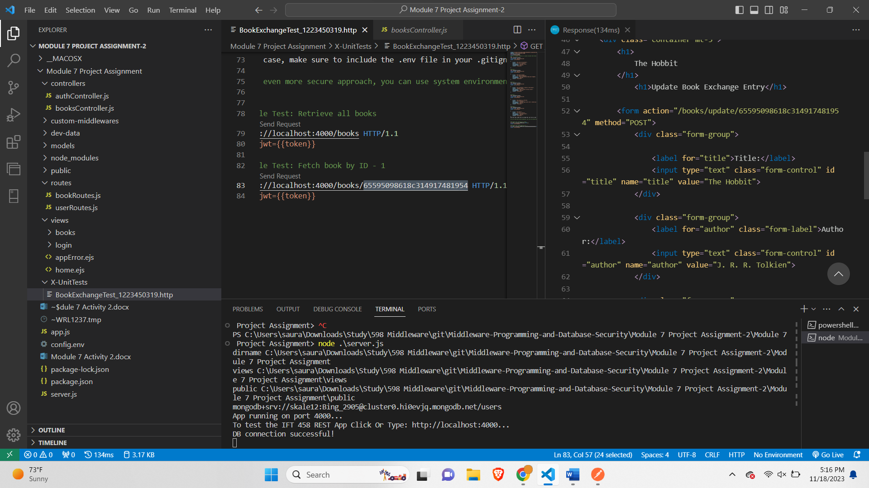

Book 2-

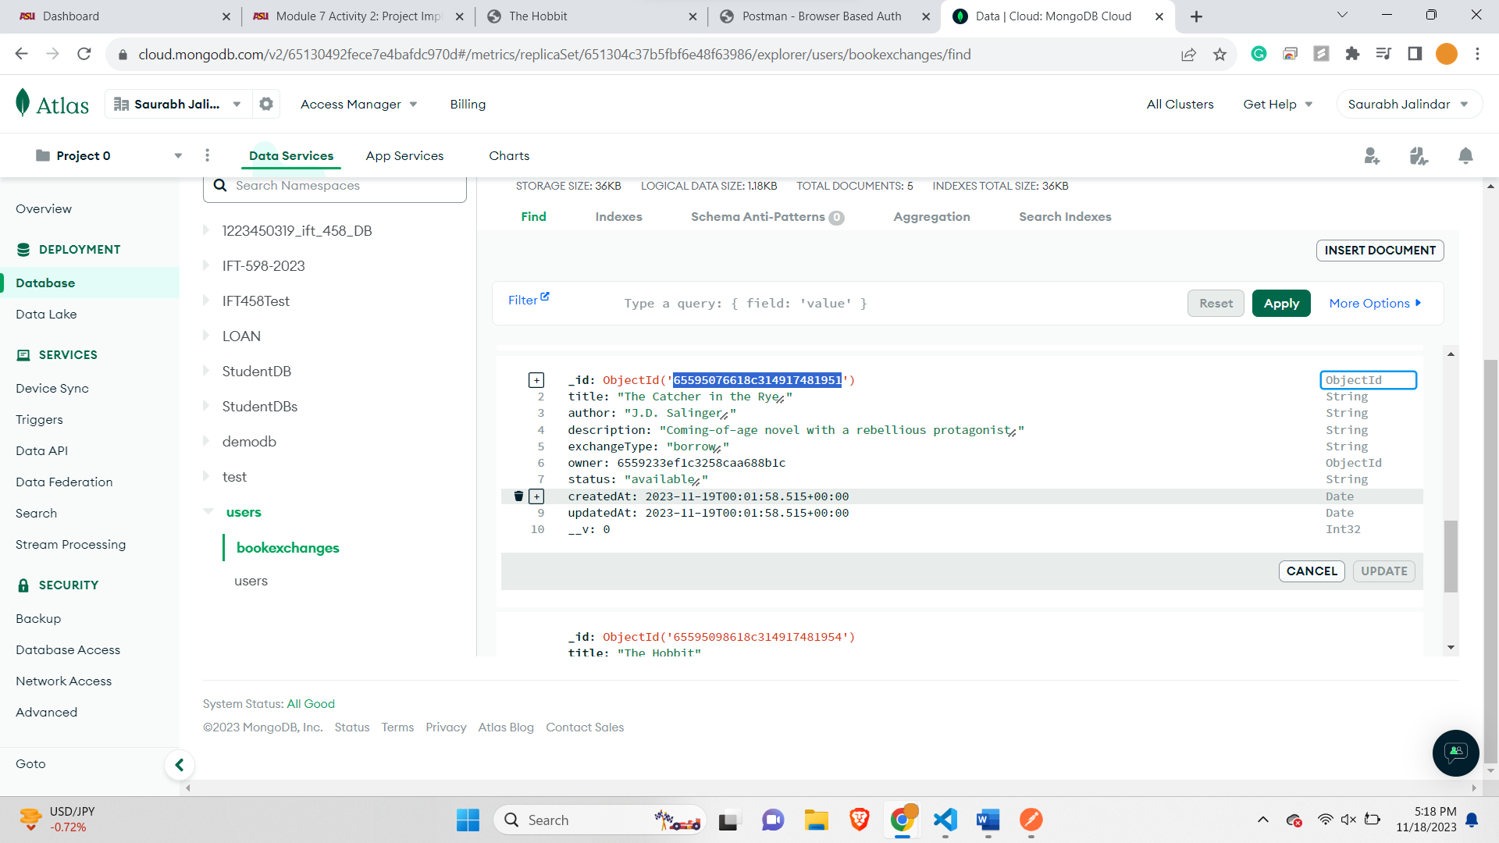

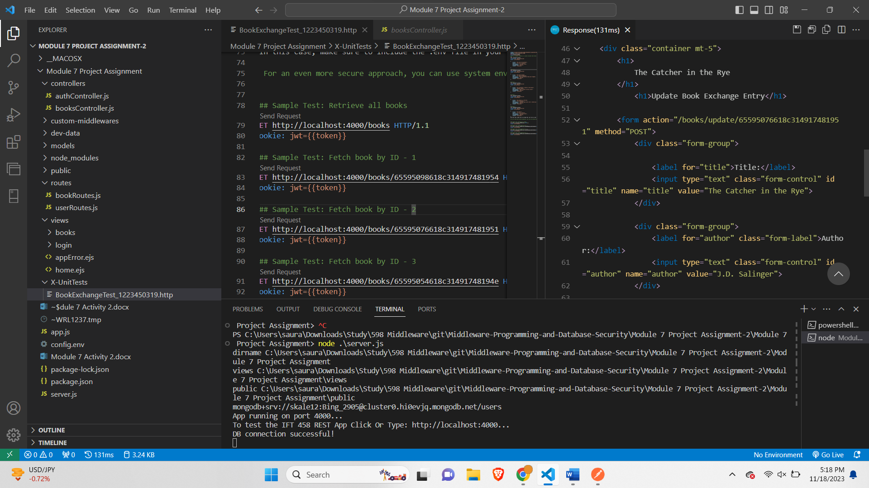

Book 3-

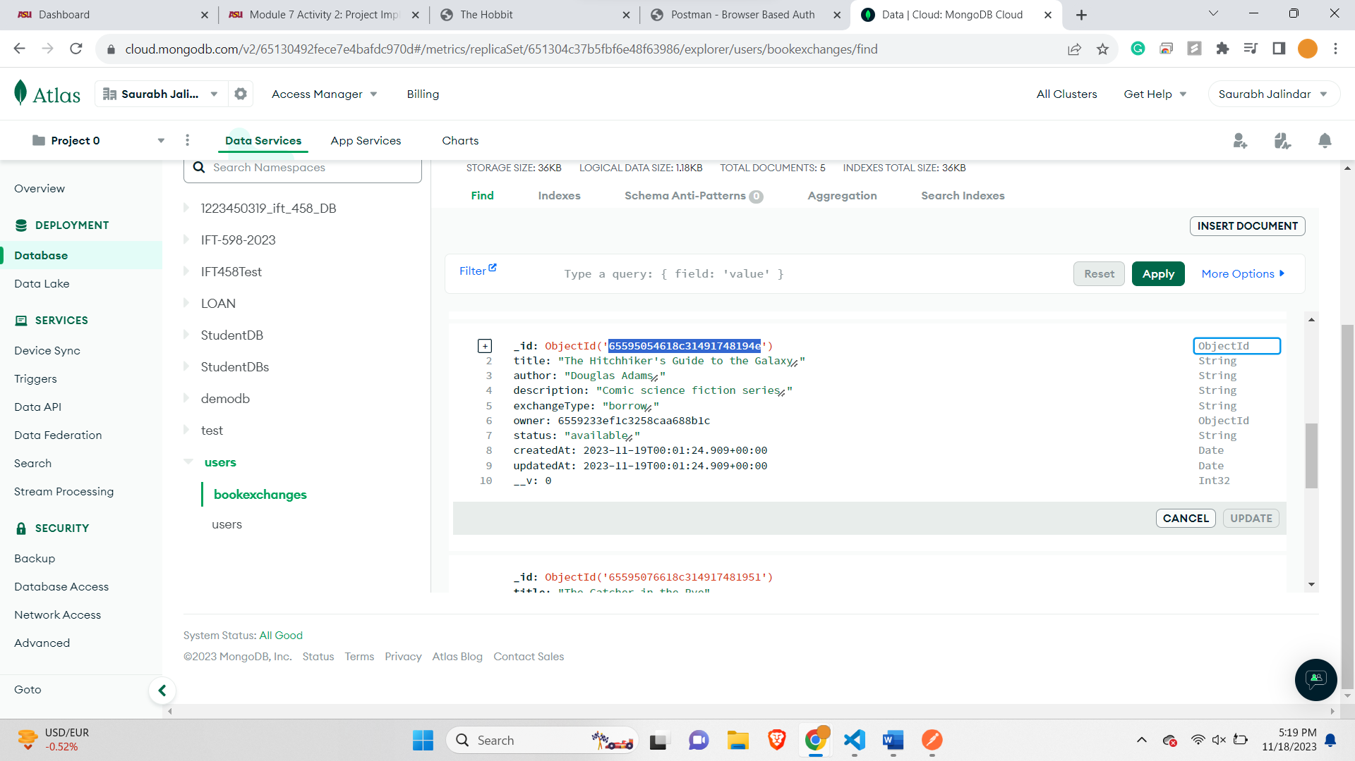

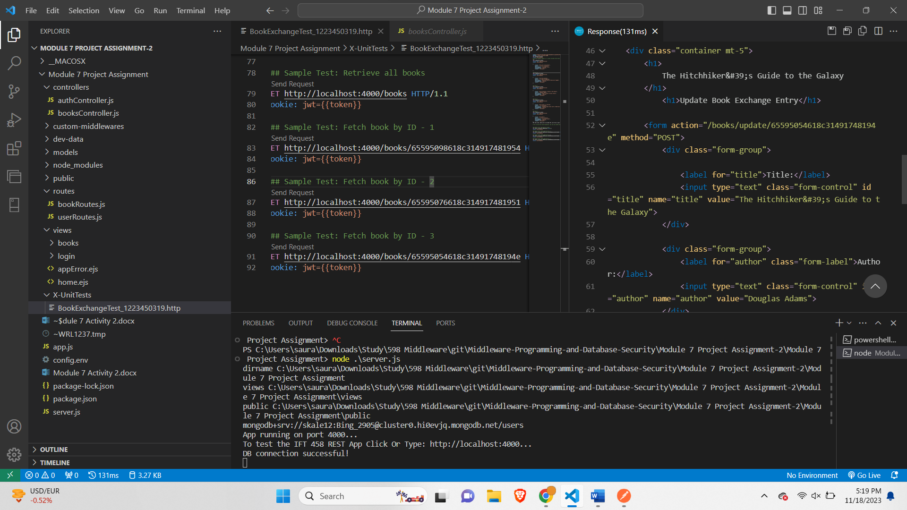

**6. PUT Request: Modify a Specific Book by ID:**

**For update and delete following changes made-**

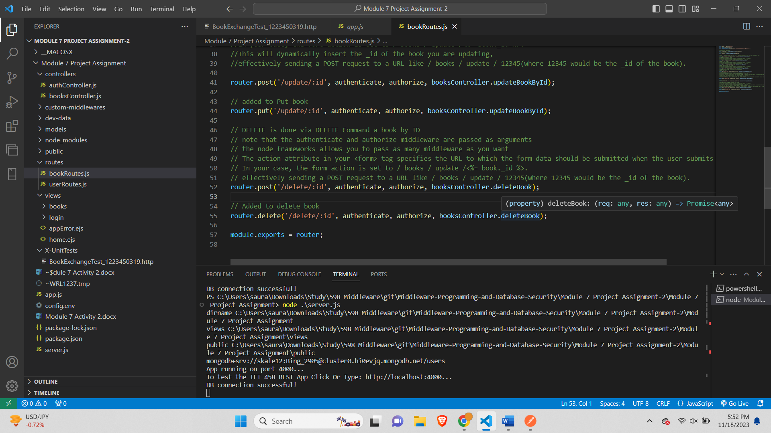

Book 1 before pic-

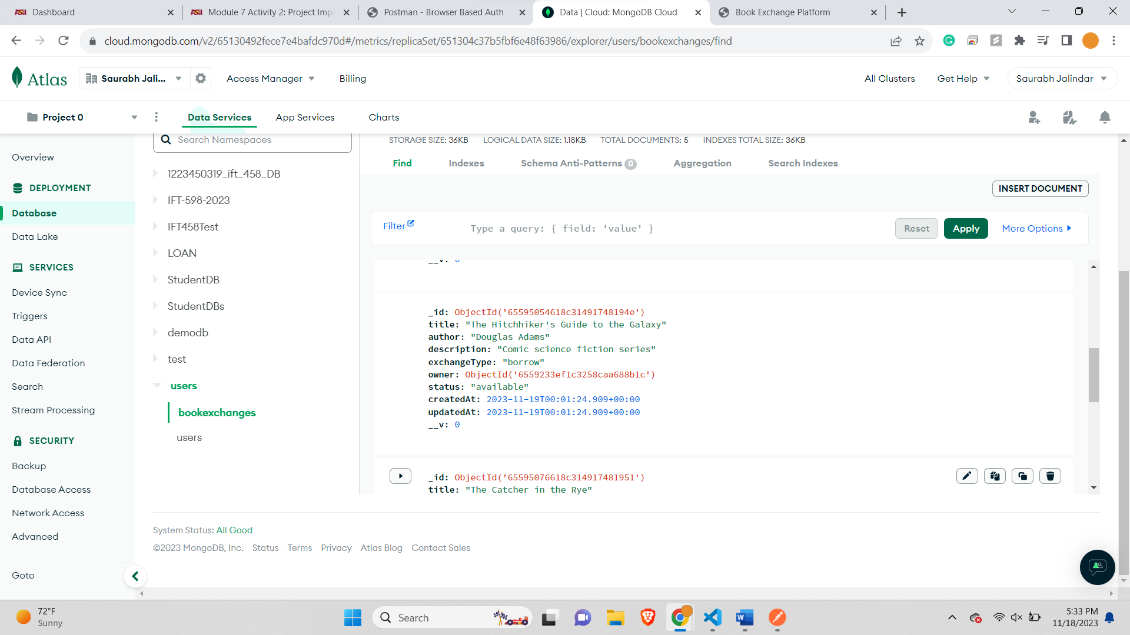

Book 1 Changes-

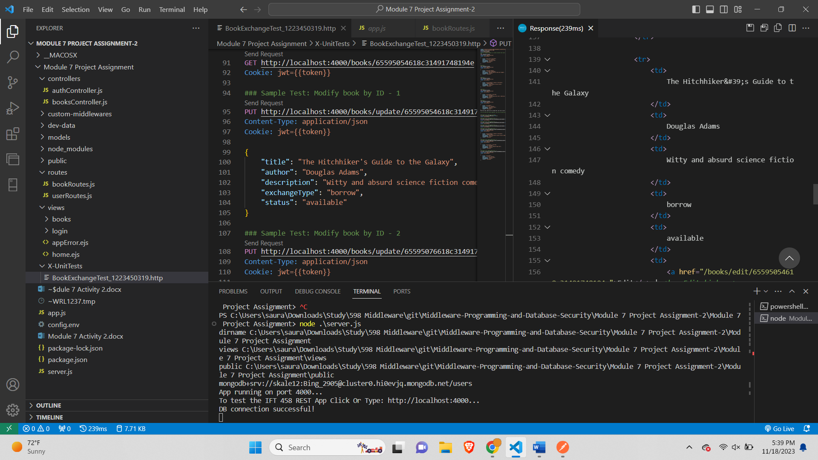

After change-

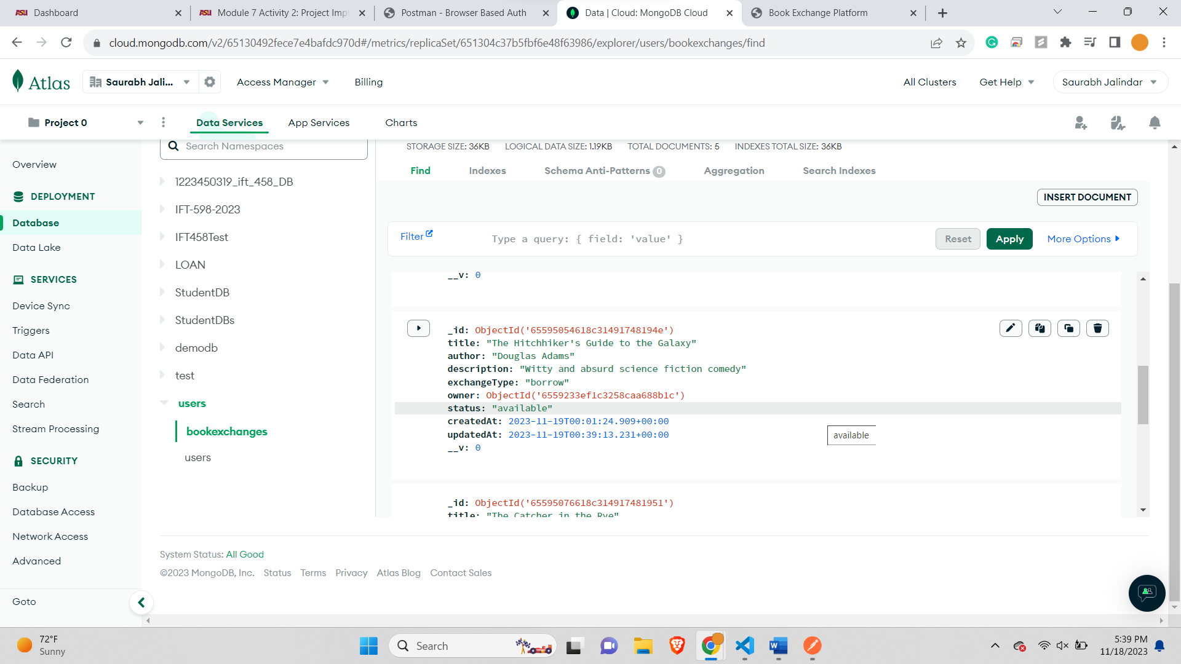

Book 2-

Before Changing-

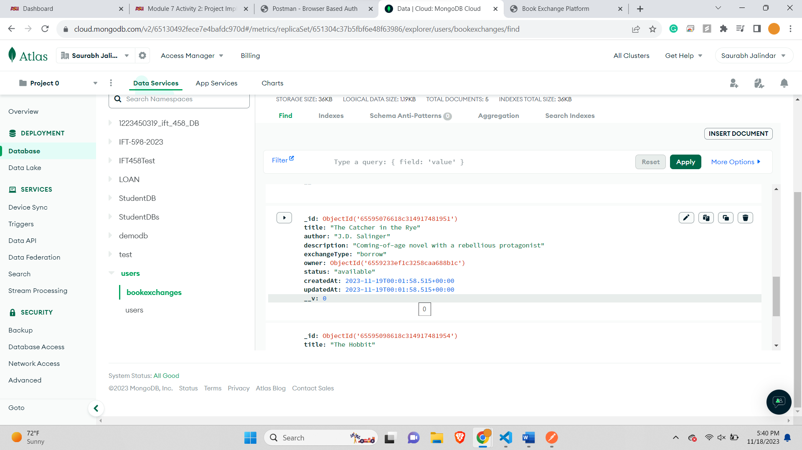

Changing book 2-

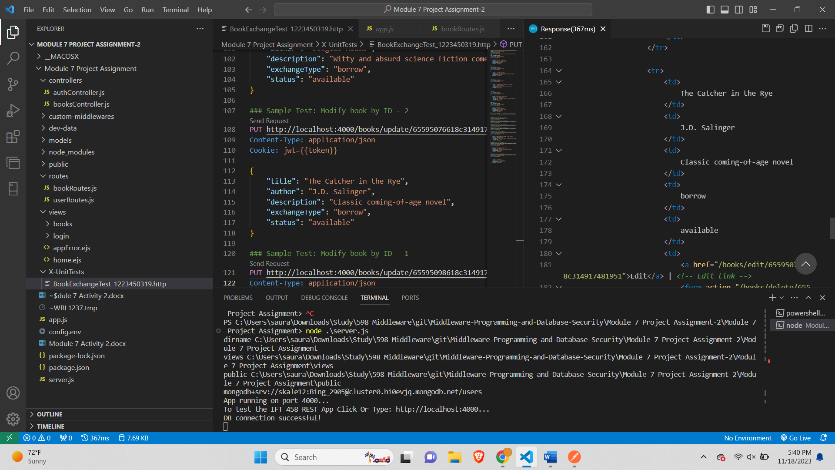

After changing book 2-

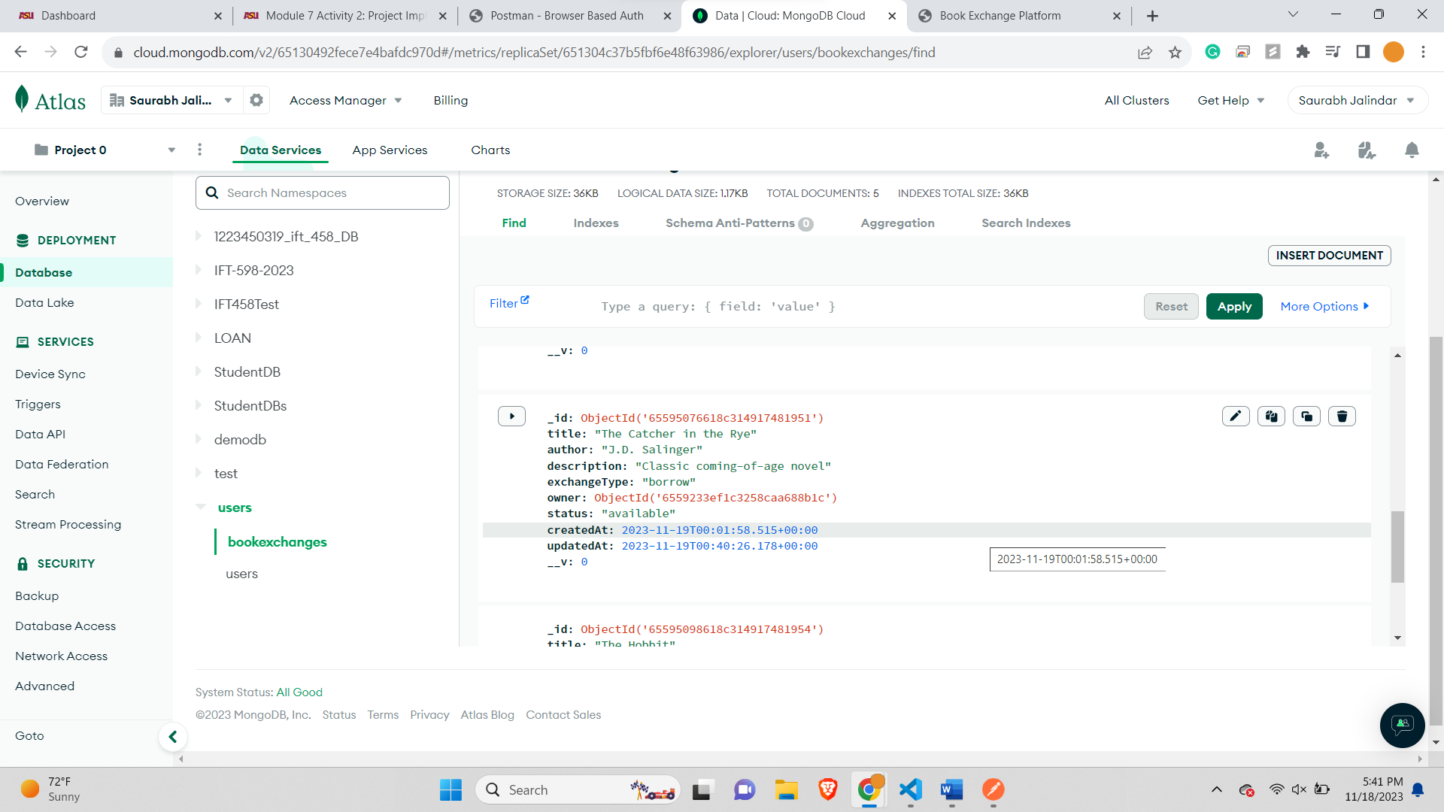

Book 3 Before Changing-

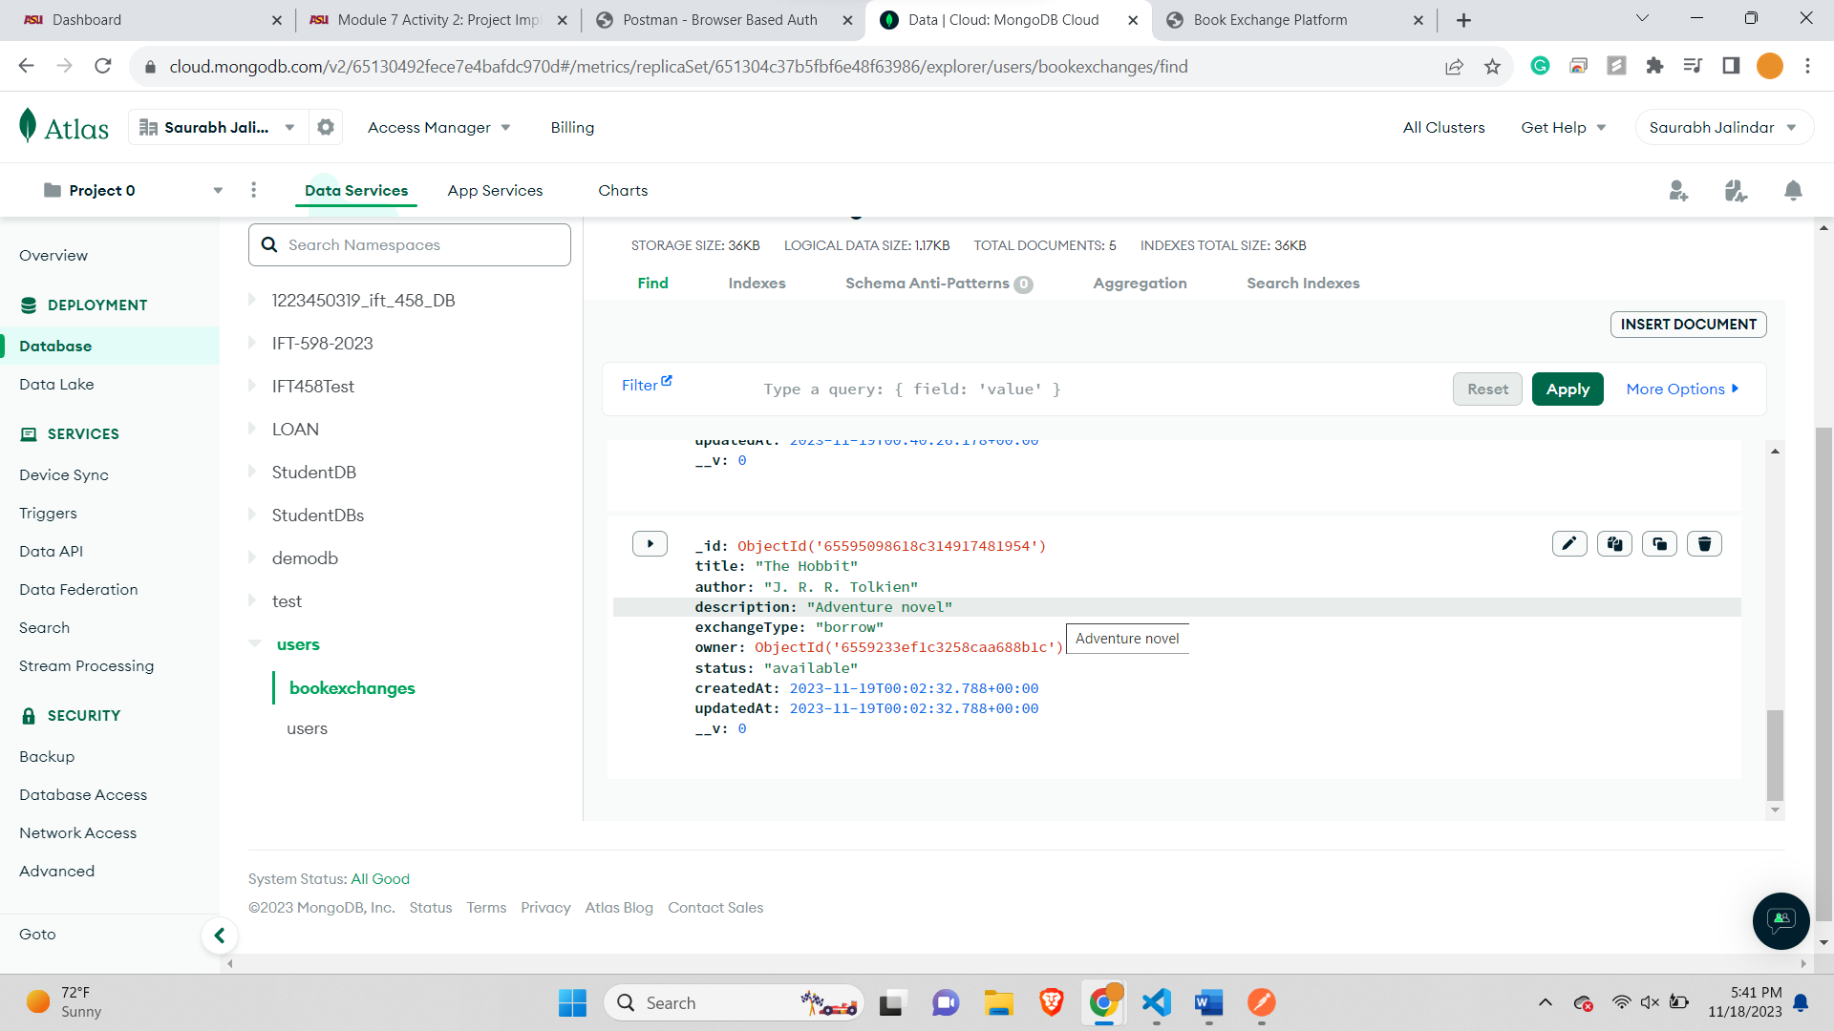

Book 3 Changing-

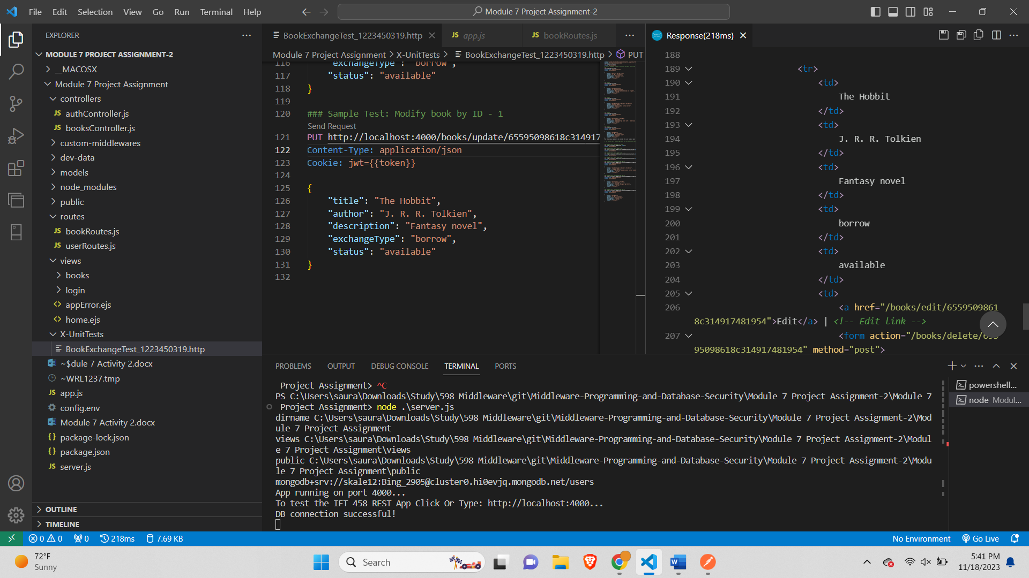

Book 3 After changing-

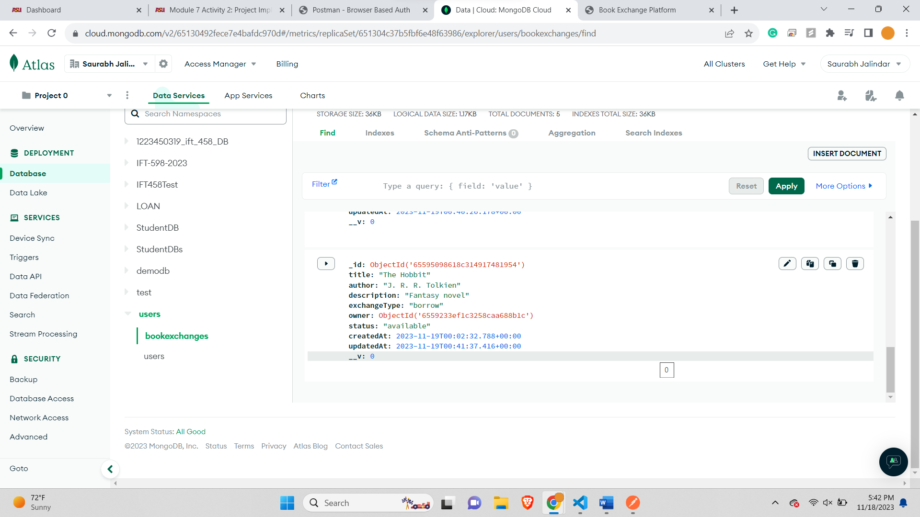

**7. DELETE Request: Erase a Specific Book by ID:**

Before Deleting 1 book 5 records are there-

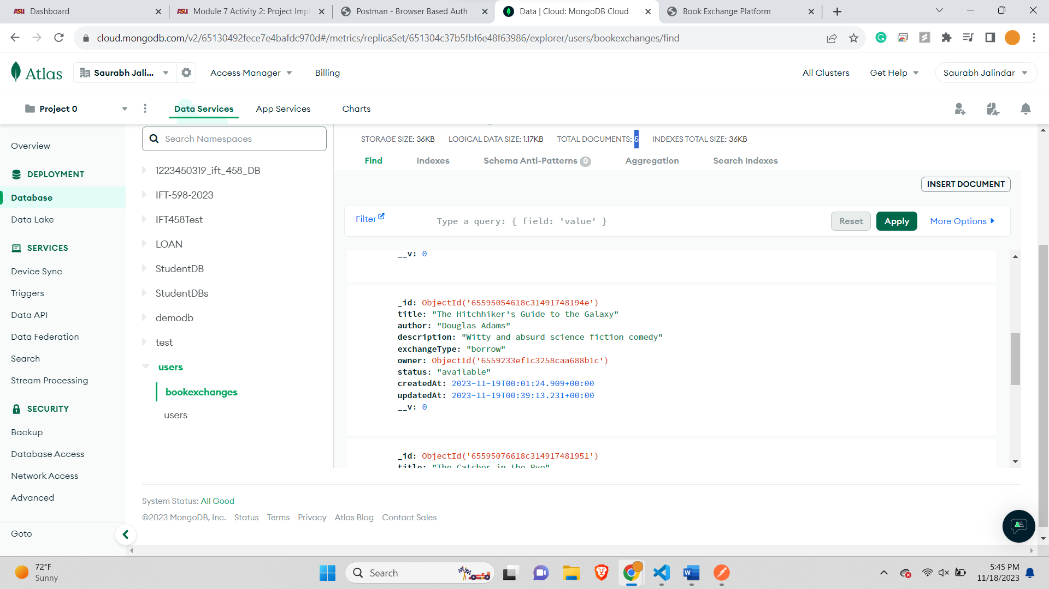

Deleting 1 book-

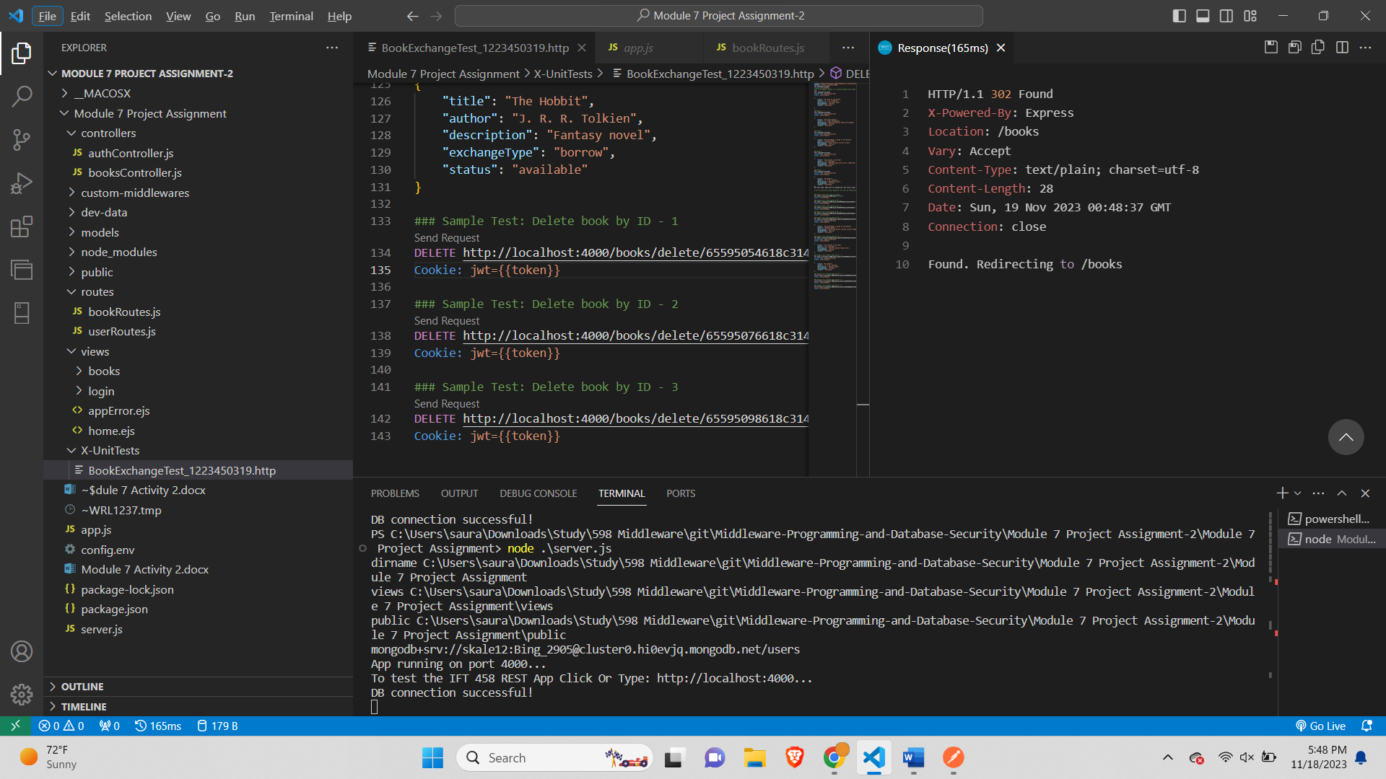

After Deleting book 1 book 4 records remain-

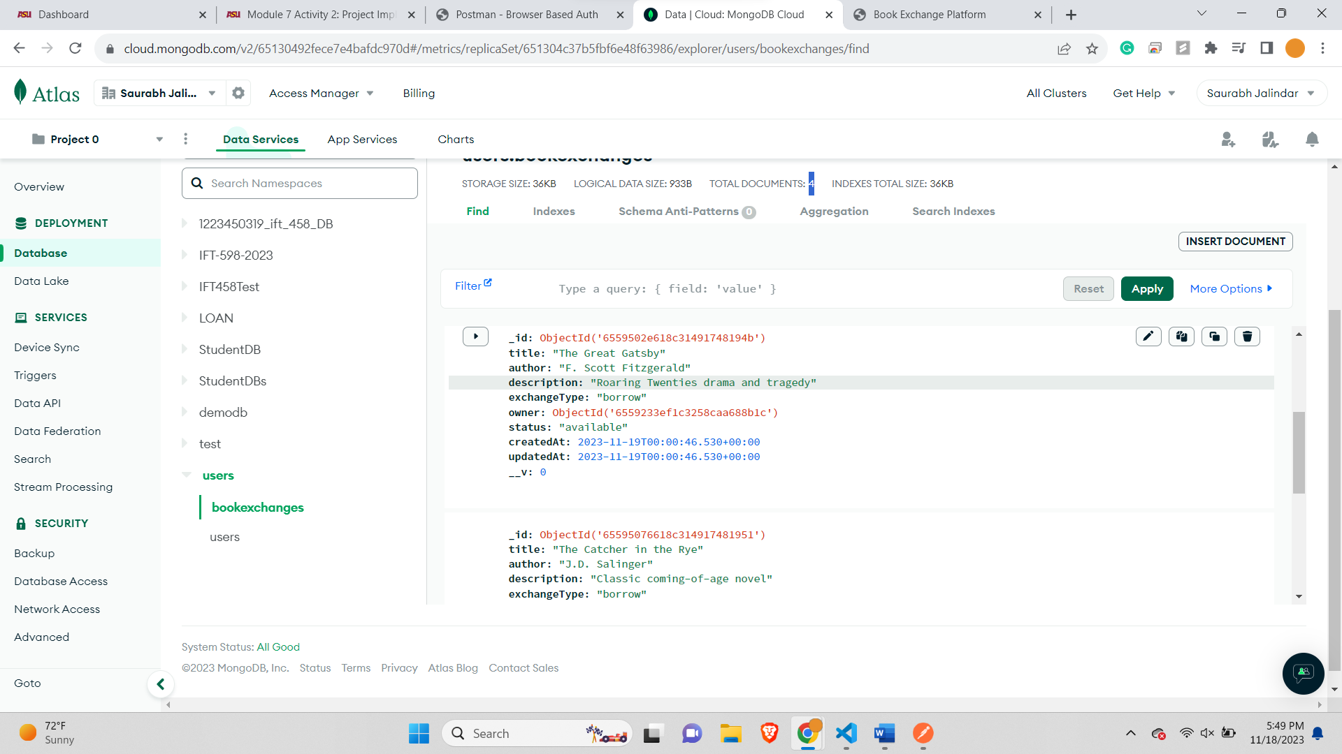

Before Deleting 2nd books 4 records remain-



Deleting 2nd book-

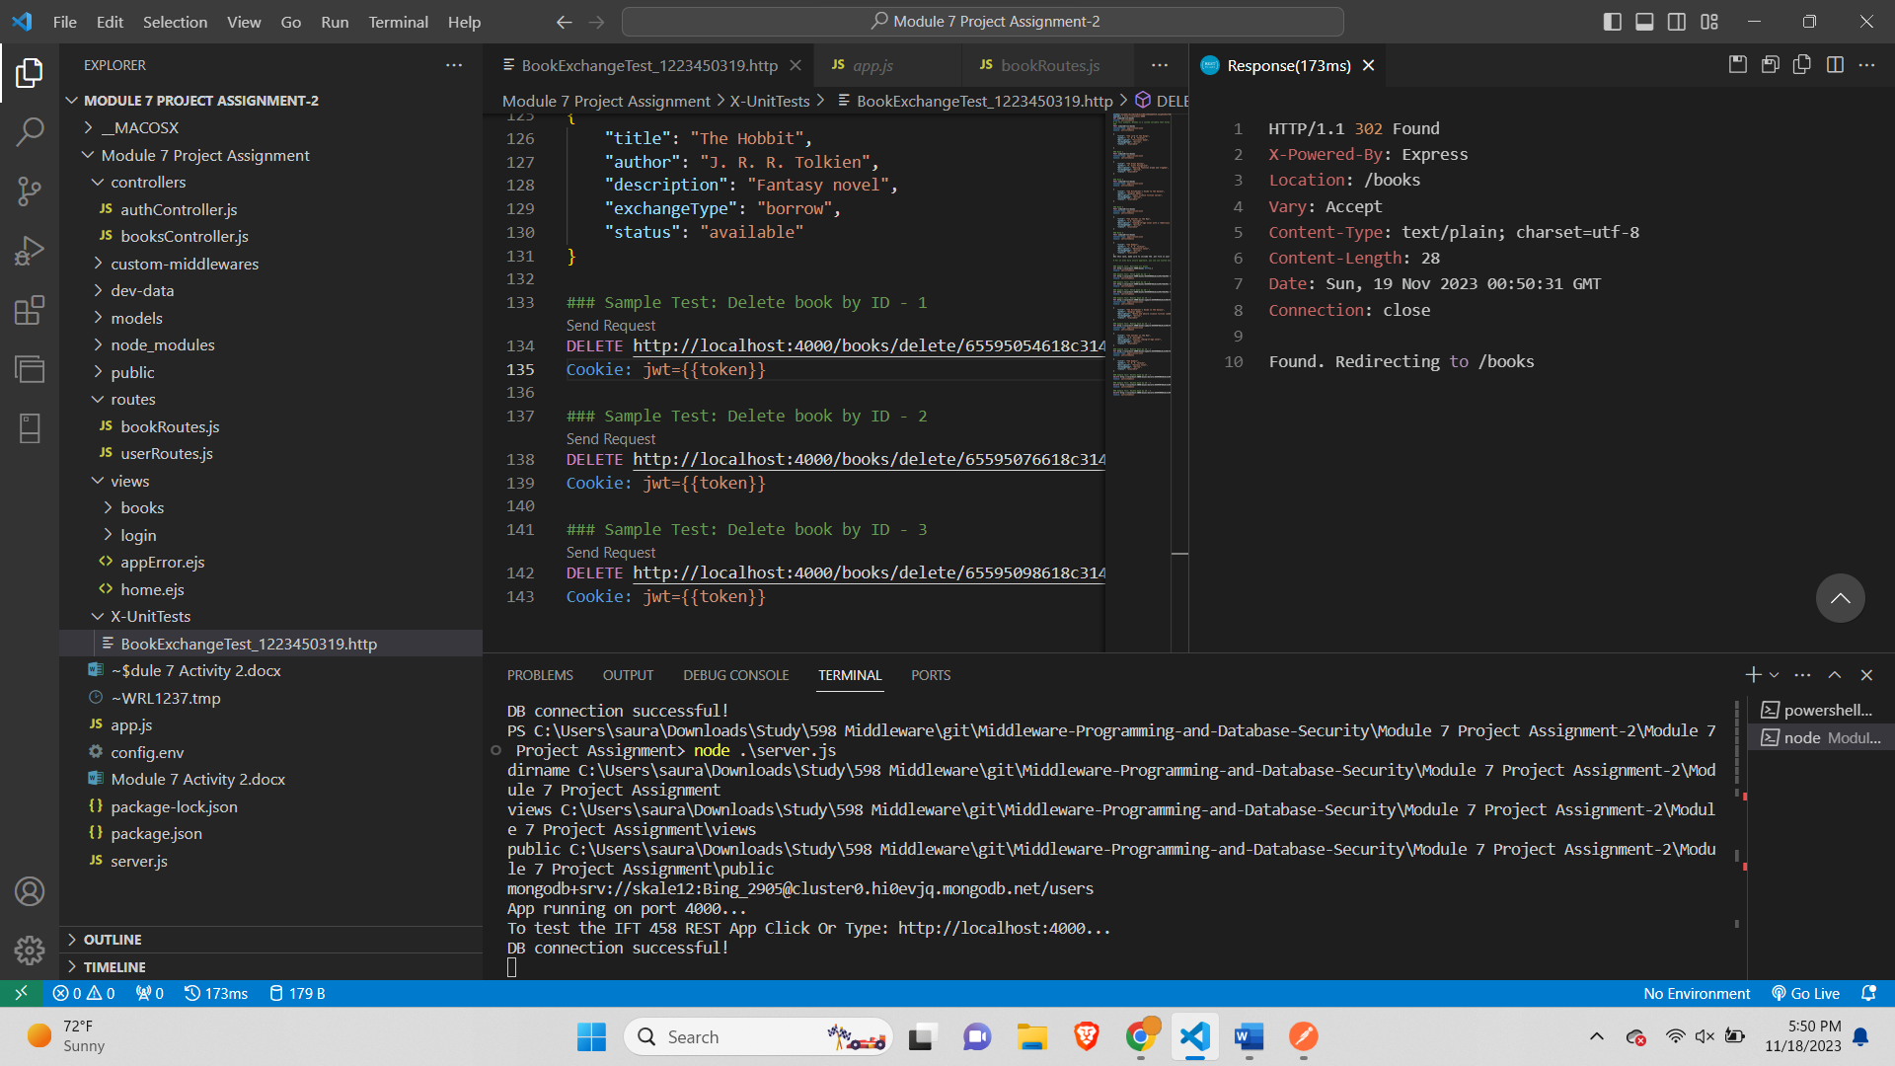

After Deleting 2nd book 3 records remain-

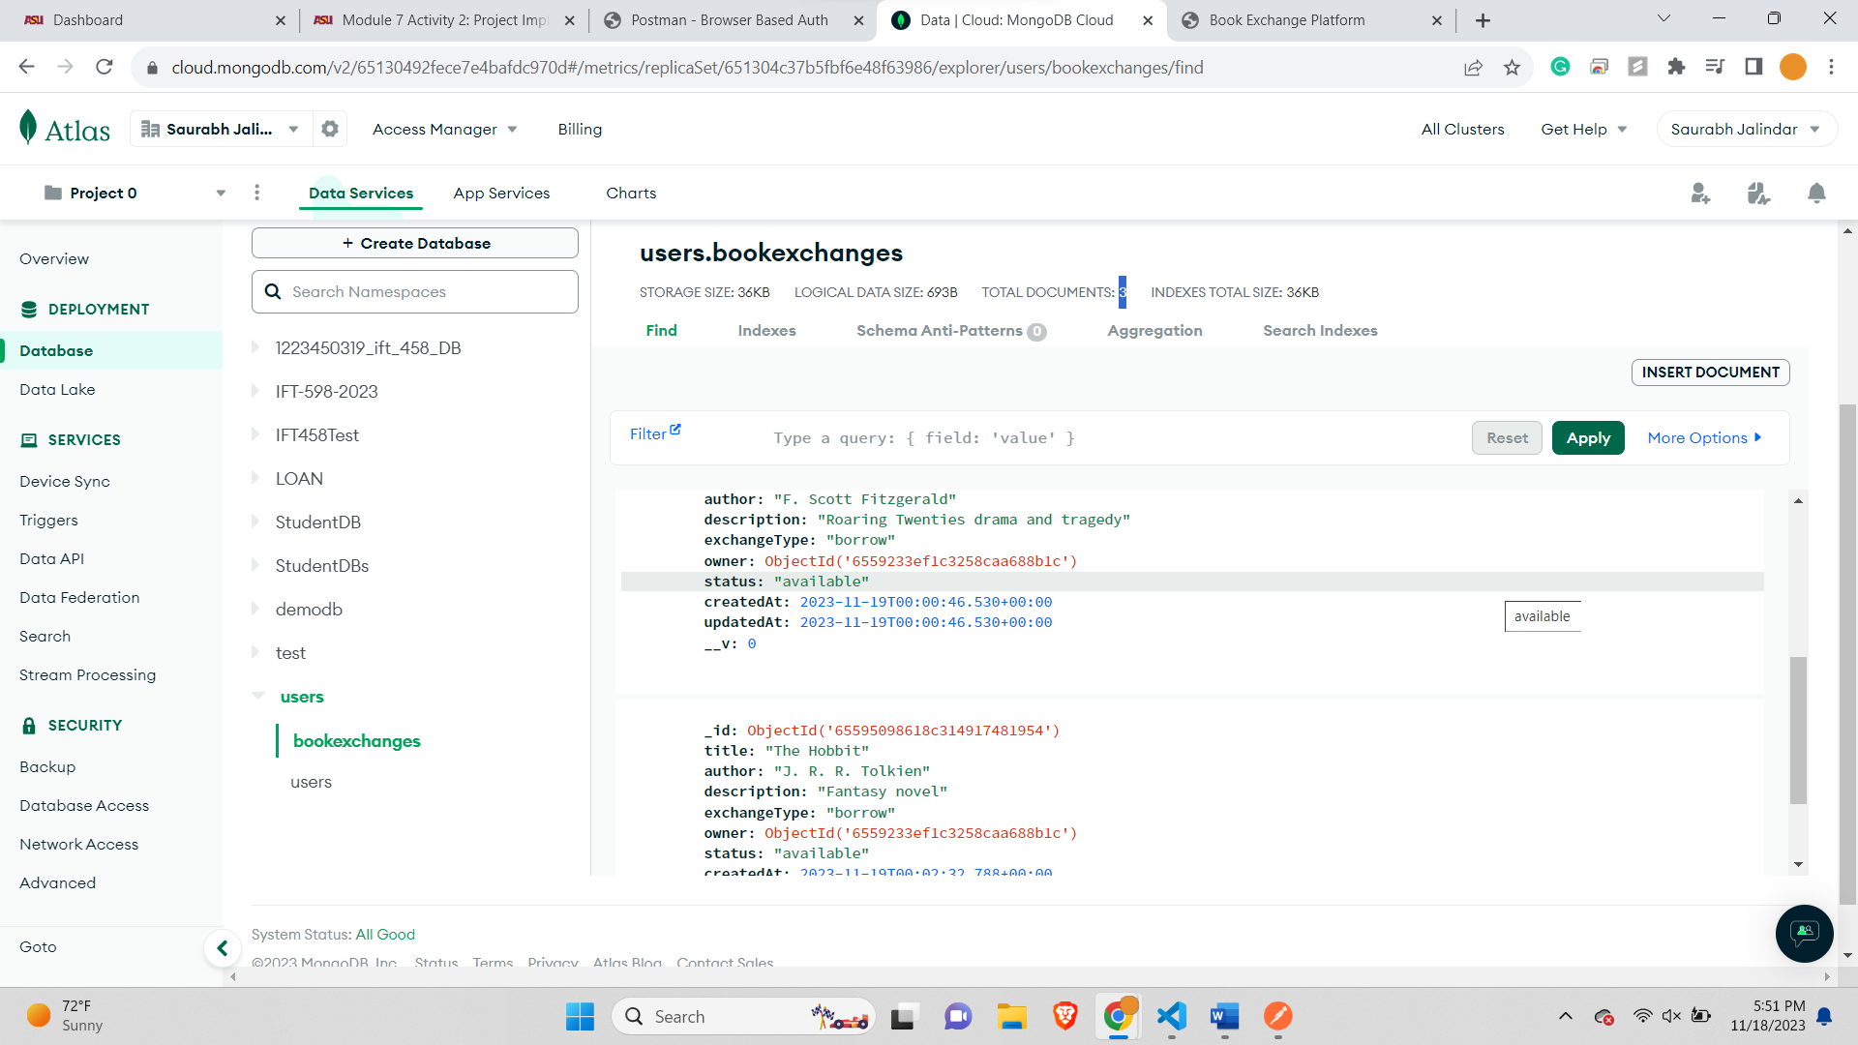

Before Deleting 3rd book 3 Records remain-



Deleting 3rd book-

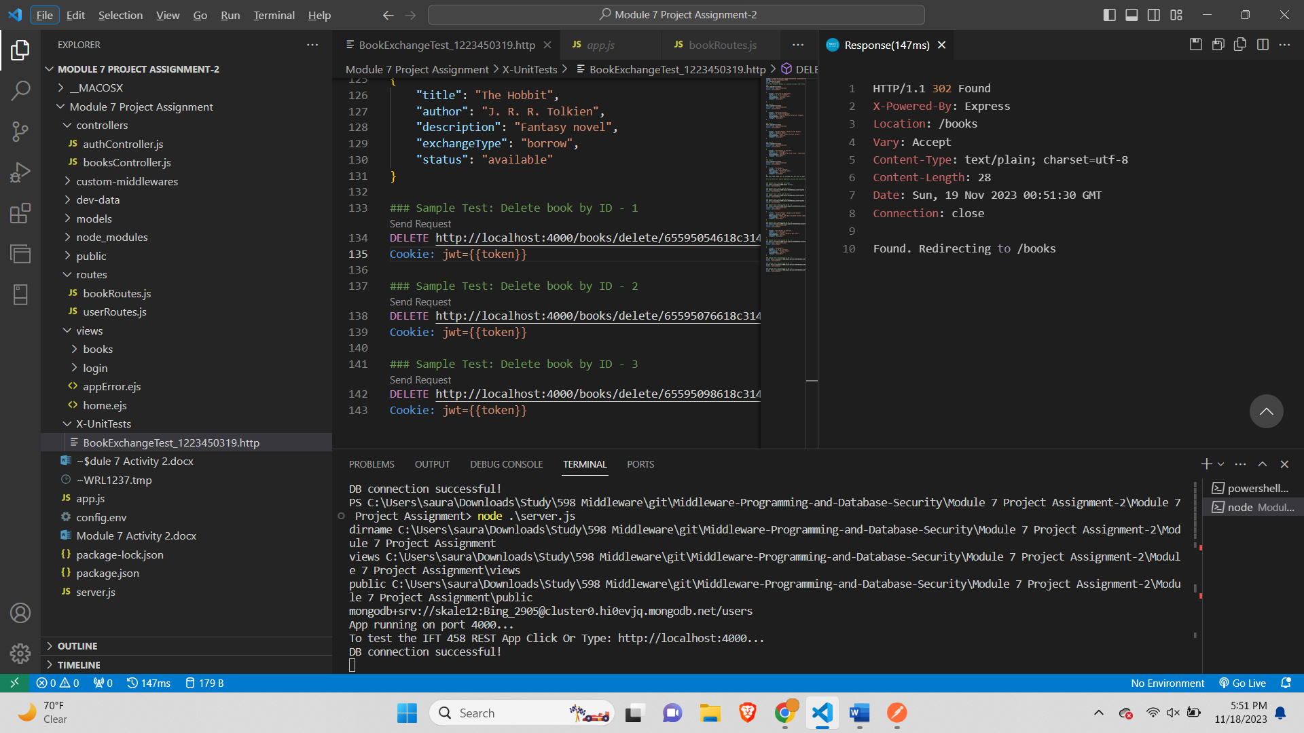

After Deleting 3rd book 2 Records Remain-

